Version #2

5-1-25

**Summer 2025 General Information**

**Classes start June 2-- In-Person and Online Classes.**

**Summer Registration Now Open**

**Members:**

Email the listed facilitator to register for a class or activity.

**Non-Members, please be our guests this Summer.**

Register for up to 3 classes by emailing the facilitator or leaving a message on the NFLL phone: 480-461-7497. Members of NAIL* and RISE** may register for unlimited in-person or onine classes by calling the NFLL office or emailing the facilitator

*New Adventures in Learning, Chandler-Gilbert CC

**RISE Learning for Life, Rio Salado College

**How to Join NFLL for Fall 2025**

1. **Step One**: NFLL members must enroll in MCC as a non-credit student before registering for New Frontiers classes. The enrollment process may take 2-5 days, so it is important to complete this process before class registration opens.

To enroll as a new member

* 1. To begin, go to *newfrontiers.mesacc.edu*. Click on the ***Members Acct***tab at the top of the page.
  2. Select “***New User? Start Here***.” Complete the form according to the online instructions and select Submit. Enter your name as you would like it to on your name tag.

1. **Step Two**:
   1. Go to *newfrontiers.mesacc.edu/membership.html**.*
   2. Click here [*NFLL Enrollment Form*](https://forms.gle/Pwa36QWtxwbtYR7z8)link*.* Once submitted, you will be notified by the MCC Community Partnerships/New Frontiers office for confirmation and instructions on payment of enrollment fee.
   3. In 2 to 3 business days, you will receive an email with instructions on how to contact the MCC cashier and pay the New Frontiers Annual Enrollment fee of $80. When enrolling, you will enroll in the following class:   
      **SENIORS100-10200 Class No. 23046: New Frontiers Annual**

**CLASSES FOR SUMMER 2025 BY DATE**

|  |  |  |
| --- | --- | --- |
| Date | Class Information | Location |
| Monday,  June 2 | **Monday, Morning Conversations via WebEx**  Contact:  8:30 am - 10:00 am  Discussion of local, state, national, and international issues, or whatever the group wants to discuss. If you register late, please contact the facilitator. | <https://maricopa.webex.com/maricopa/j.php?MTID=mc405e24b28d9479b87bc8fc19770743c> |
|  |  |  |
| Monday,  June 2 | **Summer Monday, Movies**  Contact:  1:00 pm - 3:30 pm  Pay It Forward, A Youth starts a chain reaction of goodness Captioned, 123 min. | Dobson BP 1S |
|  |  |  |
| Tuesday,  June 3 | **Games, Games, Games**  Contact:  9:00 am - 11:00 am  Join us to socialize and play a variety of games. We have all your favorites: Mexican Train, Word Games, Five Crowns, Sequence, Quiddler, Rummikub, Skip Bo and more. For Summer, we will meet at the Gilbert Senior Center and plan to go out to lunch afterwards. Lunch is optional. | Gilbert Senior Center, 130 N. Oak Street, Gilbert, AZ 85233 |
|  |  |  |
| Tuesday,  June 3 | **B17 Flying Fortress Sentimental Journey**  Contact:  1:00 pm - 2:30 pm  While the famous B17 of the Commemorative Air Force is on her summer tour of the Western USA, we will survey the history of this iconic aircraft in WW II and in the years following. You cannot visit this beautiful aircraft during the summer, but we will give you an opportunity to see her nonetheless. | https://go.nailaz.org/Zoom2025 |

|  |  |  |
| --- | --- | --- |
|  |  |  |
| Wednesday, June 4 | **Have You Tasted That? - Fruits**  Contact:  9:30 am - 11:30 am  Come learn about different fresh fruits available in our area. We'll taste several different kinds in this class; perhaps you will find a new favorite. | Red Mountain  PV 207 |
|  |  |  |
| Wednesday, June 4 | **Great Tour of Turkey**  Contact:  1:00 - 2:30 pm  This series of classes will visit Turkey through Great Course lectures. The last lecture date will be a talk on modern Turkey. | https://us02web.zoom.us/j/81048300985?pwd=u0F8Us8tlce4630WNltEMHTVapQHLN.1 |
|  |  |  |
| Thursday, June 5 | **The Art of Income Production in Retirement**  Contact:  10 AM - 11:30 am PST  From dividend portfolios to annuities this class will dissect what it takes to create sustainable income and review all investments and techniques commonly used. Brought to you by a non-profit organization dedicated to providing communities with a consistent resource through unbiased classes that are free of sales. | https://us02web.zoom.us/j/5143090665?pwd=drpC0VJ5WRvIm0wcpHKstm2ohxaWag.1 |
|  |  |  |
| Friday,  June 6 | **First Friday, Book Discussion**  Contact:  10:00 am - 11:25 am  This is a companion book club to the Bookshelf and Mystery and Mayhem book clubs; however, it is being offered at the Red Mountain Aster Senior Center. Participants need to buy, borrow, or download a copy of each novel.  June 6, 2025 - *Under the Tulip Tree* by Michelle Shocklee | Red Mountain Multigenerational Center, 7550 E Adobe St, Mesa, AZ 85207, USA |

|  |  |  |
| --- | --- | --- |
|  |  |  |
| Friday,  June 6 | **Knit Wits**  Contact:  10:00 am - 11:30 am  Knit Wits is for people who knit, crochet, or enjoy any hand work who are looking for a place to work on projects and share with others. Doing handwork has benefits ranging from calming the mind and finding some tranquility to a fulfilling sense of accomplishment! The group will help you get started if you are a beginner. Come join us for some time to work and camaraderie! We will meet weekly, but you don't have to come every week. | Offsite in various areas. Email facilitator for information: mcdugle@gmail.com |
|  |  |  |
| Monday, June 9 | **Monday, Morning Conversations via WebEx**  Contact:  8:30 am - 10:00 am  Discussion of local, state, national, and international issues, or whatever the group wants to discuss. If you register late, please contact the facilitator. | https://maricopa.webex.com/maricopa/j.php?MTID=mc405e24b28d9479b87bc8fc19770743c |
|  |  |  |
| Monday, June 9 | **NFLL Council Meeting**  Contact: [prking@charter.net](mailto:prking@charter.net)  9:30 am – 11:30 am  Want to really know what is going on in NFLL? Come to the Council Meeting and get involved. | [https://us02web.zoom.us/j/87360065933](https://www.google.com/url?q=https://us02web.zoom.us/j/87360065933&sa=D&source=calendar&usd=2&usg=AOvVaw2ZRxQ6li-xJ8b2zFpSY3ar)  Meeting ID: 873 6006 5933 |
|  |  |  |
| Monday, June 9 | **Journaling: An Event in the World That Changed My Family's Story**  Contact:  1:00 - 2:30 pm  Events in the world can affect many people in many ways. For example, the Irish potato famine drove many people to leave Ireland in the late 1840s. Perhaps, though, a smaller event had a major impact on your family e.g., a fire that caused the family to quit farming. In this workshop we will discuss events and then each of us will write about some large or small event that changed the course for our family. | Dobson BP 3S |
|  |  |  |
| Monday, June 9 | **Summer Monday, Movies**  Contact:  1:00 - 3:30 pm  .  *The Butler*, a story of a butler that served 7 presidents Captioned 132 min. | Dobson BP 1S |
|  |  |  |

|  |  |  |
| --- | --- | --- |
|  |  |  |
| Monday, June 9 | **Social Security News and Updates**  Contact:  3:00 - 4:00 pm  We will discuss the latest changes, news and things those who collect Social Security need to know - and answer questions from the group as well. | https://go.nailaz.org/Zoom2025 |
|  |  |  |
| Tuesday, June 10 | **Desert Botanical Gardens - Field Trip**  Contact:  8:00 am - 10:00 am  Come join your fellow NFLL members for an early morning stroll through the Desert Botanical Gardens. Admission is free this date. Bring a hat, sunscreen, and water. We will stroll at our own pace. Carpooling available from Dobson Campus. | Desert Botanical Garden, 1201 N. Galvin Pkway, Phoenix, AZ |
|  |  |  |
| Tuesday, June 10 | **Games, Games, Games**  Contact:  9:00 am - 11:00 am  Join us to socialize and play a variety of games. We have all your favorites: Mexican Train, Word Games, Five Crowns, Sequence, Quiddler, Rummikub, Skip Bo and more. For Summer, we will meet at the Gilbert Senior Center and plan to go out to lunch afterwards. Lunch is optional. | Gilbert Senior Center, 130 N. Oak Street, Gilbert, AZ 85233 |
|  |  |  |
| Tuesday, June 10 | **How Do Drugs Get Developed? A Case for Melanoma**  **Anand Ganesan, MD, PhD, Research Scientist, Professor Dermatology, UC Irvine.**  Contact:  2:00 - 3:00 pm  The “C” word is a word we fear and don’t want to hear. But what does it take to develop a new drug to treat cancer? What training does one have to do this? And what steps must occur before it becomes an approved treatment for patients? Here we discuss what is involved using melanoma as an example. Through this lecture, the attendee will learn what is really behind medical innovation and will outline why this is a public good that the government must continue to support. | https://us02web.zoom.us/j/81048300985?pwd=u0F8Us8tlce4630WNltEMHTVapQHLN.1 |
|  |  |  |

|  |  |  |
| --- | --- | --- |
|  |  |  |
| Wednesday, June 11 | **Mysteries and Mayhem Book Discussion**  Contact:  10:00 - 11:25 am  Do you enjoy mysteries? Come to one session or all as your schedule permits.  June 11 *Double Whammy* by Carl Hiassen | Aster Senior Center at Mesa Downtown, 247 N Macdonald, Mesa, AZ 85201, USA |
|  |  |  |
| Wednesday, June 11 | **Movie Musicals**  Contact:  1:00 - 3:30 pm  *Unsinkable Molly Brown*, from rags to riches, Captioned, 135 min. | Dobson BP 1S |
|  |  |  |
| Wednesday, June 11 | **Great Tour of Turkey**  Contact:  1:00 - 2:30 pm  This series of classes will visit Turkey through Great Course lectures. The last lecture date will be a talk on modern Turkey. | https://us02web.zoom.us/j/81048300985?pwd=u0F8Us8tlce4630WNltEMHTVapQHLN.1 |
|  |  |  |
| Thursday, June 12 | **Open to Debate - In Person**  Contact:  9:00 am - 11:00 am  Open to Debate is a nonpartisan, debate-driven media organization dedicated to bringing multiple viewpoints together for a constructive, balanced, respectful exchange of ideas. Each month we will view a different program and discuss the issues and concepts. To learn more about Open to Debate, check out their website at: https://opentodebate.org/about/. If you see a topic you want us to discuss, let the facilitator know. | Dobson BP 3S |
|  |  |  |
| Thursday, June 12 | **Out-to-Lunch – Mall Walk and Lunch**  Contact: Roland Tanner ROL2135531@maricopa.edu  11:00 am  Mall Walk and Lunch | Arizona Mills Mall |

|  |  |  |
| --- | --- | --- |
|  |  |  |
| Thursday, June 12 | **Open to Debate - Online**  Contact:  3:00 - 5:00 pm  Open to Debate is a nonpartisan, debate-driven media organization dedicated to bringing multiple viewpoints together for a constructive, balanced, respectful exchange of ideas. Each month we will view a different program and discuss the issues and concepts. To learn more about Open to Debate, check out their website at: https://opentodebate.org/about/. If you see a topic you want us to discuss, let the facilitator know. | https://us02web.zoom.us/j/81048300985?pwd=u0F8Us8tlce4630WNltEMHTVapQHLN.1 |
|  |  |  |
| Friday,  June 13 | **Knit Wits**  Contact:  10:00 am - 11:30 am  Knit Wits is for people who knit, crochet, or enjoy any hand work who are looking for a place to work on projects and share with others. We welcome all who want to work on projects, get a little bit of help from others (there will be a facilitator but not an instructor), want to make time to work on charity blanket, hats, etc. The group will help you get started if you are a beginner. Come join us for some time to work and camaraderie! We will meet weekly, but you don't have to come every week. | Offsite in various areas. Email facilitator for information: mcdugle@gmail.com |
|  |  |  |
| Monday, June 16 | **Monday, Morning Conversations via WebEx**  Contact:  8:30 am - 10:00 am  Discussion of local, state, national, and international issues, or whatever the group wants to discuss. If you register late, please contact the facilitator. | https://maricopa.webex.com/maricopa/j.php?MTID=mc405e24b28d9479b87bc8fc19770743c |
|  |  |  |
| Monday, June 16 | **Summer Monday, Movies**  Contact:  1:00 - 3:30 pm  *The Prize Winner of Ohio*, true story of a extraordinary woman. CC, 90, min. | Dobson BP 1S |
|  |  |  |
| Tuesday, June 17 | **Games, Games, Games**  Contact:  9:00 am - 11:00 am  Join us to socialize and play a variety of games. For Summer, we will meet at the Gilbert Senior Center and plan to go out to lunch afterwards. Lunch is optional. | Gilbert Senior Center, 130 N. Oak Street, Gilbert, AZ 85233 |
|  |  |  |
| Tuesday, June 17 | **Let's Make Greeting Cards**  Contact:  10:00 - 11:30 am  Let's learn to make simple ink stamp greeting cards. We'll have all supplies. Come have fun with us. A two-session class. | Red Mountain  PV 207 |
|  |  |  |
| Tuesday, June 17 | **History of India**  Contact:  3:30 - 5:00 pm  Over the past 5,000 years, the cultures and people of the Indian subcontinent have developed in fascinating and complex ways. Today, India, Pakistan, and Bangladesh comprise one of the most dynamic and increasingly significant parts of humanity. South Asians currently total 20 percent of the world's population. Join us for lectures 24-36 in this Great Course. | https://us02web.zoom.us/j/81048300985?pwd=u0F8Us8tlce4630WNltEMHTVapQHLN.1 |
|  |  |  |
| Wednesday, June 18 | **Have You Tasted That? Beans**  Contact:  9:30 - 11:30 am  Come learn about different beans (legumes) and taste several different kinds in this class; perhaps you will find a new favorite. | Red Mountain  PV 207 |
|  |  |  |
| Wednesday, June 18 | **Great Tour of Turkey**  Contact: suzannebrownpt@gmail.com  1:00 - 2:30 pm  This series of classes will visit Turkey through Great Course lectures. The last lecture date will be a talk on modern Turkey. | https://us02web.zoom.us/j/81048300985?pwd=u0F8Us8tlce4630WNltEMHTVapQHLN.1 |
|  |  |  |
| Wednesday, June 18 | **The Art of Income Production in Retirement**  Contact:  4:00 - 5:30 pm  From dividend portfolios to annuities this class will dissect what it takes to create sustainable income and review all investments and techniques commonly used. Brought to you by a non-profit organization dedicated to providing communities with a consistent resource through unbiased classes that are free of sales. | https://us02web.zoom.us/j/5143090665?pwd=drpC0VJ5WRvIm0wcpHKstm2ohxaWag.1 |

|  |  |  |
| --- | --- | --- |
|  |  |  |
| Thursday, June 19, | **Adult Diagnosis of Autism**  Contact:  11:00 - 12:30 pm  Kate Mohler will share the process and trials of an adult getting a diagnosis of Autism and the challenges of making life changes. | https://us02web.zoom.us/j/81048300985?pwd=u0F8Us8tlce4630WNltEMHTVapQHLN.1 |
|  |  |  |
| Friday,  June 20 | **Knit Wits**  Contact:  10:00 am - 11:30 am  Knit Wits is for people who knit, crochet, or enjoy any hand work who are looking for a place to work on projects and share with others. Doing handwork has benefits ranging from calming the mind and finding some tranquility to a fulfilling sense of accomplishment! We welcome all who want to work on projects, get a little bit of help from others (there will be a facilitator but not an instructor), want to make time to work on charity blanket, hats, etc. The group will help you get started if you are a beginner. Come join us for some time to work and camaraderie! We will meet weekly, but you don't have to come every week. | Offsite in various areas. Email facilitator for information: mcdugle@gmail.com |
|  |  |  |
| Monday, June 23 | **Monday, Morning Conversations via WebEx**  Contact:  8:30 am - 10:00 am  Discussion of local, state, national, and international issues, or whatever the group wants to discuss. If you register late, please contact the facilitator. | https://maricopa.webex.com/maricopa/j.php?MTID=mc405e24b28d9479b87bc8fc19770743c |
|  |  |  |
| Monday, June 23 | **Summer Monday, Movies**  Contact:  1:00 - 3:30 pm  *Faith of our Fathers*, story of an American hero, Captioned 90 min. | Dobson BP 1S |
|  |  |  |
| Tuesday, June 24 | **Games, Games, Games**  Contact:  9:00 am - 11:00 am  Join us to socialize and play a variety of games. We have all your favorites: Mexican Train, Word Games, Five Crowns, Sequence, Quiddler, Rummikub, Skip Bo and more. For Summer, we will meet at the Gilbert Senior Center and plan to go out to lunch afterwards. Lunch is optional. | Gilbert Senior Center, 130 N. Oak Street, Gilbert, AZ 85233 |
|  |  |  |
| Tuesday, June 24, | **Let's Make Greeting Cards**  Contact:  10:00 - 11:30 am  Let's learn to make simple ink stamp greeting cards. We'll have all supplies. Come have fun with us. A two-session class. | Red Mountain  PV 207 |
|  |  |  |
| Tuesday. June 24 | **North American B-25 “Mitchell” and “Made in the Shade”**  Contact:  1:00 - 2:30 pm  While the Commemorative Air Force aircraft are on their summer tour of the Western USA for 2025 and you cannot see this beautiful aircraft at Falcon Field, we will talk about the history of the B-25 in WW II and later with the CAF at Airbase Arizona. | https://go.nailaz.org/Zoom2025 |
|  |  |  |
| Tuesday, June 24 | **History of India**  Contact:  3:30 - 5:00 pm  Over the past 5,000 years, the cultures and people of the Indian subcontinent have developed in fascinating and complex ways. Today, India, Pakistan, and Bangladesh comprise one of the most dynamic and increasingly significant parts of humanity. South Asians currently total 20 percent of the world's population. Join us for lectures 24-36 in this Great Course. | https://us02web.zoom.us/j/81048300985?pwd=u0F8Us8tlce4630WNltEMHTVapQHLN.1 |
|  |  |  |
| Wednesday, June 25 | **Bookshelf Book Discussion**  Contact:  10:00 - 11:25 am  If you love to read, this is the perfect class for you! Lively discussions of the author and the book occur at each session. Class participants select books to read and discuss each semester. Participants are not required to read all books or attend all sessions.  Participants will need to borrow, buy or download books.  *The Unlikely Pilgrimage of Harold Fry* by Rachel Joyce. | Aster Senior Center at Mesa Downtown, 247 N Macdonald, Mesa, AZ 85201, |
|  |  |  |
| Wednesday, June 25 | **Movie Musicals**  Contact:  1:00 - 3:30 pm  *Joseph and . . . the Dreamcoat.* Captioned 78 minutes | Dobson BP 1S |

|  |  |  |
| --- | --- | --- |
|  |  |  |
| Wednesday, June 25 | **Great Tour of Turkey**  Contact: suzannebrownpt@gmail.com  1:00 - 2:30 pm  This series of classes will visit Turkey through Great Course lectures. The last lecture date will be a talk on modern Turkey. | https://us02web.zoom.us/j/81048300985?pwd=u0F8Us8tlce4630WNltEMHTVapQHLN.1 |
|  |  |  |
| Thursday, June 26 | **ASU Art Museum - Field Trip**  Contact:  10:00 am - 11:30 am  Come open your minds and eyes to contemporary art by a wide variety of artists. We will wander through the exhibits in small groups. For those who wish, we will go to a nearby restaurant for lunch. Carpooling available from Dobson . | 51 East 10th Street, Tempe, AZ 85281 |
|  |  |  |
| Friday,  June 27 | **Knit Wits**  Contact:  10:00 am - 11:30 am  Knit Wits is for people who knit, crochet, or enjoy any hand work who are looking for a place to work on projects and share with others. Doing handwork has benefits ranging from calming the mind and finding some tranquility to a fulfilling sense of accomplishment! We welcome all who want to work on projects, get a little bit of help from others (there will be a facilitator but not an instructor), want to make time to work on charity blanket, hats, etc. The group will help you get started if you are a beginner. Come join us for some time to work and camaraderie! We will meet weekly, but you don't have to come every week. | Offsite in various areas. Email facilitator for information: mcdugle@gmail.com |
|  |  |  |
| Monday, June 30 | **Monday, Morning Conversations via WebEx**  Contact:  8:30 am - 10:00 am  Discussion of local, state, national, and international issues, or whatever the group wants to discuss. If you register late, please contact the facilitator. | https://maricopa.webex.com/maricopa/j.php?MTID=mc405e24b28d9479b87bc8fc19770743c |

|  |  |  |
| --- | --- | --- |
|  |  |  |
| Monday, June 30, | **Pinecone Crafts**  Contact:  10:00 am - 11:30 am  I picked up a bag of pinecones this Spring, so let's release our inner child and make some pinecone pets. Bring scissors; we'll have all the other supplies! | Red Mountain  PV 207 |
|  |  |  |
| Monday, June 30 | **Q&A The Art of Income Production in Retirement**  Contact:  4:00 - 530 pm  An Open session to allow more time to answer your questions on the topic. | https://us02web.zoom.us/j/5143090665?pwd=drpC0VJ5WRvIm0wcpHKstm2ohxaWag.1 |
|  |  |  |
| Tuesday, July 1 | **Games, Games, Games**  Contact:  9:00 am - 11:00 am  Join us to socialize and play a variety of games. We have all your favorites: Mexican Train, Word Games, Five Crowns, Sequence, Quiddler, Rummikub, Skip Bo and more. For Summer, we will meet at the Gilbert Senior Center and plan to go out to lunch afterwards. Lunch is optional. | Gilbert Senior Center, 130 N. Oak Street, Gilbert, AZ 85233 |
|  |  |  |
| Tuesday, July 1 | **History of India**  Contact:  3:30 - 5:00 pm  Over the past 5,000 years, the cultures and people of the Indian subcontinent have developed in fascinating and complex ways. Today, India, Pakistan, and Bangladesh comprise one of the most dynamic and increasingly significant parts of humanity. South Asians currently total 20 percent of the world's population. Join us for lectures 24-36 in this Great Course. | https://us02web.zoom.us/j/81048300985?pwd=u0F8Us8tlce4630WNltEMHTVapQHLN.1 |
|  |  |  |
| Wednesday, July 2 | **Have You Tasted That? - Vegetables**  Contact:  9:30 - 11:30 am  Come learn about different veggies. Have you tasted long beans, bok choy, fennel? We'll taste several different kinds in this class; perhaps you will find a new favorite. | Red Mountain  PV 207 |

|  |  |  |
| --- | --- | --- |
|  |  |  |
| Wednesday, July 2 | **Great Tour of Turkey**  Contact: suzannebrownpt@gmail.com  1:00 - 2:30 pm  This series of classes will visit Turkey through Great Course lectures. The last lecture date will be a talk on modern Turkey. | https://us02web.zoom.us/j/81048300985?pwd=u0F8Us8tlce4630WNltEMHTVapQHLN.1 |
|  |  |  |
| Thursday, July 3 | **Preparing for Long-Term Care Costs**  Contact:  10 AM - 11:30 am PST  This is an unbiased review of the primary resources to fund long-term care including, but not limited to, Medicare/Medicaid, VA Aid & Attendance, life insurance, traditional LTC insurance, and annuities. Brought to you by a non-profit organization dedicated to providing communities with a consistent resource through unbiased classes that are free of sales. | https://us02web.zoom.us/j/5143090665?pwd=drpC0VJ5WRvIm0wcpHKstm2ohxaWag.1 |
|  |  |  |
| Monday, July 7 | **Monday, Morning Conversations via WebEx**  Contact:  8:30 am - 10:00 am  Discussion of local, state, national, and international issues, or whatever the group wants to discuss. If you register late, please contact the facilitator. | https://maricopa.webex.com/maricopa/j.php?MTID=mc405e24b28d9479b87bc8fc19770743c |
|  |  |  |
| Monday, July 7 | **Nature's Fury, a National Geographic DVD Film**  Contact:  1:00 - 2:30 pm  Study of the powerful forces in earth and sky. Captioned 55 minutes | Dobson BP 1S |
|  |  |  |
| Tuesday, July 8 | **Games, Games, Games**  Contact:  9:00 am - 11:00 am  Join us to socialize and play a variety of games. We have all your favorites: Mexican Train, Word Games, Five Crowns, Sequence, Quiddler, Rummikub, Skip Bo and more. For Summer, we will meet at the Gilbert Senior Center and plan to go out to lunch afterwards. Lunch is optional. | Gilbert Senior Center, 130 N. Oak Street, Gilbert, AZ 85233 |

|  |  |  |
| --- | --- | --- |
|  |  |  |
| Tuesday, July 8 | **Journaling: Names in My Family:**  Contact:  1:00 - 2:30 pm  Family members have first names (given names), middle names, and last names. Each of those names has an origin and a meaning. Throughout history, naming practices have varied around the world, and in recent history, some names have gone in and out of favor. Each of us has emotions that we associate with our names. In this workshop, we will write about our own names or the names of family members to explore what we know about them and how we feel about them. | Dobson BP 3S |
|  |  |  |
| Tuesday, July 8 | **History of India**  Contact:  3:30 - 5:00 pm  Over the past 5,000 years, the cultures and people of the Indian subcontinent have developed in fascinating and complex ways. Today, India, Pakistan, and Bangladesh comprise one of the most dynamic and increasingly significant parts of humanity. South Asians currently total 20 percent of the world's population. Join us for lectures 24-36 in this Great Course. | https://us02web.zoom.us/j/81048300985?pwd=u0F8Us8tlce4630WNltEMHTVapQHLN.1 |
|  |  |  |
| Wednesday, July 9 | **Mysteries and Mayhem Book Discussion**  Contact:  10:00 - 11:25 am  Do you enjoy mysteries? Do you like to discuss books after reading them? Do you want to expand your knowledge of Mystery Writers? Then join our group to discuss books chosen by the group. Come to one session or all as your schedule permits.  *Spider Woman's Daughter* by Anne Hillerman | Aster Senior Center at Mesa Downtown, 247 N Macdonald, Mesa, AZ 85201, USA |
|  |  |  |
| Wednesday, July 9 | **Great Tour of Turkey**  Contact: suzannebrownpt@gmail.com  1:00 - 2:30 pm  This series of classes will visit Turkey through Great Course lectures. The last lecture date will be a talk on modern Turkey. | https://us02web.zoom.us/j/81048300985?pwd=u0F8Us8tlce4630WNltEMHTVapQHLN.1 |

|  |  |  |
| --- | --- | --- |
|  |  |  |
| Thursday, July 10 | **Out to Lunch**  Contact:  11:30 am – 1:30 pm  Bucca di Beppo Italian Restaurant | Bucca di Beppo  1730 S Val Vista Dr, Mesa, AZ |
|  |  |  |
| Friday,  July 11 | **Knit Wits**  Contact:  10:00 am - 11:30 am  Knit Wits is for people who knit, crochet, or enjoy any hand work who are looking for a place to work on projects and share with others. We welcome all who want to work on projects, get a little bit of help from others (there will be a facilitator but not an instructor), want to make time to work on charity blanket, hats, etc. Come join us for some time to work and camaraderie! We will meet weekly, but you don't have to come every week. | Offsite in various areas. Email facilitator for information: mcdugle@gmail.com |
|  |  |  |
| Monday, July 14 | **Monday, Morning Conversations via WebEx**  Contact:  8:30 am - 10:00 am  Discussion of local, state, national, and international issues, or whatever the group wants to discuss. If you register late, please contact the facilitator. | https://maricopa.webex.com/maricopa/j.php?MTID=mc405e24b28d9479b87bc8fc19770743c |
|  |  |  |
| Monday, July 14 | **NFLL Council Meeting**  Contact: prking@charter.net  9:30 - 11:00 am  Open to all members. | https://us02web.zoom.us/j/87360065933 |
|  |  |  |
| Monday, July 14 | **Nefertiti Resurrected, Discovery Channel DVD**  Contact:  1:00 - 3:00 pm  The process of discovering the identity of a mummy, no CC 98 minutes | Dobson BP 1S |
|  |  |  |
| Tuesday, July 15 | **Games, Games, Games**  Contact:  9:00 am - 11:00 am  Join us to socialize and play a variety of games. We have all your favorites: Mexican Train, Word Games, Five Crowns, Sequence, Quiddler, Rummikub, Skip Bo and more. For Summer, we will meet at the Gilbert Senior Center and plan to go out to lunch afterwards. Lunch is optional. | Gilbert Senior Center, 130 N. Oak Street, Gilbert, AZ 85233 |
|  |  |  |
| Tuesday. July 15 | **Taxes in Retirement by Matthew Benson**  Contact:  10:15 - 11:15 am  Master the essentials of retirement taxation in this concise course. Learn how various income sources—Social Security benefits, pensions, traditional and Roth IRAs, 401(k)s, and investment income—are taxed during retirement. Explore strategies such as Roth conversions, tax gain and loss harvesting, and managing required minimum distributions (RMDs) to optimize your tax situation. Gain insights into the U.S. tax system, including tax brackets and deductions, to make informed financial decisions. | https://go.nailaz.org/Zoom2025 |
|  |  |  |
| Tuesday, July 15 | **History of India**  Contact:  3:30 - 5:00 pm  Over the past 5,000 years, the cultures and people of the Indian subcontinent have developed in fascinating and complex ways. Today, India, Pakistan, and Bangladesh comprise one of the most dynamic and increasingly significant parts of humanity. South Asians currently total 20 percent of the world's population. Join us for lectures 24-36 in this Great Course. | https://us02web.zoom.us/j/81048300985?pwd=u0F8Us8tlce4630WNltEMHTVapQHLN.1 |
|  |  |  |
| Wednesday, July 16 | **Have You Tasted That? -Grains**  Contact:  9:30 - 11:30 am  Come learn about different grains Have you tasted quinoa, grits, or couscous? We'll taste several different kinds in this class; perhaps you will find a new favorite. | Red Mountain PV 207 |
|  |  |  |
| Wednesday, July16 | **Preparing for Long-Term Care Costs**  Contact:  4:00 - 530 pm  This is an unbiased review of the primary resources to fund long term-care including, but not limited to, Medicare/Medicaid, VA Aid & Attendance, life insurance, traditional LTC insurance, and annuities. Brought to you by a non-profit organization dedicated to providing communities with a consistent resource through unbiased classes that are free of sales. | https://us02web.zoom.us/j/5143090665?pwd=drpC0VJ5WRvIm0wcpHKstm2ohxaWag.1 |

|  |  |  |
| --- | --- | --- |
|  |  |  |
| Thursday, July 17 | **Felt Bookmark Crafts**  Contact:  10:00 am - 11:30 am  Let's release our inner child and make some whimsical felt bookmarks. Bring scissors, we'll have all the other supplies! | Red Mountain PV 207 |
|  |  |  |
| Friday, July 18 | **Knit Wits**  Contact:  10:00 am - 11:30 am  Knit Wits is for people who knit, crochet, or enjoy any hand work who are looking for a place to work on projects and share with others. We welcome all who want to work on projects, get a little bit of help from others, want to make time to work on charity blanket, hats, etc. | Offsite in various areas. Email facilitator for information: mcdugle@gmail.com |
|  |  |  |
| Monday, July 21 | **Monday, Morning Conversations via WebEx**  Contact:  8:30 am - 10:00 am  Discussion of local, state, national, and international issues, or whatever the group wants to discuss. If you register late, please contact the facilitator. | https://maricopa.webex.com/maricopa/j.php?MTID=mc405e24b28d9479b87bc8fc19770743c |
|  |  |  |
| Monday, July 21 | **Craft Time - Project TBA**  Contact:  10:00 am - 11:30 am  Our last craft time for the Summer, we'll pick a project or have a mixture of our favorites. Come be creative! | Red Mountain PV 207 |
|  |  |  |
| Wednesday, July 21 | **Movie Musicals**  Contact:  1:00 - 3:30 pm  *My Fair Lady part 1.* Captioned 173 minutes | Dobson BP 1S |
|  |  |  |
| Tuesday, July 22 | **Games, Games, Games**  Contact:  9:00 am - 11:00 am  Join us to socialize and play a variety of games. We have all your favorites: Mexican Train, Word Games, Five Crowns, Sequence, Quiddler, Rummikub, Skip Bo and more. For Summer, we will meet at the Gilbert Senior Center and plan to go out to lunch afterwards. Lunch is optional. | Gilbert Senior Center, 130 N. Oak Street, Gilbert, AZ 85233 |
|  |  |  |
| Tuesday, July 22 | **History of India**  Contact:  3:30 - 5:00 pm  Over the past 5,000 years, the cultures and people of the Indian subcontinent have developed in fascinating and complex ways. Today, India, Pakistan, and Bangladesh comprise one of the most dynamic and increasingly significant parts of humanity. South Asians currently total 20 percent of the world's population. Join us for lectures 24-36 in this Great Course. | https://us02web.zoom.us/j/81048300985?pwd=u0F8Us8tlce4630WNltEMHTVapQHLN.1 |
|  |  |  |
| Wednesday, July 23 | **Bookshelf Book Discussion**  Contact:  10:00 - 11:25 am  If you love to read, this is the perfect class for you! Lively discussions of the author and the book occur at each session. Class participants select books to read and discuss each semester. Participants are not required to read all books or attend all sessions.  Participants will need to borrow, buy or download books.  *The Snow Child* by Eowyn Ivey. | Aster Senior Center at Mesa Downtown, 247 N Macdonald, Mesa, AZ 85201, USA |
|  |  |  |
| Wednesday, July 23 | **Movie Musicals**  Contact:  1:00 - 3:30 pm  *My Fair Lady part 2*, Captioned 173 minutes | Dobson BP 1S |
|  |  |  |
| Thursday, July 24 | **Open to Debate - In Person**  Contact:  9:00 am - 11:00 am  Open to Debate is a nonpartisan, debate-driven media organization dedicated to bringing multiple viewpoints together for a constructive, balanced, respectful exchange of ideas. Open to Debate is a platform for intellectually curious and open-minded people to engage with others holding opposing views on complex issues. Each month we will view a different program and discuss the issues and concepts. To learn more about Open to Debate, check out their website at: https://opentodebate.org/about/. If you see a topic you want us to discuss, let the facilitator know. | Dobson BP 3S |

|  |  |  |
| --- | --- | --- |
|  |  |  |
| Thursday, July 24 | **Open to Debate - Online**  Contact:  3:00 - 5:00 pm  **See description above** | https://us02web.zoom.us/j/81048300985?pwd=u0F8Us8tlce4630WNltEMHTVapQHLN.1 |
|  |  |  |
| Friday, July 25 | **Knit Wits**  Contact:  10:00 am - 11:30 am  Knit Wits is for people who knit, crochet, or enjoy any hand work who are looking for a place to work on projects and share with others. Come join us for some time to work and camaraderie! We will meet weekly, but you don't have to come every week. | Offsite in various areas. Email facilitator for information: mcdugle@gmail.com |
|  |  |  |
| Monday, July 28 | **Monday, Morning Conversations via WebEx**  Contact:  8:30 am - 10:00 am  Discussion of local, state, national, and international issues, or whatever the group wants to discuss. If you register late, please contact the facilitator. | https://maricopa.webex.com/maricopa/j.php?MTID=mc405e24b28d9479b87bc8fc19770743c |
|  |  |  |
| Monday, July 28 | **Q&A Preparing for Long-Term Care Costs**  Contact:  4:00 - 530 pm  An Open session to allow more time to answer your questions on the topic. | https://us02web.zoom.us/j/5143090665?pwd=drpC0VJ5WRvIm0wcpHKstm2ohxaWag.1 |
|  |  |  |
| Tuesday, July 29 | **Games, Games, Games**  Contact:  9:00 am - 11:00 am  Join us to socialize and play a variety of games. We have all your favorites: Mexican Train, Word Games, Five Crowns, Sequence, Quiddler, Rummikub, Skip Bo and more. For Summer, we will meet at the Gilbert Senior Center and plan to go out to lunch afterwards. Lunch is optional. | Gilbert Senior Center, 130 N. Oak Street, Gilbert, AZ 85233 |
|  |  |  |

|  |  |  |
| --- | --- | --- |
|  |  |  |
| Friday,  August 1 | **First Friday, Book Discussion**  Contact:  10:00 - 11:25 am  This is a companion book club to the Bookshelf and Mystery and Mayhem book clubs; however, it is being offered at the Red Mountain Aster Senior Center. Participants need to buy, borrow, or download a copy of each novel.  *Midnight Sun* by Jo Nesbo | Red Mountain Multigenerational Center, 7550 E Adobe St, Mesa, AZ 85207, USA |
|  |  |  |
| Thursday, August 7 | **Positioning Yourself to Thrive in Retirement**  Contact:  10:00 - 11:30 am  With volatile markets and unpredictable interest rates, financially navigating retirement can be tricky. We will discuss what is changing, why it is changing, and how to position yourself for success in retirement. Brought to you by a non-profit organization dedicated to providing communities with a consistent resource through unbiased classes that are free of sales. | https://us02web.zoom.us/j/5143090665?pwd=drpC0VJ5WRvIm0wcpHKstm2ohxaWag.1 |
|  |  |  |
| Thursday August 14 | **Social Committee hosts Out-to-Lunch**  Watch your email for more information. | TBD |
|  |  |  |
| Wednesday, August 20 | **Positioning Yourself to Thrive in Retirement**  Contact:  4:00 - 530 pm  With volatile markets and unpredictable interest rates, financially navigating retirement can be tricky. We will discuss what is changing, why it is changing, and how to position yourself for success in retirement. Brought to you by a non-profit organization dedicated to providing communities with a consistent resource through unbiased classes that are free of sales. | https://us02web.zoom.us/j/5143090665?pwd=drpC0VJ5WRvIm0wcpHKstm2ohxaWag.1 |
|  |  |  |
| Monday, August 25 | **Q&A Positioning Yourself to Thrive in Retirement**  Contact:  4:00 - 530 pm  An Open session to allow more time to answer your questions on the topic. | https://us02web.zoom.us/j/5143090665?pwd=drpC0VJ5WRvIm0wcpHKstm2ohxaWag.1 |
|  |  |  |
| Tuesday, August 26 | Social Committee hosts **Study Hall (AKA Happy Hour)**  4:00 – 6:00 pm at **The Perch Brewery.** | The Perch  232 S Wall St  Chandler, AZ 85225 |

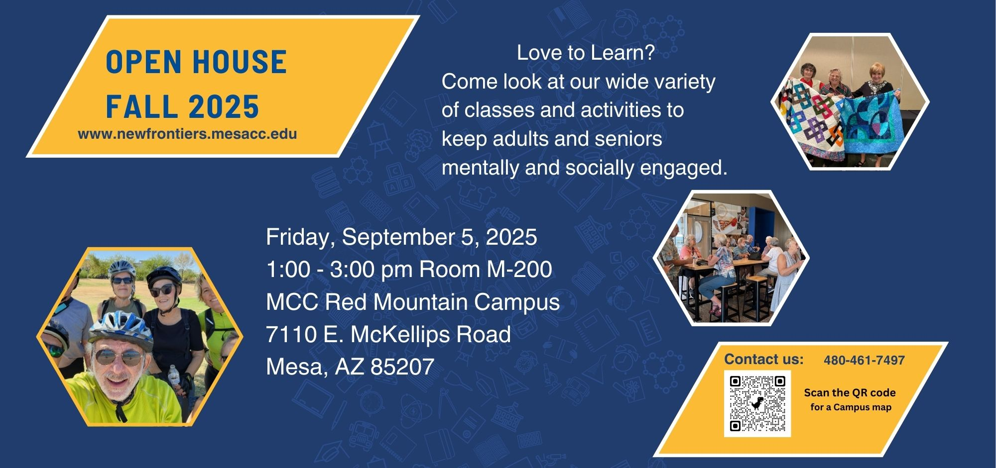

**For more information, email us at** [**http://newfrontiers.mesacc.edu**](http://newfrontiers.mesacc.edu)

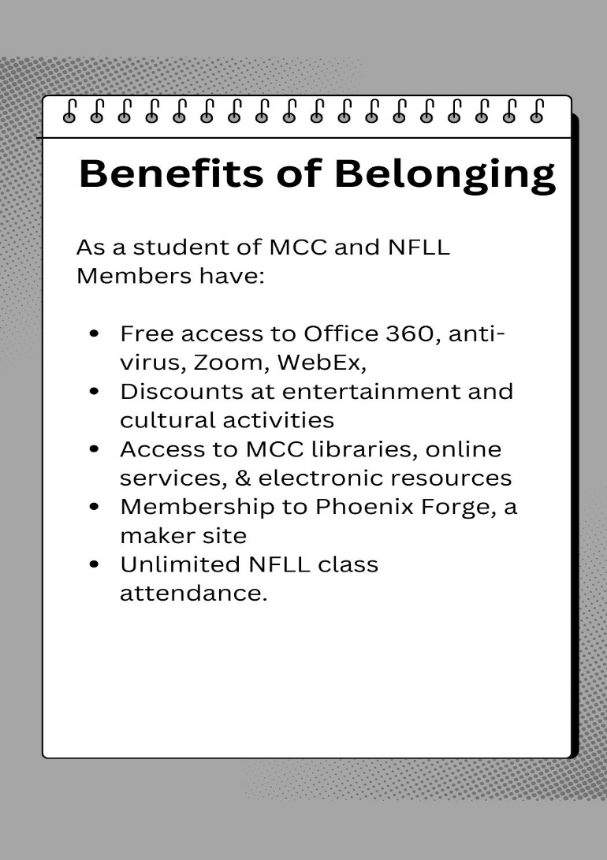**NOTES AND COMMENTS:**

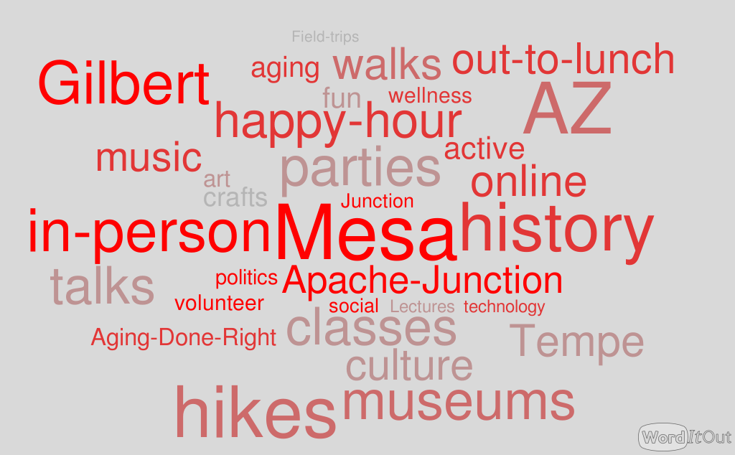

**New Frontiers Office**

**Red Mountain**

**Desert Willow Bldg Room 136-B**

**7110 E McKellips Rd, Mesa AZ 85207**

**(480) 461-7497**

**New Frontiers for Lifelong Learning**

**Online Classes**

Online class links are provided in your class confirmation email. We use both **Zoom** and **Webex** sites.

**Offsite Locations**

Offsite location addresses are in the confirmation email and in the schedule.



**MCC Southern & Dobson**

1833 W Southern Ave Mesa AZ 85201

Scan QR code with your phone for map

**MCC Red Mountain**

7110 E McKellips Rd

Mesa AZ 85207

Scan QR code with your phone for map

**New Frontiers for Lifelong Learning**

**Council Members**

**President**: Jacki McDugle **Vice President:** Allan Zisner

**Secretary:** Pat King **Treasurer:** Fred Searing

**Past President:** Roland Tanner

**At Large Members:** Jan Lorette, Lois Schaffer, Carolyn Follett, Janice Overdorff

**Standing Committee Chairs:**

**Curriculum:** Suzanne Brown **Social:** Joanne Handlong

**Communication:** Dawn Flemming **Membership**: Mary Boehlen

**Volunteer:** Mary Adamick & Dan Taylor **Technology**: Open

**To Update Name, Address, Phone, or Email Address in the NFLL database:**

* Go to http://NewFrontiers.mesacc.edu
* Select “**Member Account”** at upper right, select **My Account**. Make changes, **Save.**
* No computer? Call the **MCC New Frontiers Office at 480-461-7497**
* Email NFLL at [Newfrontiers@mesacc.edu](mailto:Newfrontiers@mesacc.edu)