**New Frontiers News**

**May 2025 Volume 33 Issue 10**



**Take Note!**

**NFLL calendar** [HERE.](https://newfrontiers.mesacc.edu/calendar.html) Find classes, socials, and more.

**May 2, General Meeting**10 to 11:30 a.m., Dobson Campus, BP-4

**May 8, Out to Brunch**10 a.m. Crackers & Company Cafe

535 West Iron Ave., Ste.131, Mesa

**May 12, NFLL Council Meeting** 9:30-11:00 a.m.

145 N. Centennial Way, 4th floor conference room, or via Zoom (for the link, email [mcdugle@gmail.com](mailto:mcdugle@gmail.com))

**May 21, ASU Ceramics Research Center,** flyer coming soon

**May 27, Study Hall**

4 p.m. Blue 32, McKellips and Gilbert, Mesa

**Class** [**proposals**](https://newfrontiers.mesacc.edu/propose-a-class.html) **welcomed.**

**Report Volunteer Hours**

If you volunteered for NFLL or MCC during the month, please record your hours. Access the form [HERE](https://docs.google.com/forms/d/e/1FAIpQLSctKD_-CbnA37vwXVPJXAw_clNcUva_v8R-hspse1rg4QXrbw/viewform).

Dawn Fleming, Editor

**Summer Schedule is Available!**

The new Summer Schedule is available online. There are opportunities to taste new things and a variety of other classes online and in person. As usual, bring your friends, relatives, or anyone who might be interested in attending up to three classes for free.

**Spring Picnic**by Jennifer Wong

New Frontiers held its annual Spring picnic at Joe’s Real BBQ in downtown Gilbert on April 3. We were so pleased that the venue was moved closer to home, we made haste to sign up that we were coming.

A large rotunda with picnic tables and chairs allowed everyone to sit in a shaded area while they ate their lunch and visited other NFLL members.

Greg Masters had trivia questions related to Arizona. Just in case you need to know, the state’s neckwear (Bolo tie), the state’s fossil (petrified wood), the state’s dessert (prickly pear sorbet or sopapilla) and the state’s drink (lemonade) were some of the creative items.

Participants in the white elephant gift exchange chose a gift followed by the judging for the “Coolest People” with prizes for the best cool look, the most imaginative person, the most colorful person and the funniest person. (See the pictures included and online.) Costumes ranged from cool sunglasses, funny T-shirt to an all-out cool costume. For those who wanted to be active, there were outdoor games and some NFLL members played Corn Hole.

**General Meeting**

On May 2, the General Meeting was held on the Dobson Campus. Over 50 members heard from Mesa City Councilmember Heredia, MCC Administrative Services VP Rob Budach, and Kathleen Perales, Student Conduct Administrator, Vice President of Student Affairs.

Attendees heard committee updates. Nominations of Allan Zisner for President and Terri Pokosh for Vice President were approved. Their terms begin July 1.

Janice Overdorff donated a quilt for the door prize drawing and others donated gift cards for door prizes.

**Volunteer Appreciation Luncheon**

|  |  |
| --- | --- |
| New Frontiers’ Volunteer Committee held a luncheon in appreciation of its volunteers on March 26 at EVIT (East Valley Institute of Technology). New Frontiers’ volunteers serve as Council members, committee members, class presenters, facilitators, and/or photographers.  In essence, our volunteers are the backbone of New Frontiers as we could not function without our volunteers stepping up, among other things, to help increase New Frontiers’ membership and schedule classes and social activities. At the heart of this lies our gatekeepers, our webmaster, as well as the folks who maintain our database. |  |

You can start by recruiting a guest presenter to do a class for us. If you have a skill, interest, or hobby, you can share it with your fellow members by presenting a class. Or you can facilitate a class which has a guest presenter. These are all good ways to strengthen our group. All committees are looking for new ideas and members.

As a facilitator, you will take class attendance by having in-person class participants sign in on the class roster or take a head count of participants if the class is online. You will also introduce the guest presenter and end the session by thanking the speaker and inviting class participants to show their appreciation for the class with a round of applause.

If you want to serve within the community while at the same time representing New Frontiers, you can volunteer to help at MCC’s annual Empty Bowls event or for We Care Wednesdays, the monthly food distribution event held at both the Red Mountain and Dobson campuses.

At the end of the school year, you will be recognized for your contribution to New Frontiers at the Volunteer Appreciation Luncheon at EVIT. Culinary Arts students prepare and serve the delicious food. This year we began lunch with a salad followed by our choice of chicken piccata or vegetable hash. Lunch ended with dessert of mini tarts and cakes and a cup of coffee.

With our batteries recharged, we are good to go for another year. Please join us next year!

|  |
| --- |
| **My Dude Ranch Experience by Jennifer Wong**  Anyone remember the 1991 movie, “City Slickers”? In “City Slickers,” a middle-aged tenderfoot and his friends visited a ranch where they joined a cattle drive to herd Longhorn cattle along a cattle trail in the southwest.  My family and I recently had an opportunity to visit the Mayan Dude Ranch to experience ranch life. The Mayan Dude Ranch is several hours away from Austin, Texas, in the town of Bandera.  Alas, there were no cattle on the ranch but there were lots of horses to ride.  For riding enthusiasts, you could ride twice a day for about 45 minutes each session. For novices especially, the horses went at a steady walk which gave you an opportunity to get used to riding on a horse and enjoy the passing scenery. Since I was short and the horse was tall, that meant I had to get a boost up to get onto the saddle and help getting down.  During the day, the horses remained in the corral. By night, they freely roamed around the property. Early in the morning they were rounded up and brought back to the corral in order to be saddled and ready to go by 8:00 a.m. so some people could ride to the site of the outdoor cowboy breakfast.  For our first breakfast at the ranch, we opted to experience a cowboy breakfast. Since we had not yet ridden a horse, we decided to take a hayride to the breakfast site. After about 1-2 miles of plodding along a trail, we reached the breakfast site which consisted of picnic tables and chairs which were gathered by an outdoor fire pit that was being used to cook the food, which consisted of scrambled eggs, beans and grits. The grits, I am told, are made with cornmeal and are a Texas favorite.  When you weren’t riding, you could climb Fossil Hill and search for fossils or you could look for dinosaur tracks which were imprinted in the rocks.  We spent three days at the dude ranch and quite enjoyed ourselves. The food was home-cooked and we didn’t have to cook while we were there.  What’s to complain about!  C:\Users\reiki\Documents\new frontiers\newletter\fossil.jpg  Fossil seen at the dude ranch.  Picture by Jennifer Wong. |

**General Membership Meeting – May 2, 2025**

**A Few Highlights**

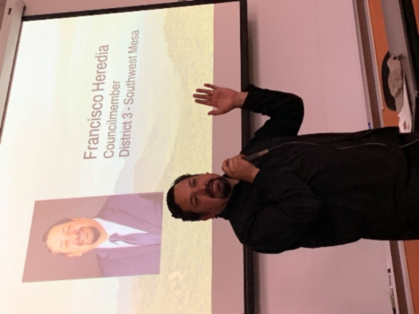

Mesa Councilmember  
Francisco Heredia

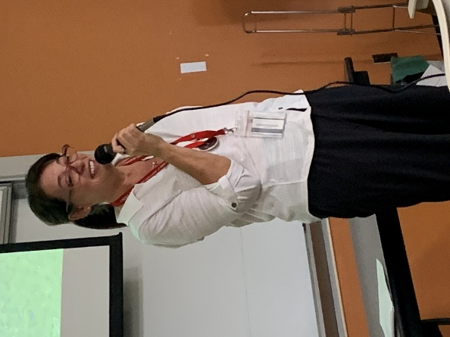

Kathleen Perales, VP Student Affairs (and NFLL admin mgr)

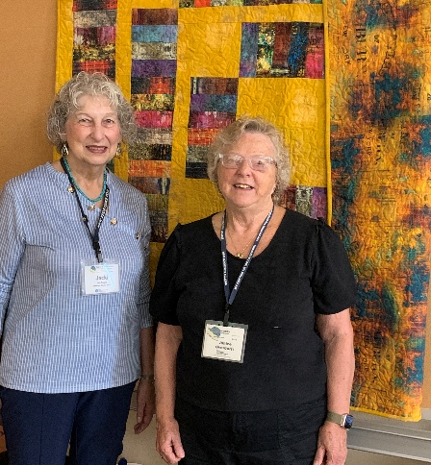

Pres Jacki McDugle and quiltmaker/donor Janice Overdorrf

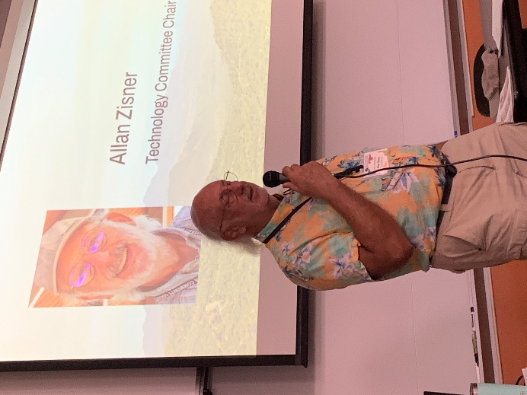

Allan Zisner, VP  
NFLL Incoming President

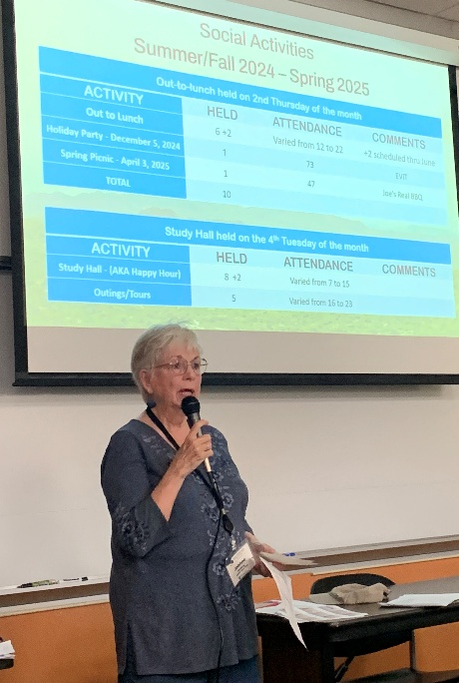

Joanne Handlong  
Social Committee Chair

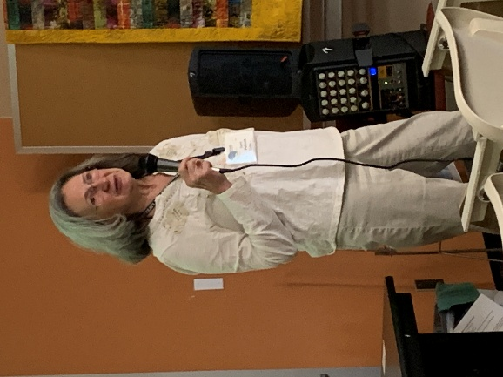

Terri Pokosh  
NFLL Incoming Vice President

**Photos Courtesy of Pat King**

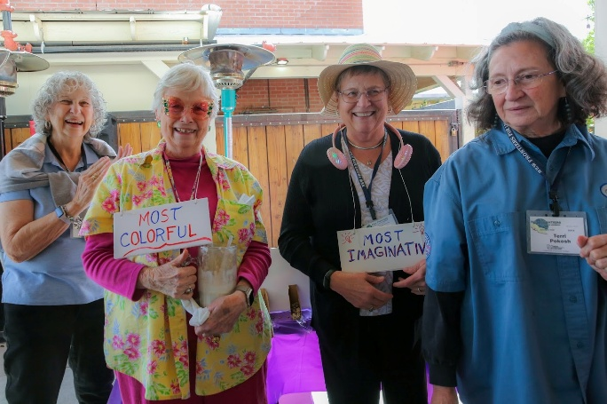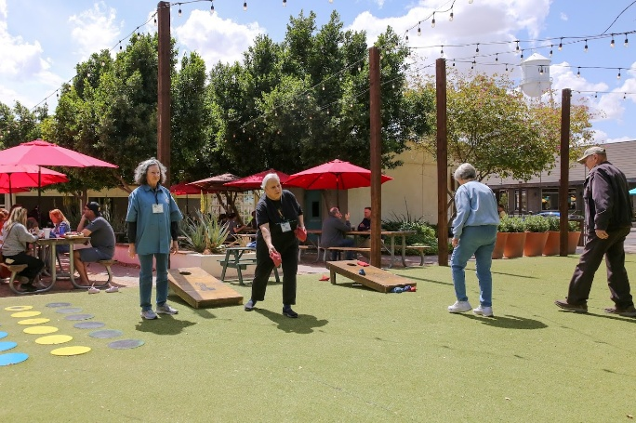

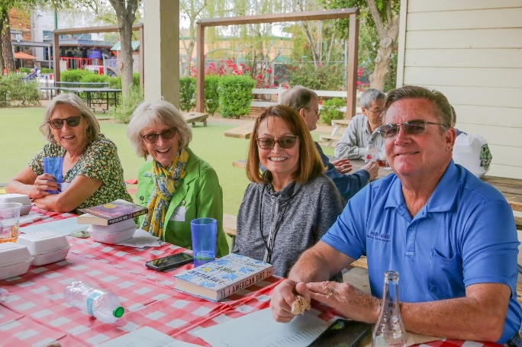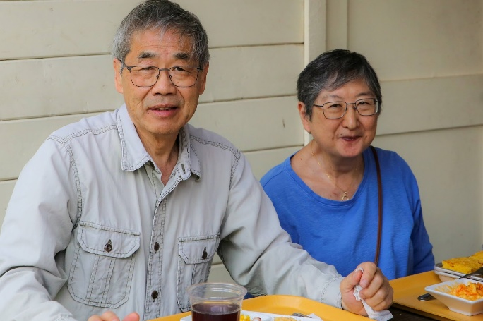

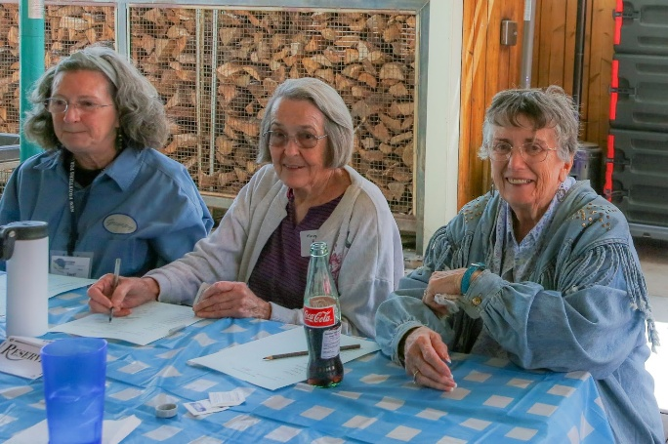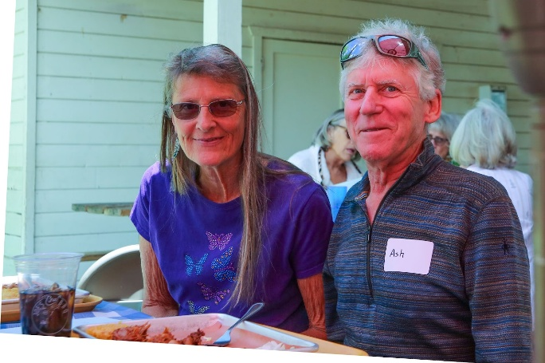

NFLL Picnic Pictures

**Photos Courtesy of Marie F.**

|  |  |
| --- | --- |
| New Frontiers for Lifelong Learning | Phone: 480-461-7497 |
| Mesa Community College | Website: [New Frontiers](https://newfrontiers.mesacc.edu/index.html) |
| Office of Community Partnerships | Debby Smith, MCC Liaison, NFLL |
| 7110 East McKellips Road | Email: [newfrontiers@mesacc.edu](mailto:newfrontiers@mesacc.edu) |
| Mesa, AZ 85207 |  |

The Maricopa County Community College District (MCCCD) is an EEO/AA institution. .For Title IX/504 concerns, call the following number to reach the appointed coordinator:  [(480) 731-8499](tel:(480)%20731-8499).  For additional information, as well as a listing of all coordinators within the Maricopa College system, visit [**http://www.maricopa.edu/non-discrimination**](http://www.maricopa.edu/non-discrimination)**.**