**New Frontiers News**

**June 2025 Volume 33 Issue 11**



**Take Note!**

Find classes, socials, and more on the **NFLL calendar** [HERE.](https://newfrontiers.mesacc.edu/calendar.html)

**The NFLL office at MCC Red Mountain will be closed this summer. Debby will still be monitoring calls and emails.**

**June 2, Summer Classes begin.**

**June 10, 9:30-11:00 a.m.**

**NFLL Council Meeting** MCC Downtown and via Zoom (email [mcdugle@gmail.com](mailto:mcdugle@gmail.com) for the Zoom link)

**June 12, 11:00 a.m.**[**Out to lunch and Mall Walk**](https://www.google.com/maps/place/Arizona+Mills/@33.3835635,-111.9704929,3196m/data=!3m1!1e3!4m6!3m5!1s0x872b0f59e166f987:0x1dc752fa1319b15d!8m2!3d33.383125!4d-111.964485!16zL20vMDZqOGhy?entry=ttu&g_ep=EgoyMDI1MDUxNS4wIKXMDSoASAFQAw%3D%3D) at AZ Mills Mall, 5000 S. Arizona Mills Cr., Tempe, 11:00 AM Walk meet at Merry-go-Round, 11:30 AM Lunch in Food Court.

**June 19, Juneteenth holiday**, no on campus classes

**June 24, 4 to 6 p.m. Study Hall**  
[**Boulders**](https://newfrontiers.mesacc.edu/short-term-flyers/2024-2025-flyers/spring-2025/boulders-20250324.pdf) on Southern, 1010 W. Southern Ave, Mesa,

**Fall Class** [**proposals**](https://newfrontiers.mesacc.edu/propose-a-class.html) **now welcomed.**

**Report Volunteer Hours**

If you volunteered for NFLL or MCC during the month, please record your hours. Access the form [HERE](https://docs.google.com/forms/d/e/1FAIpQLSctKD_-CbnA37vwXVPJXAw_clNcUva_v8R-hspse1rg4QXrbw/viewform).

Dawn Fleming, Editor  
reikidawn@yahoo.com

**President’s Message**

Did you know that New Frontiers classes are **FREE** this summer? Yes, I said **FREE**. What a great time to bring a friend or relative and introduce them to NFLL.

There are classes being held at both campuses and online. You can catch a class wherever you are at the moment.

Want to explore different foods? We’ve got a class for that! Want to create something (cards, pinecone crafts, bookmarks, etc.), watch a movie, talk about a book, play a game, knit, crochet or other handwork, virtually visit another country—you get the idea! We’ve got a class for that. There are field trips, lunches, and Study Halls planned.

Participate this summer and bring a friend!

Jacki McDugle

**Summer Fun Is Coming!**

Summer classes and activities will begin June 2 and run through July 25 this year. We are offering over 60 different class opportunities for our members. There are in-person classes on both campuses, field trips, out-to-lunches, study halls, and online classes. We encourage those of you who are out of the area for cooler climates to join online for any of the classes, if only to keep up with friends.

Many curriculum classes have been scheduled to take advantage of the cooler morning temperatures while afternoon classes offer indoor or online learning. Margo Heaps will present a wide variety of movies and documentaries at the Dobson campus during the afternoons, while learning about different foods or making crafts will be in the mornings on the Red Mountain campus. There are also visits to interesting museums or gardens planned throughout the term. The Social Committee will host Out-to-Lunches each month along with field trips and Study Hall (AKA Happy Hour).

The full schedule is online on the New Frontiers website. If you want a printed copy of the schedule, you can call the NFLL office at 480-461-7497 and leave a message with your name and address and say that you want a printed schedule and one will be sent to you. If you have friends who may want a copy, then also leave that message and we will send additional copies to you.

(continues on next page)

**SPOTLIGHT ON SPEAKERS**

Did you know that NFLL hosted 35 community speakers during the Spring 2025 term?

These speakers came from a variety of fields including finance (Scott Sandell, Stacey Bendfelt, Beverly Bowers, Matthew Benson, and Jack Burns), law (Heather Parker, Nancy Juarez), Healthcare (Dr. Sanpedro, Dr. K. Nichols, Elaine Poker Younts, Ron Truman), and history, science and politics (Mesa City Councilwoman Alicia Goforth, Vasu Bandhu, James Evans, Bill Haskell, Dr. Brian Dille, and Randi Martinsen), and fun activities and passions (Alice Garcia, Ron Meeks, Ron Applebaum, Jay Mark, Dr. Duane Roen, Maureen Roen, Kyle Messner). Without these friends of NFLL we could not offer the curriculum we do. Please tell them thank you when you cross paths or need their professional services.

Also, without our NFLL members who volunteer to present programs we wouldn’t have such a wide range of subjects to learn. Thanks to Margo Heaps, Marilyn Klingler, Dick Falconer, William Zipperer, Greg Master, Marie-France Ganesia, Allan Zisner, Ron Schumann, Jacki McDugle, Mike Scarbrough, Joanne Hancock, Jennifer Wong, Diane Grogan, Mary Boehlen, and Suzanne Brown.

Please consider presenting a program in a future term. We love having classes about your latest travel adventure, an interesting book, or just sharing your passions and hobbies.

**Understanding NFLL Committees**

**Communications Committee Spreads the Word!**

The Communications Committee looks at how NFLL gets the word out, whether it is in the form of brochures, social media, our newsletter or in presentations to groups interested in joining NFLL. We publish a monthly newsletter. We develop flyers and brochures to give to perspective members. Our committee members, who are part of the Speakers Bureau, go out to a variety of groups that cater to seniors to tell them about the benefits of joining New Frontiers!

How you can participate…

Write an article to be included in one of our newsletters. If you have an idea but are not sure it would be good for our newsletter, send me an email (address below) with your article idea.

Do you like to get up in front of groups and do presentations? If so, maybe you would like to be part of the Committee’s Speaker Bureau.

Do you like to do research? We are looking for people who can find groups or communities that we can give our NFLL presentation to.

Do you have ideas on how we can communicate with our members or the public better? Send me your thoughts.

**As Communications Committee Chair I am asking two things of all members. If you live in a community that has a newsletter, please send me the contact information for the newsletter so that I can see if we can insert a paragraph or two in that community’s newsletter. If you are part of a group or live in a community that might be interested in NFLL, please provide me the name and email or phone number of someone I can contact so we can give a presentation. It takes a community to ensure ongoing success. Your help is appreciated!**

If you are interested in joining this committee or have ideas, send them my way.

Dawn Fleming, [reikidawn@yahoo.com](mailto:reikidawn@yahoo.com).

Peggy Randolph passed away April 25. Peggy volunteered in many positions within New Frontiers and had been our Database Administrator. She loved helping others and getting new members signed up. She was a whirlwind and a master of many skills. Her enthusiasm and presence will be missed.

**Tips for Dealing with the Summer Heat**

By Dawn Fleming

Seniors in Arizona face unique challenges during the intense summer temperatures. It is very important to make sure that we stay hydrated and not get overheated, which can happen easily if we are outdoors in the months of June-September. There are many things that we can do to avoid heat related issues. Some are very simple like avoiding strenuous activities during the peak heat time and wearing clothes that keep us cool.  It is also important to be aware of warning signs of heat-related illnesses.

Here's a list of recommendations for heat safety for seniors in Arizona according to AARP:

Drink plenty of water throughout the day, even if you don't feel thirsty. Consider adding electrolyte-rich beverages to help replace lost fluids. Avoid sugary drinks and caffeine, as they can dehydrate you.

Stay indoors between 10 a.m. and 4 p.m. Make sure you stay in an air-conditioned building. Visit cooling centers, libraries, senior centers, or malls if your air conditioner is not working.

Wear lightweight, light-colored, and loose-fitting clothing. Natural fabrics like cotton and linen feel cooler. Wear hats and sunglasses, and protect your skin with sunscreen.

Avoid strenuous activities during the hottest hours of the day. Exercise indoors or enjoy going to the pool. Consider using a cooling towel or a neck wrap.

Recognize the symptoms of [heat stroke](https://www.google.com/search?cs=1&sca_esv=08e5a2bc280f5ca1&q=heat+stroke&sa=X&ved=2ahUKEwiNq-6CiZ2NAxXVJ0QIHRh1MkEQxccNegQIVxAC&mstk=AUtExfCRlGYwTzZyNLdlqY2xTthGnXsvCANN5qUDwaB9ezOUfvN6IqEA2EkfXpvFaZ9VjaCsYIgmmSy2vTTs8YhWas-Y2Knq-fnltrKUbosMaFmyKsdXYcihkCppKd4NUIyfKvk&csui=3) and [heat exhaustion](https://www.google.com/search?cs=1&sca_esv=08e5a2bc280f5ca1&q=heat+exhaustion&sa=X&ved=2ahUKEwiNq-6CiZ2NAxXVJ0QIHRh1MkEQxccNegQIVxAD&mstk=AUtExfCRlGYwTzZyNLdlqY2xTthGnXsvCANN5qUDwaB9ezOUfvN6IqEA2EkfXpvFaZ9VjaCsYIgmmSy2vTTs8YhWas-Y2Knq-fnltrKUbosMaFmyKsdXYcihkCppKd4NUIyfKvk&csui=3): Heat Stroke: High body temperature (103°F or higher), hot, red, dry or damp skin, fast pulse, confusion. Heat Exhaustion: Heavy sweating, dizziness, nausea, weakness. Call emergency services immediately if you suspect heat stroke.

Many seniors take one or more prescription drugs. Be aware of any medications you take that might increase your vulnerability to heat. Talk to your doctor about potential interactions between your medications and heat.

The City of Mesa recorded a Guide to Heat Safety in April 2025. You can access this presentation for free at <https://www.youtube.com/watch?v=Di2zhKdTp78>

Go have yourself another glass of water and enjoy your summer!

**Photo Gallery**

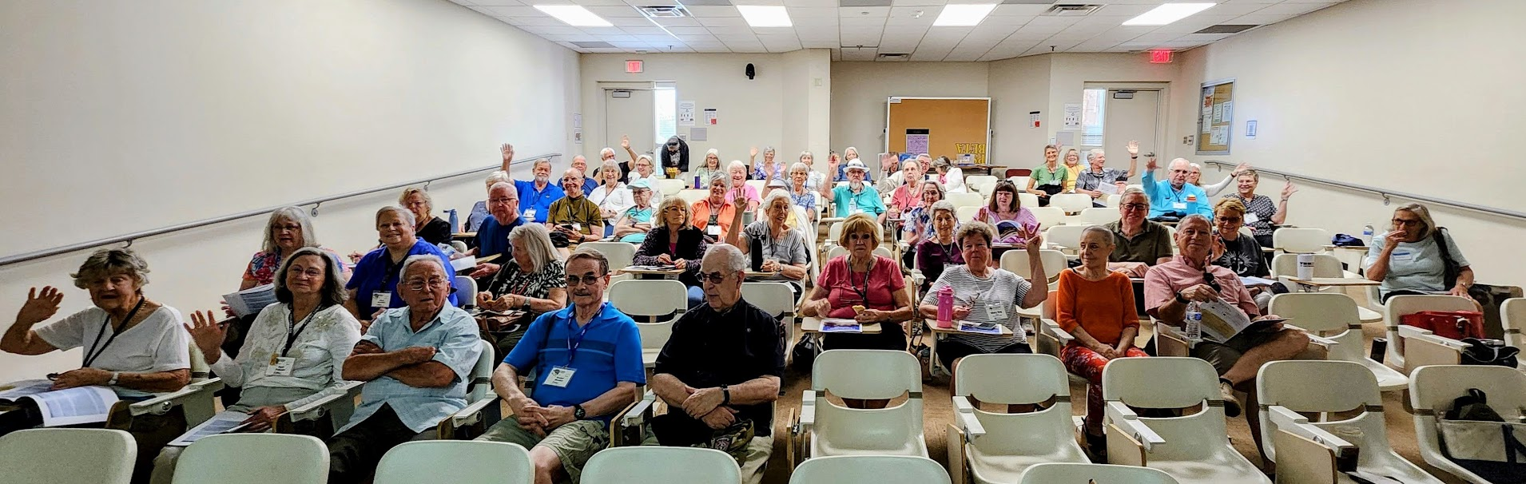Over 50 members attended the NFLL General Meeting on May 3

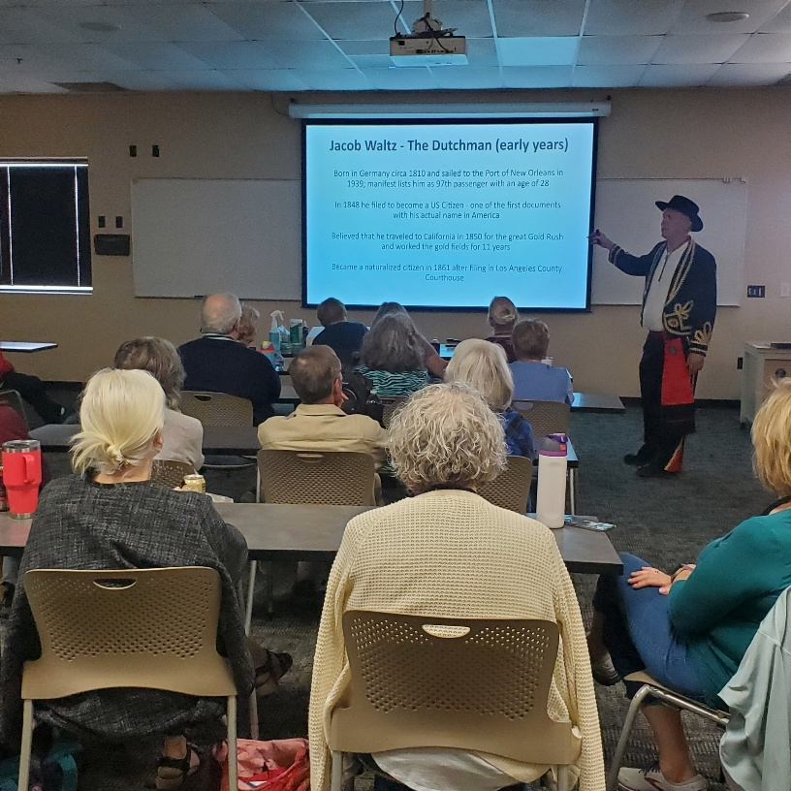

Want to see more photos? Visit (and follow) *New Frontiers for Lifelong Learning* on FACEBOOK to view pictures of our recent classes, outings, and other activities.

<https://www.facebook.com/groups/760852587875975>

Jacki McDugle and Janice Overdorff display one of the door prizes, a quilt created by Janice.

Mike Scarbrough (NFLL member) presents the Superstition Mountains and the Legend of the Lost Dutchman.

April Study Hall at Spinato’s.

**Have you joined us for Study Hall?**

It’s a chance to visit with friends old and new, share ideas, get out of the house, and have dinner! Meet us for our next Study Hall on Tuesday, June 24, at Boulders on Southern. Watch your email for the next event announcement.

Photos taken by NFLL members

|  |  |
| --- | --- |
| New Frontiers for Lifelong Learning | Phone: 480-461-7497 |
| Mesa Community College | Website: [New Frontiers](https://newfrontiers.mesacc.edu/index.html) |
| Office of Community Partnerships | Debby Smith, MCC Liaison, NFLL |
| 7110 East McKellips Road | Email: [newfrontiers@mesacc.edu](mailto:newfrontiers@mesacc.edu) |
| Mesa, AZ 85207 |  |

The Maricopa County Community College District (MCCCD) is an EEO/AA institution and an equal opportunity employer of protected veterans and individuals with disabilities. All qualified applicants will receive consideration for employment without regard to race, color, religion, sex, sexual orientation, gender identity, age, or national origin. A lack of English language skills will not be a barrier to admission and participation in the career and technical education programs of the District. The Maricopa County Community College District does not discriminate on the basis of race, color, national origin, sex, disability or age in its programs or activities.  For Title IX/504 concerns, call the following number to reach the appointed coordinator:  [(480) 731-8499](tel:(480)%20731-8499).  For additional information, as well as a listing of all coordinators within the Maricopa College system, visit [**http://www.maricopa.edu/non-discrimination**](http://www.maricopa.edu/non-discrimination)**.**