**New Frontiers News**

**JULY 2025 Volume 33 Issue 12**

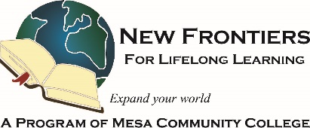

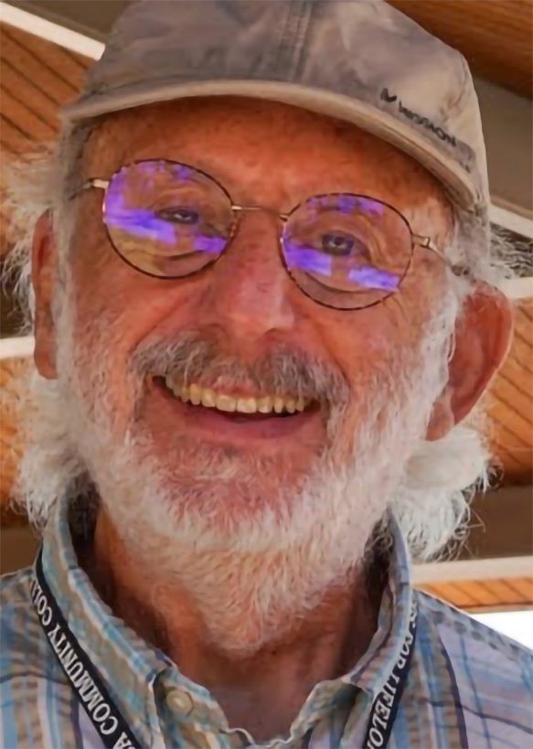**PRESIDENT’S MESSAGE**

Thirty years is an incredible legacy of learning, connection, and community—it speaks volumes about the staying power of New Frontiers and the passion of its members. That evolution from "New Frontiers for Learning in Retirement" to "New Frontiers in Lifelong Learning" feels like more than just a name change; it reflects an entire philosophy: that growth doesn’t have an age limit.

The fact that the heart of your activities—curiosity, camaraderie, contribution—has remained constant through the decades makes it feel like a living time capsule with a pulse. And with such active committees and an ever-expanding lineup of classes and adventures, boredom doesn’t stand a chance!

Are you involved with any of the committees yourself, or do you have a favorite memory with New Frontiers that always brings a smile? Let us know!

Allan Zisner

President – New Frontiers for Lifelong Learning  
azisner@outlook.com

**Fall Courses and Facilitators Needed**

Class proposals for Fall are needed! At present we have only 27 proposals and the deadline for submissions is August 1, 2025. If you want to share your travels, review a favorite book, lead a card or games group, host a paper craft group, or give a lecture on your hobby, please fill out a proposal on the web at <https://forms.gle/mvvSRGhQfTT9u1A89>.

If you have a friend or an acquaintance with an interesting story to tell, please encourage him/her to speak to our group. We normally host about 85 different speakers each term so with only 27 now, we are behind. NFLL is a volunteer organization and without your help we cannot exist.

If you want to host a course but don’t know what, give our Curriculum Chair Suzanne Brown a call at 480-688-1497 and leave a message. She’ll get back to you! Here are some ideas with no computer use that just need someone to say I’ll be responsible for hosting the activity: jigsaw puzzle exchange, games exchange, evening games group, evening or Saturday card group, women’s kitchen talk group, men’s coffee group, and other fun learning things.

**Take Note!**

**NFLL calendar** [HERE.](https://newfrontiers.mesacc.edu/calendar.html) Find classes, socials, and more.

**No NFLL Council Meeting** this July.

**July 10, 11:30 a.m.** [**Out to Lunch at Buca di Beppo**](https://www.google.com/maps/place/Buca+di+Beppo+Italian+Restaurant/@33.3837042,-111.7543818,771m/data=!3m2!1e3!4b1!4m6!3m5!1s0x872baf2e6f7c9ead:0x9347e7e55cade9de!8m2!3d33.3837042!4d-111.7543818!16s%2Fg%2F1tmg709f?authuser=0&entry=ttu&g_ep=EgoyMDI1MDYxNi4wIKXMDSoASAFQAw%3D%3D)

**July 19, 1030am,** [**Outing to Heard Museum**](https://newfrontiers.mesacc.edu/short-term-flyers/2024-2025-flyers/spring-2025/heard-20250719.pdf)

**No Study Hall in July**

**August 1, Fall 2025 NFLL Class Proposal Deadline**

**The NFLL office at MCC Red Mountain will be closed this summer.** Debby will still be monitoring calls and emails.

**Fall Class** [**proposals**](https://newfrontiers.mesacc.edu/propose-a-class.html) **now welcomed.**

**Report Volunteer Hours**

If you volunteered for NFLL or MCC during the month, please record your hours. Access the form [HERE](https://docs.google.com/forms/d/e/1FAIpQLSctKD_-CbnA37vwXVPJXAw_clNcUva_v8R-hspse1rg4QXrbw/viewform).

Dawn Fleming, Editor  
reikidawn@yahoo.com

**Looking Back at Mount St. Helens  
By Sandy Bartlett**

The 45th anniversary of the Mount St. Helens eruption is definitely a “where were you moment” for me. We lived in Richland, Washington, about 150 miles from Mount St. Helens. For several weeks before the eruption, there were many reports of small earthquakes and some rumbling from the volcano, but we didn’t think too much about it.

May 18, 1980, began as a clear and beautiful day. It was a Sunday morning, and I was making breakfast for my family. My husband was reading the newspaper when we heard a loud bang coming from the sky. We went out to the patio and looked around but didn’t see anything and decided it was just a sonic boom.

A couple of hours later, the sky turned darker and darker. We thought we were going to get some much-needed rain, but it started “raining” a light gray ash, lasting a few hours. It made a mess everywhere and many people wore masks as they swept it up or hosed it down. I tried to keep it out of the house, but my two young toddlers thought it was fun to track it all over the floors. We collected some of the ash in a couple of coffee cans and put it away. Several years later, I was going though storage containers and found the coffee cans, or what was left of them. The ash had eaten away at them.

The magnitude of the eruption left us both with a sense of awe and gratitude that we were able to witness the impact of Mother Nature.   
If you have a looking-back story, appropriate for our readers, send it to our editor, Dawn Fleming at [reikidawn@yahoo.com](mailto:reikidawn@yahoo.com).  
----------------------------------------------------------------------------------------------------------------------------------------------------

**Stay Hydrated and Manage Living in the Heat  
by Suzanne Brown**

Most of us who stay in the Valley during the Summer think we know about surviving the heat, or do we? The City of Mesa has a free **Residents’ Guide to Heat Safety,** available as a webinar with lots of hints for surviving the Summer. This 60-minute program features City of Mesa Fire and Medical and Human Services experts. In the webinar, you will learn: 1) How to identify the symptoms of heat-related illness and how to help 2) How to prevent heat-related illness and reduce heat exposure, both indoors and outdoors 3) What resources are available in Mesa to mitigate and prevent risks associated with heat exposure.

Visit <https://www.mesaaz.gov/Resident-Resources/Heat-Safety> for more information. Resident’s Guide to Mesa, combines in-person classes, webinars, on-demand videos and downloadable resources to walk you through the programs and services offered to our residents. This online page also has information on assistance with electric bills, cooling sites, and other hints to help us survive!



**Out to Lunch** at Arizona Mills in June. They got their steps in!

Members who enjoyed the **Have You Tasted This Fruit** class.

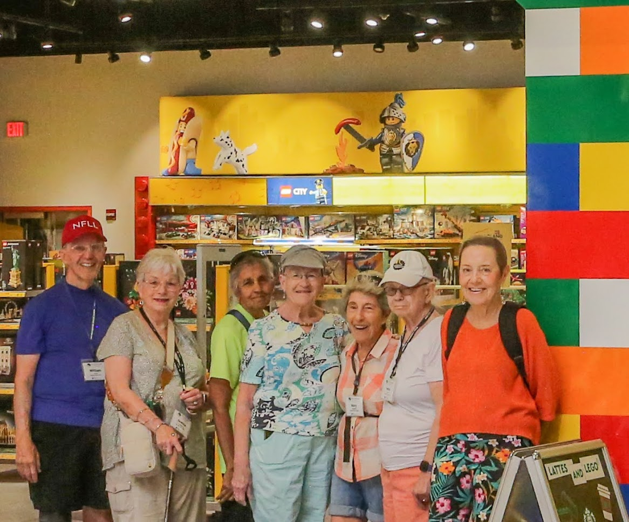

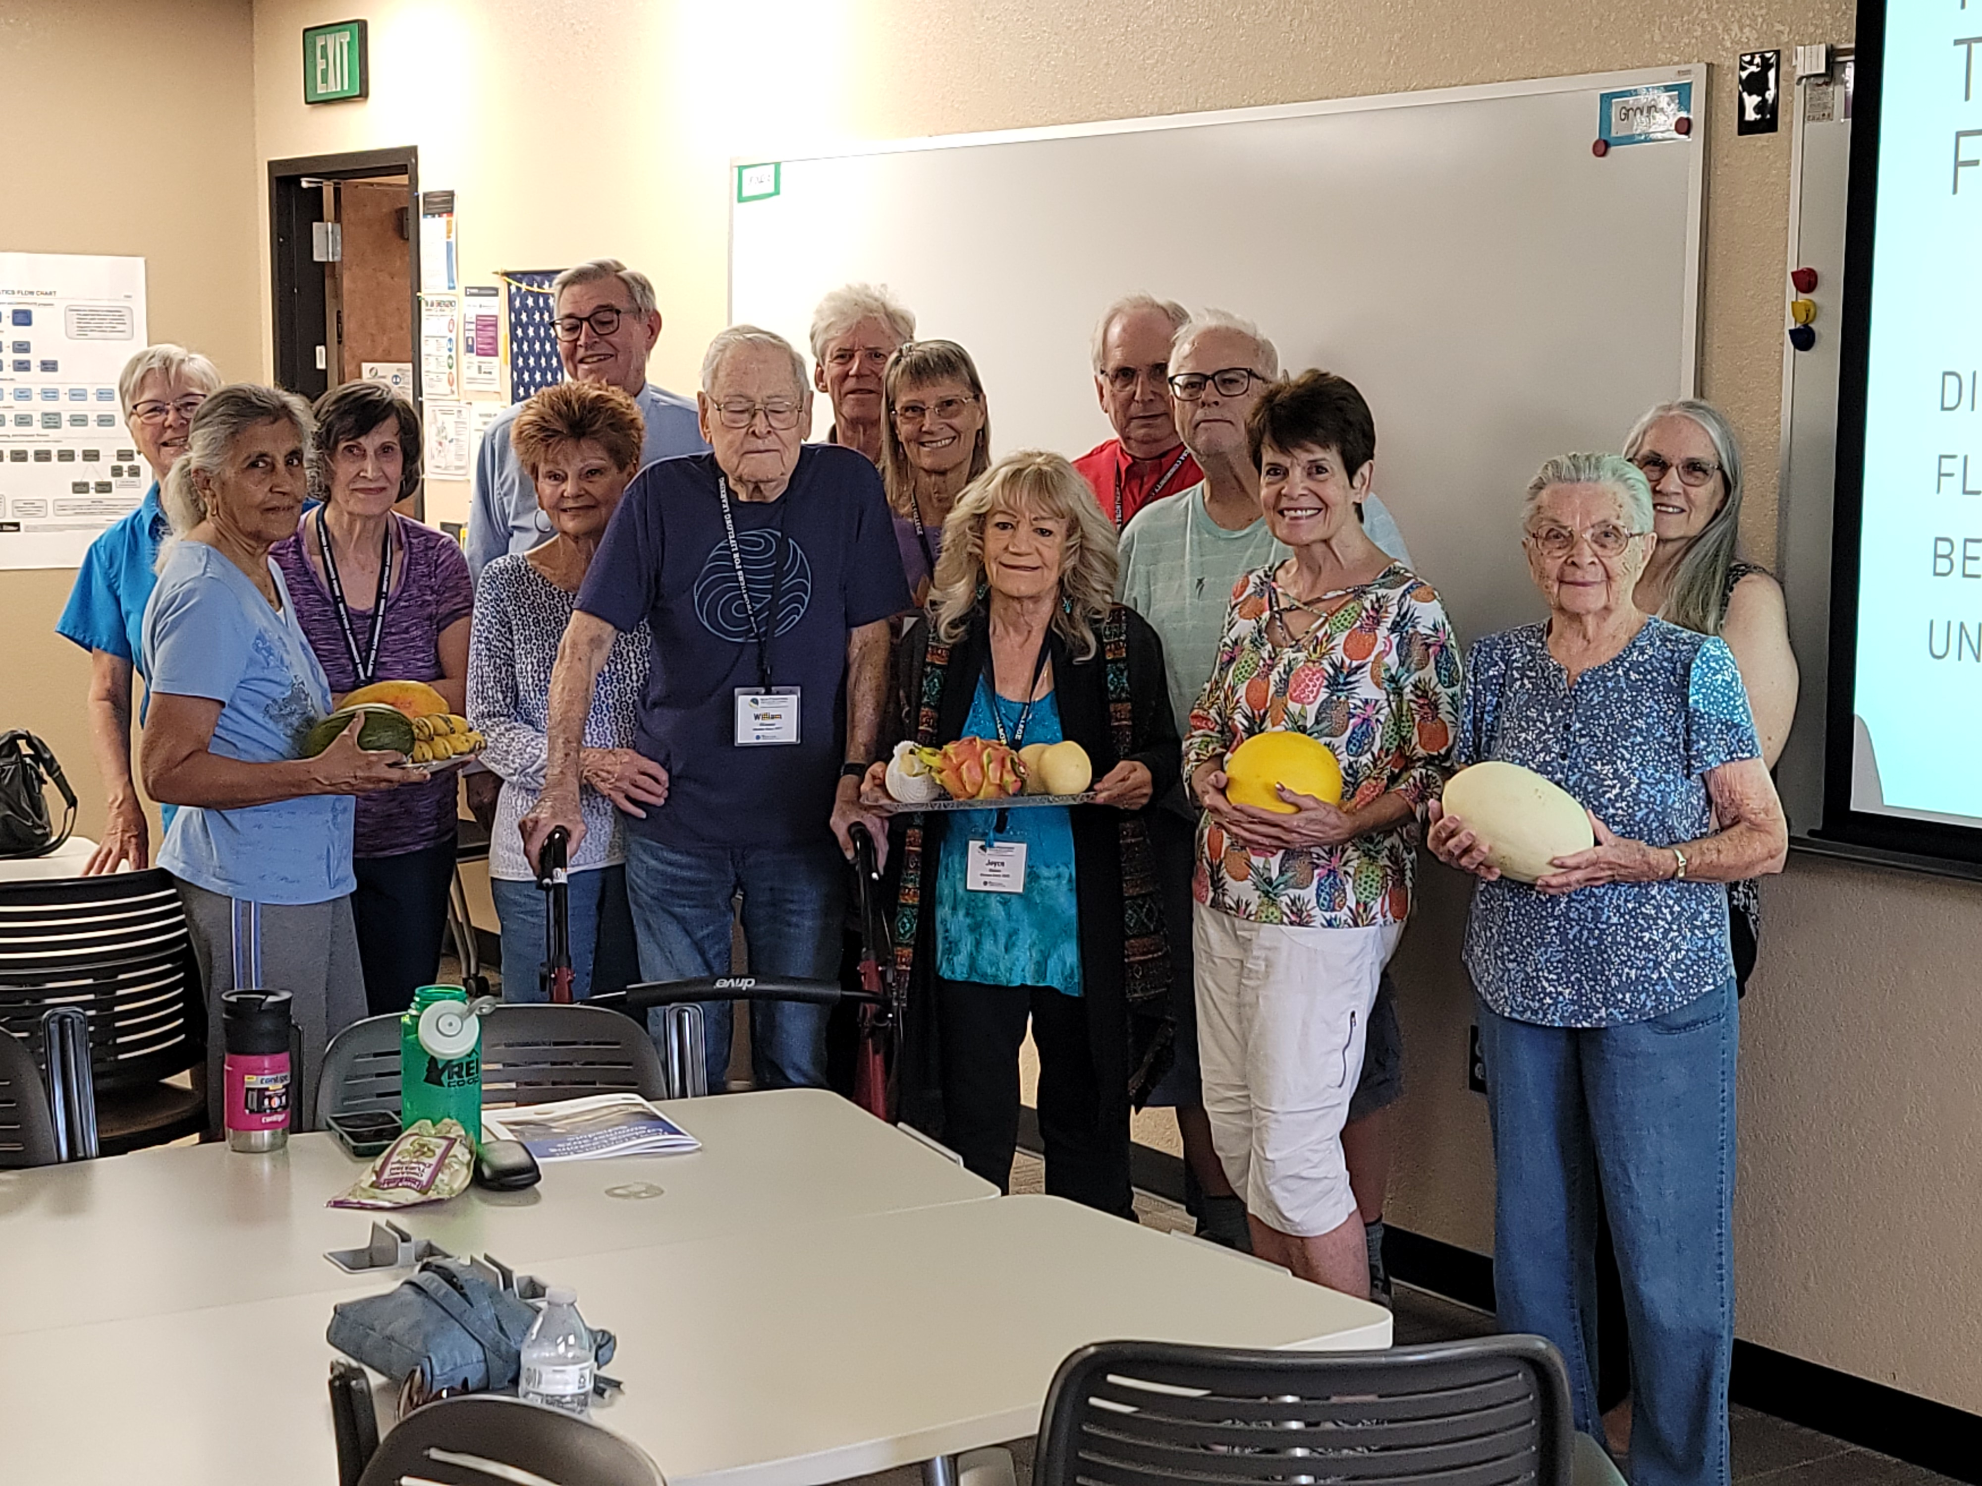

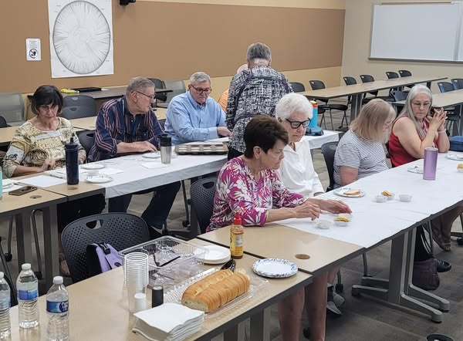

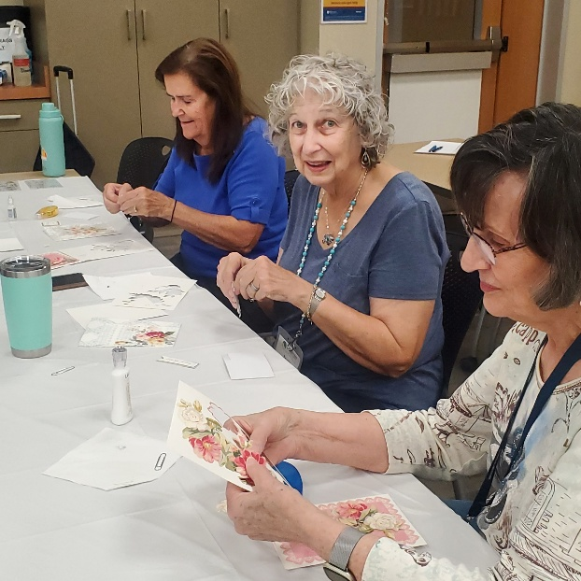

Top: Have You Tasted this Legume class. Bottom: Greeting Card making class.   
Pictures were taken by NFLL members.

Look for exciting changes in the Open House in September! We’re going to need volunteers, so get ready to step up!

To see more pictures like these below visit New Frontiers on FACEBOOK. Lots of pictures of most of our recent classes, outings, and activities! <https://www.facebook.com/groups/760852587875975>

|  |  |
| --- | --- |
|  | Phone: 480-461-7497 |
| Mesa Community College | Website: [New Frontiers](https://newfrontiers.mesacc.edu/index.html) |
| Office of Community Partnerships | Debby Smith, MCC Liaison, NFLL |
| 7110 East McKellips Road | Email: [newfrontiers@mesacc.edu](mailto:newfrontiers@mesacc.edu) |
| Mesa, AZ 85207 |  |

The Maricopa County Community College District (MCCCD) is an EEO institution and an equal opportunity employer of protected veterans and individuals with disabilities. All qualified applicants will receive consideration for employment without regard to race, color, religion, sex, sexual orientation, gender identity, age, or national origin. A lack of English language skills will not be a barrier to admission and participation in the career and technical education programs of the District. The Maricopa County Community College District does not discriminate on the basis of race, color, national origin, sex, disability or age in its programs or activities. For Title IX/504 concerns, call the following number to reach the appointed coordinator: [480-731-8499](tel:4807318499). For additional information, as well as a listing of all coordinators within the Maricopa College system, visit [www.maricopa.edu/non-discrimination](http://www.maricopa.edu/non-discrimination).