**New Frontiers News**

**April 2025 Volume 33 Issue 9**

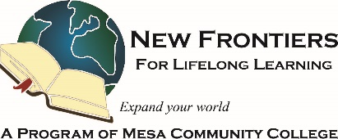

***Hello Spring!***

Curriculum is winding down for the Spring 2025 term, but we still have lots of great classes during April and all have space for YOU! Upcoming are courses on Wills and Trusts, What to do if You’re an Executor for an Estate, The Great Australian Ocean Road, Open to Debate, Steps for a Healthy Back, Brian Dille’s Town Hall on Voting, Allan Zisner’s Art Walk on the Dobson Camus, Traveling in a Digital World, Photo Files, Oregon Trail Re-Visited, and many more! Come attend an in-person or online course, especially if you are getting ready to go back to your summer homes. Remember, Summer online courses are available to all members regardless of where you are!

Requests for proposals for Summer and Fall 2025 are open now. The form to submit courses and ideas is available on the website. Please submit your suggestions and ideas now. The Curriculum Committee welcomes members to help call speakers to arrange courses.

**Get Involved!**

**On April 15 at 2 p.m. at Red Mountain Campus,** **Room DW 131,** join with Councilwoman Goforth on Tax Day, no less, to gain a comprehensive understanding of the City of Mesa’s budget process with the Office of Management and Budget. This session will cover the fiscal year cycle, and how budget decisions are made. Learn where Mesa prioritizes its spending across key areas like public safety, infrastructure, and recreation. This informative presentation will help you better understand how the city manages its resources to serve the community.

We hope all NFLL members will register for these events, if you have neighbors or friends who would enjoy these Town Halls, please invite them to come along!

Suzanne Brown

Follow New Frontiers on FACEBOOK. Lots of pictures of most of our recent classes, outings, and activities! <https://www.facebook.com/groups/760852587875975>

**Take Note!**

**NFLL calendar** [HERE.](https://newfrontiers.mesacc.edu/calendar.html) Find classes, socials, and more.

**April 3, 11:30 a.m.**Annual Spring Picnic  
Joe’s Real BBQ  
301 N. Gilbert Rd, Gilbert

**April 14, 9:30-11:00 a.m.**

NFLL Council Meeting MCC Downtown and via Zoom (email [mcdugle@gmail.com](mailto:mcdugle@gmail.com) for the Zoom link)

**April 26, 9 a.m. – Noon**

Human Library, at Red Mountain Campus Library

**April 29, 4 p.m.**  
Study Hall –Spinato’s in Tempe

**Summer and Fall Class** [**proposals**](https://newfrontiers.mesacc.edu/propose-a-class.html) **now welcomed.**

**We Care Wednesdays** April 2 @ Dobson; April 15 @ Red Mountain

**Report Volunteer Hours**

If you volunteered for NFLL or MCC during the month, please record your hours. Access the form [HERE](https://docs.google.com/forms/d/e/1FAIpQLSctKD_-CbnA37vwXVPJXAw_clNcUva_v8R-hspse1rg4QXrbw/viewform).

Dawn Fleming, Editor



**Understanding NFLL Committees**

Have you ever wondered about the different committees that make up New Frontiers? Maybe you would be interested in joining one but aren’t sure which might fit your interests or talents. For the next few months, one or two committees will be featured by listing the current members, describing its mission, and identifying regular meeting days (if scheduled).

A part of Mesa Community College, volunteers make up the NFLL Council and standing committees that lead and guide our organization. Other members volunteer by assisting in determining our programming, conducting or facilitating classes, helping at member events such as Open House and Out to Lunch, and many MCC events. To ensure a future of continued success, New Frontiers needs dedicated members to assume responsibility in these positions so all members will be able to continue their discovery of knowledge, advance their learning and enjoy continued social opportunities with new friends. Wouldn’t you like to try your hand in helping at an event or serving on a committee?

**THE SOCIAL COMMITTEE**

The Social Committee adds an element of “organized fun” to New Frontiers by planning, organizing, and hosting activities beyond the classrooms. In most months of the year, the committee hosts three activities: 1) Out-to-lunch at a restaurant on the second Thursday of the month; 2) Study Hall (aka Happy Hour) on the fourth Tuesday of the month; and 3) an outing, usually a tour, of a place chosen for its educational value and interest to members, on an unspecified day of the month.

The committee also plans, organizes and hosts two major annual activities: the Spring Picnic and a Holiday Luncheon. The picnic has a theme which gives members the opportunity to don a costume (optional) and perhaps win a prize. It includes a White Elephant gift exchange and a Used Book exchange. In the past, it has been held at a city park, but this year it is being held at Joe’s Real BBQ Restaurant in downtown Gilbert for the first time. The Holiday Luncheon is a festive event, complete with door prizes, raffles, and entertainment. For the past several years, it has been held at the East Valley Institute of Technology (EVIT) in Mesa with delicious food prepared by their culinary students.

This committee meets monthly to discuss their ideas and plan activities. They also entertain suggestions from NFLL members. Ideas are researched by committee members to determine their viability for the membership. The committee usually decides on an activity by consensus, sometimes by a show of hands. Individual members volunteer to host the various activities and are responsible for making appropriate contact and arrangements with the facility. Committee members also prepare flyers for activities which are emailed to the membership and posted on the NFLL website, [NFLL Social Happenings](https://newfrontiers.mesacc.edu/social.html), and [NFLL Social Photos](https://newfrontiers.mesacc.edu/photos-2024-2025.html).

The Social Committee currently has seven members:

Helen Dodds Joanne Handlong (Chair) Monica Karels

Greg Masters Arlys Medlicott Roland Tanner

Diana Yarbrough

The committee meets on the first Monday of the month through the regular school session, at 10:00 a.m. Meetings are held in the Board Room (2nd floor) of the Mesa Public Library, 64 East 1st Street, Mesa.

Joining the Social Committee is a great way to meet and interact with new people and broaden your friend list. Contact [Joanne Handlong](mailto:justjo34@gmail.com) if you would like to be part of this committee.

**Social Committee volunteers work for YOU! Join the Fun!**

|  |
| --- |
| **REMEMBERING ROSE DUKELOW**    **_________________________________________________________________________**  **Planting New Seeds this Spring**  On March 11, 2025, NFLL member Rose Dukelow passed. Rose and her husband, Bob Dukelow, have been longtime New Frontiers members.  Those who remember Rose say that she was a positive force in the world. Rose volunteered, attended classes and helped out when and where she was needed. She sang praises for New Frontiers and recruited many members.  Rose was kind, caring and generous.  She was a dear friend to many of us.  While attending classes, she shared her experience and wisdom. Rose will be missed.  Funeral arrangements are listed on the NFLL Facebook page.  **By Dawn Fleming**  As winter in Arizona has come to an end, and all of our activities slow down with the warmer weather coming in, the arrival of spring announces itself with the blooming of the ocotillo and other flowering cactus. Even in Arizona, in winter, some trees are bare, most flowers vanish, and the snakes go into hibernation. As the weather warms up, our body and mind, and spirit prepare to embrace spring.  As spring arrives, we celebrate the longer days of sunshine. It is as if new life is breathed into our body. In nature, spring brings beautiful flowers. The trees fill out, and we spend more time in the sun. We see the miracles of nature unfolding all around us. In the Native American tradition, spring is represented by the direction of east, where the sun rises. East represents a time of giving birth to not only children but to new ideas. East represents the element of fire (sun), fresh start, innocence, where we birth ourselves, new beginnings, seeing things with new eyes, the seed that is planted. Our new ideas inspired by the return of spring are like seeds that are planted in the ground during spring to be warmed by the earth and the sun to manifest in another season.  What new seeds do you want to plant in your life? It is never too late to start something new, or to learn and experience something different. NFLL is about trying new things and expanding our knowledge and experiences.  The promise of spring is that as we sow, so shall we also reap. For every focused effort, our rewards will be great. Is there something that you have always wanted to do, places you wanted to visit, or experiences that have been on your bucket list? What are you waiting for?  Spring shows us that life is truly a constant beginning, with new opportunities and choices to be embraced. If we can be like children, curious and in awe of our world, we can see the miracles in all that seems so ordinary. Our attitudes are lifted, and inspiration returns. What wants to spring forth from within you this spring? What opportunities are appealing to you? How will you embrace them? Let’s welcome spring in big and small ways!  Happy Spring!  **Rodeo At the Stockyards**  **By Jennifer Wong**  If you are in Texas and have an opportunity to attend a rodeo, you would immediately seize the opportunity.  That’s what we did.  While we were recently visiting Dallas, we soon realized we could see a rodeo in nearby Ft. Worth.  We immediately bought our tickets to the rodeo months in advance for a Sunday matinee show.  For those who want to fully embrace the cowboy look, you can don a checked shirt, jeans, cowboy hat and boots with a bandana a la John Wayne to complete the look.  The drive from Dallas to Ft. Worth was short, about 20-30 mins. away.  Since it was an overcast day with the possibility of rain, we first checked into our hotel and then drove to the Cowtown Coliseum.  Thankfully the coliseum was a covered building which meant the rodeo was indoors and we would not get wet if it rained.  Sitting down in our seat which was located in the middle of the coliseum, we looked around and found the coliseum was almost fully packed with people.  The rodeo began with a cowgirl riding into the arena, holding the American flag, and then stopped so the national anthem could be played and a prayer could be said for the participants of the rodeo.  Participants hailed nationally and internationally from as far away as Mexico, Brazil and Australia.  The first performance was the bucking bronco which was followed by the bucking bull.  Cowboys had to stay on their mounts for as long as possible.  The winner of these events was the person who was able to stay on their mount for the longest period of time.  Next up was the roping event in which the rider had to rope and tie up the legs of a cow as fast as possible.  Children in the audience also had an opportunity to participate by herding a calf across the arena.  The rodeo ended just in time for us to see some cowboys herding cattle down the street.  Apparently, Ft. Worth is located on the Chisholm Trail so back in the day, it was not uncommon to see cattle walking down the street.  Afterwards we walked around The Stockyards and checked out cowboy hats in the stores.  Much to our surprise, we discovered that good cowboy hats cost approximately $300.  We ended the day with dinner at the Hotel Drover where we tried a bison steak.  Surprisingly the bison did not taste gamey and was quite tasty.  If you have not yet attended a rodeo in the southwest, we highly recommend you go have a look-see.  You will not be disappointed. |

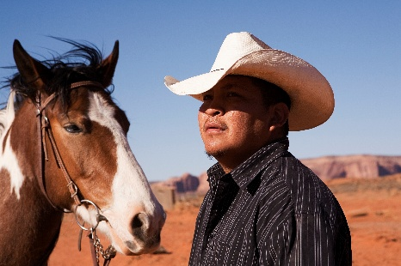

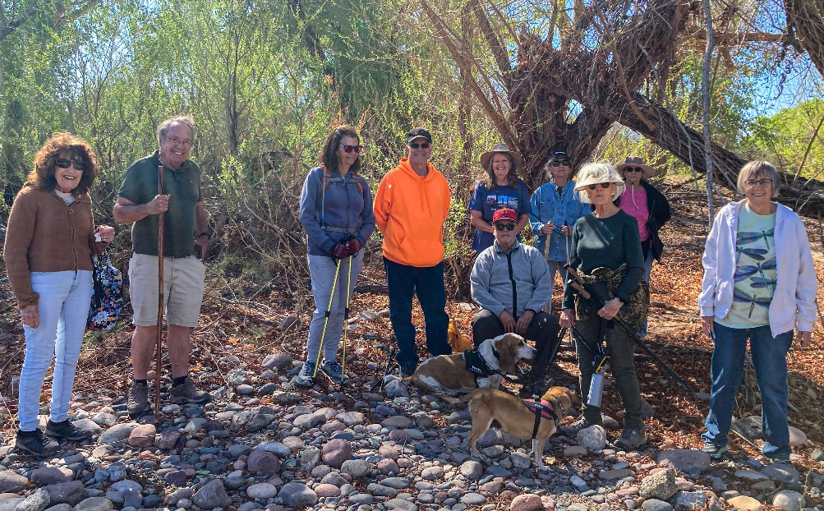

Trailers hike Phon D. Sutton nature trail in March.

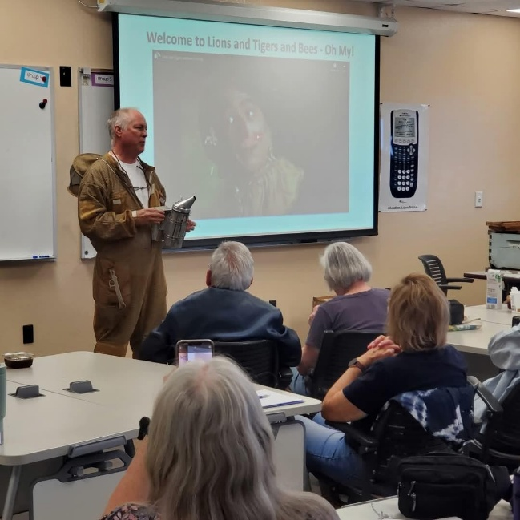 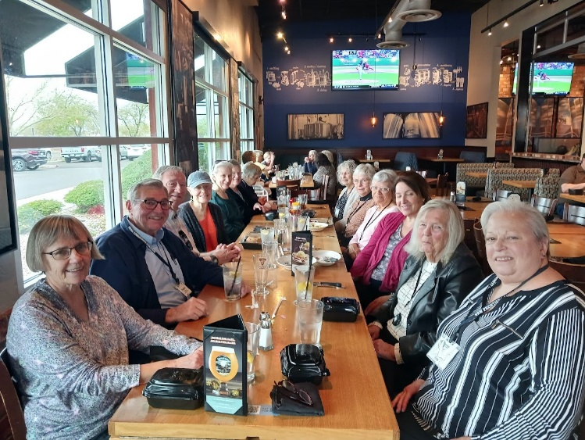

Mike Scarbrough shared his beekeeping hobby with us.

NFLL Out to Lunch as BJ’s Restaurant and Brewhouse.

**Photos courtesy of Monica Karels, Greg Master, and Suzanne Brown**

|  |  |
| --- | --- |
| New Frontiers for Lifelong Learning | Phone: 480-461-7497 |
| Mesa Community College | Website: [New Frontiers](https://newfrontiers.mesacc.edu/index.html) |
| Office of Community Partnerships | Debby Smith, MCC Liaison, NFLL |
| 7110 East McKellips Road | Email: [newfrontiers@mesacc.edu](mailto:newfrontiers@mesacc.edu) |
| Mesa, AZ 85207 |  |

The Maricopa County Community College District (MCCCD) is an EEO/AA institution and an equal opportunity employer of protected veterans and individuals with disabilities. All qualified applicants will receive consideration for employment without regard to race, color, religion, sex, sexual orientation, gender identity, age, or national origin. A lack of English language skills will not be a barrier to admission and participation in the career and technical education programs of the District. The Maricopa County Community College District does not discriminate on the basis of race, color, national origin, sex, disability or age in its programs or activities.  For Title IX/504 concerns, call the following number to reach the appointed coordinator:  [(480) 731-8499](tel:(480)%20731-8499).  For additional information, as well as a listing of all coordinators within the Maricopa College system, visit [**http://www.maricopa.edu/non-discrimination**](http://www.maricopa.edu/non-discrimination)**.**