**New Frontiers News**

**AUGUST 2025 Volume 34 Issue 1**

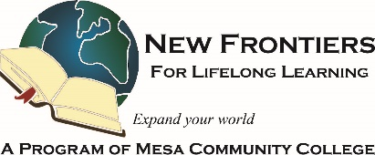

**PRESIDENT’S MESSAGE**

**Take Note!**

**NFLL calendar** [HERE.](https://newfrontiers.mesacc.edu/calendar.html) Find classes, socials, and more.

**NFLL Council Meeting**   
Monday, August 11, 10 to 11:30 a.m. at Red Mountain DW131 and via Zoom (email [mcdugle@gmail.com](mailto:mcdugle@gmail.com) for the Zoom link)

**Out to Lunch, Thursday, August 14, 11:30 a.m.**  [The Green Olive, 1262 S. Country Club Road, Mesa](https://newfrontiers.mesacc.edu/social.html)

**Study Hall, Tuesday, August 26, 4-6 p.m.**[The Perch Pub Brewery,    
232 S. Wall Street, Chandler](https://newfrontiers.mesacc.edu/social.html)

**New Schedule of Classes posted  
August 29.**

**NFLL Open House, Friday, September 5, 1-3 p.m.**

**The NFLL office at MCC Red Mountain will be closed until August 19..** Calls and emails will be returned..

**Report Volunteer Hours**

If you volunteered for NFLL or MCC during the month, please record your hours. Access the form [HERE](https://docs.google.com/forms/d/e/1FAIpQLSctKD_-CbnA37vwXVPJXAw_clNcUva_v8R-hspse1rg4QXrbw/viewform).  
**FERPA** rules state that permission to release information be renewed yearly.

Dawn Fleming, Editor  
reikidawn@yahoo.com

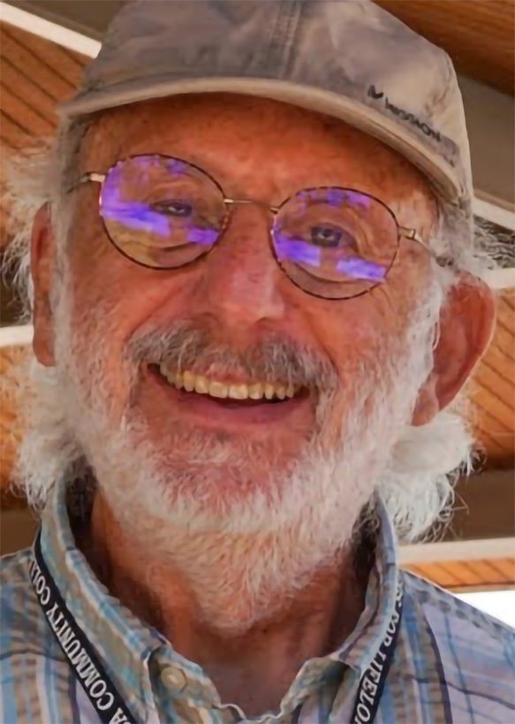

**August: A Season of Energy and Engagement**

August—one of the hottest months of the year—is often seen as a time to relax, unwind, and let the days drift by. But for our New Frontiers members, it’s anything but idle! Instead, it’s a season filled with travel to new places, reconnecting with friends, and planning for the exciting months ahead.

Throughout these past summer months, our curriculum and social committees have been hard at work, organizing a variety of indoor activities to keep us active, engaged, and connected. Whether it’s a lively discussion, a creative workshop, or a fun social gathering, there’s always something happening.

As summer draws to a close, our planning continues in earnest. This fall, we look forward to our much-anticipated Open House—a wonderful opportunity to preview upcoming classes, renew old friendships, and, most importantly, welcome prospective members into our community. An initial printing of the fall schedule will be available, so you can start planning your next adventures with us.

Meanwhile, our communications committee is busy developing fresh New Frontiers promotional materials for distribution. We encourage all members to share this information freely—help us spread the word and grow our vibrant community!

While summer may be a time for relaxation, New Frontiers members are never idle. Here’s to making the most of every season—together!

Allan Zisner

President – New Frontiers for Lifelong Learning  
azisner@outlook.com

**Message from Communications Chair**

We are gearing up for the 2025/2026 season! I am seeking groups to offer the NFLL presentation to increase NFLL membership. As our membership grows, it offers our organization resources to offer more. The Fall is a prime time to grow our group. Please let me know of any groups or communities that would sponsor us to come speak to their members. Also, I am looking for communities that have a newsletter that would let us include information on NFLL. Email information to me at [reikidawn@yahoo.com](mailto:reikidawn@yahoo.com)

Open house is Friday, September 5, 1 - 3 p.m. Red Mountain campus, in Room M-200. Send your friends and family over who might be interested in joining NFLL. We need volunteers for the open house. If you would like to help, contact Mary Boehlen at [minpins48@gmail.com](mailto:minpins48@gmail.com). **_______________________________________________________________________**

**THERE’S A LOT TO LEARN!  
by Suzanne Brown**

Our NFLL Summer Session has ended (although some off-campus classes are still meeting) and classes for the Fall 2025 session are shaping up. This Fall we will feature a series of classes in honor of America250, the celebration of the Semi quincentennial or 250th anniversary of the signing of the Declaration of Independence. Our classes will run the gamut from Bob Dukelow speaking on the intelligence arena, Robert McWhirter on the constitution, Ron Meeks on the Civil War, and Open to Debates on current politics.

In addition, Jennifer Wong will repeat her Dim Sum class while also giving us new information on the Silk Road. Dan Mueller will help us understand a History of Modern China, while Marie France Ganansia and Greg Master will educate us on “The Corner” in Winslow AZ, as well as their cruise through the regions of Veneto and Lombardy. Great Courses on more World Historic Sites and a Great Tour of Greece will get our travel bugs stirring. If you want to stay closer to home, Alice Garcia, Master Gardener will guide us towards successful Fall Vegetable Gardening.

As usual we have a full schedule of courses to help our financial and estate planning needs as well as providing us information on various health conditions. The hiking groups on Tuesday and Friday will continue as will the Thursday morning bike rides. Music will be in the air as April Thalman talks on Mindfulness and Music, and Stephen Meyer, Director of the NAU Bands will share his experience on taking the NAU band to the Macy Thanksgiving Day Parade!

There’s lots more coming to satisfy everyone in the over 80 programs and activities this Fall. The Fall Schedule will be released in late August online. Get your Annual Membership paid in advance since registration for classes will begin when the schedule is released!

**PAY YOUR ANNUAL FEE IN AUGUST!**

It is time to pay your annual fee for New Frontiers for the 2025-26 year.

**Returning New Frontier Members** should follow these steps:

1. **Complete Annual Membership Form** at: <https://forms.gle/fpvRbUxPS3LmB6Qp9>.
2. **Pay fees**. Wait for an email (within 5-7 days) confirming you are registered with instructions on how to pay your $80 fee. Payment of the Annual Fee can be made at either Enrollment Services at Red Mountain or Southern and Dobson. Check the website for hours. MCC is requesting payment by credit card this year. If you wish to pay with check or cash, you must do so at the Southern and Dobson Campus.
3. After you have paid your fee, **access your Pro Class account** from the [NFLL website](https://newfrontiers.mesacc.edu/index.html).
4. Login, ***DO NOT*** create a new account.
5. Update your member account information if necessary
6. Click on Search at the upper left and find your classes. **Registration opens August 29**.

If you have difficulty registering for classes or accessing your account, please send an email to [**newfrontiers@mesacc.edu**](mailto:newfrontiers@mesacc.edu)describing what problem you are having. A volunteer will contact you within 48 business hours to assist you.

New Members should send an email to [**newfrontiers@mesacc.edu**](mailto:newfrontiers@mesacc.edu)requesting assistance with joining NFLL. A volunteer will contact you within 48 business hours to assist you through the process.

-----------------------------------------------------------------------------------------------------------------------------------------------------  
**The Power of Connection: How Social Activity Fights Loneliness and Protects the Aging Brain**

For many, the image of aging can sometimes conjure thoughts of quiet solitude. While individual preferences for social engagement vary throughout life, research increasingly highlights a powerful truth: staying socially active is not just enjoyable, it's vital for both our emotional well-being and the health of our minds as we age. Scientists are discovering a strong connection between engaging in social activities and a reduced risk of both loneliness and dementia in older adults. Understanding how these connections work can empower us to make choices that support a healthier and more fulfilling later life.

Loneliness, often described as the feeling of being alone regardless of the amount of social contact one has, is a significant concern for older adults. As individuals retire, children move away, and friends may pass, the opportunities for regular social interaction can diminish. This can lead to feelings of isolation, sadness, and a sense of disconnection from the world. However, social activity acts as a powerful antidote. Participating in clubs, volunteering, attending religious services, or even simply engaging in regular conversations with neighbors and friends provides opportunities for meaningful connection and belonging. These interactions offer emotional support, a sense of purpose, and the feeling of being seen and valued, directly counteracting the feelings of loneliness.

Beyond the emotional benefits, engaging in social activities appears to have a remarkable impact on our cognitive health, particularly in relation to dementia. Dementia is a general term for a decline in mental ability severe enough to interfere with daily life. While the exact mechanisms are still being studied, research suggests that social engagement can act as a "cognitive reserve," strengthening the brain's ability to withstand the effects of age-related changes and potential neurological damage. When we interact with others, we are constantly processing information, engaging in conversations, and often learning new things. These mental exercises, facilitated by social interaction, help to keep our brains active and adaptable.

Different types of social activities can serve as crucial mediating factors, working in various ways to decrease loneliness and potentially lower the incidence of dementia. For example, activities that involve physical

movement, such as group exercise classes or walking clubs, not only provide social interaction but also promote physical health, which is indirectly linked to better cognitive function. Creative and intellectual pursuits, like joining a choir or attending lectures, offer mental stimulation alongside social connection. Even seemingly simple activities, such as having regular phone calls or video chats with loved ones, can provide vital social support and combat feelings of isolation. The key is engagement – actively participating and forming connections with others.

The benefits of social activity are not limited to one specific type of personality or lifestyle. Whether someone is an extrovert who thrives in large groups or an introvert who prefers smaller, more intimate interactions, finding avenues for social engagement that align with their preferences is essential. The positive impact stems from the consistent connection and the feeling of being part of something larger than oneself.

The evidence strongly suggests that staying socially active is an important aspect of healthy aging. By actively seeking and maintaining social connections, older adults can significantly reduce their risk of experiencing loneliness and potentially bolster their cognitive resilience against dementia. Recognizing this powerful link empowers individuals, families, and communities to prioritize and facilitate opportunities for meaningful social engagement throughout the aging process.

AI generated article

**IRONY**Adapted from an essay by Don L. F. Nilsen, Former Assistant Dean Humanities Division, Emeritus College, Arizona State University

We are constantly surrounded by the ironies of daily life. Banks leave their vault doors open while they chain the pens to the counters. We leave our expensive cars in the driveways while we put our useless junk in our garages. Drugstores make sick people walk all the way to the back of the store to get their prescriptions while “healthy” people can buy cigarettes at the front counter. If we want to change the subject, we say, “Not to change the subject, but….” We impose our opinions by saying, “I don’t mean to impose my opinion, but…”

Irony existed before the Age of Enlightenment, as in the story of Oedipus Rex. Or as in Chaucer’s 14th-century Canterbury Tales where an unhappily married merchant grandly praises marriage. Or as in Shakespeare’s Julius Caesar where Marc Antony’s extravagant praise of Caesar is ironic. But such pre-Enlightenment instances are more personal than they are social or political. The Age of Enlightenment allowed Irony to be a form of satire in which social and political institutions are targeted and criticized.

The irony that resulted from the double vision of the Age of Enlightenment has not only allowed a new perspective on everything we do, say, or observe, it has become increasingly important both in our literary lives and in our day-to-day lives. Edgar Alan Poe, and O. Henry were masters of irony. O. Henry’s “The Gift of the Magi” is doubly ironic, as a husband sells his watch to buy gold combs for his wife’s hair, while she sells her hair to buy a gold chain for his watch.

IRONY VS. SATIRE:

Northrup Frye makes a distinction between satire and irony. He says that satire is a criticism of society with a clear understanding in the author’s mind of what society should be like but it is not. The author of a satire hopes to persuade readers to work for the author’s vision. In contrast, authors who create gallows humor or irony do not intend to point their readers in a particular direction but instead intend to leave them in doubt.

Pinecone art class.

Because paradoxes appear to be contradictions, they are ironic in that observers must view the paradox from two competing points of view at the same time. They seem contradictory, unbelievable, or absurd, but in some sense they are true. Paradoxes are sometimes the result of paradigm shifts in the history of ideas. For example, the most basic or earliest meaning of “man” may have been in contrast to “animal.” But later in the history of thought, “man” may have developed a more nuanced meaning as it came to be contrasted with “woman.” Still later, the word “man” became even more nuanced as it was contrasted with “coward” and took on the meanings of “bravery” and “noble behavior.” It was in this sense that David Ben-Gurion in the 1970s called Israel Prime Minister Golda Meir, “The best man in government.”

Lewis Carroll was a master of parody. He would write things like “Why, sometimes I’ve believed as many as six impossible things before breakfast,” and “The rule is jam tomorrow and jam yesterday—but never jam today,” and “Now here, you see, it takes all the running you can do to keep in the same place. If you want to get somewhere else, you must run at least twice as fast as that.”

SOCRATIC IRONY:

Socratic irony occurs in a teacher-student relationship. The teacher pretends to be ignorant and willing to learn from the student but then asks adroit questions that expose the weaknesses in the student’s arguments. The name comes from the Greek philosopher Socrates (c. 470-399 B.C.), who developed the Socratic method of teaching by asking questions designed to expose the innermost thoughts of his students. Along with Aristotle and Plato, Socrates is given credit for laying the philosophical foundations of Western culture.

TRAGIC IRONY:

Tragic Irony occurs when a significant figure falls from grace. Arthur Miller’s Death of a Salesman to be an example of Tragic Irony. Joseph Heller’s Catch 22 and other examples of Gallows Humor can often be described as Tragic Irony. Other Americans can also be faced with ironies that are tragic to them and their families. Some people can’t get a job until they have experience, and they can’t get experience until they get a job.

Joseph Heller said, “When I grow up, I want to be a little boy.” Oscar Wilde said, “Nowadays people know the price of everything and the value of nothing.” Gertrude Stein said, “There isn’t any answer. There isn’t going to be any answer. There never has been an answer. That’s the answer.  
--------------------------------------------------------------------------------------------------------------------------------------------------

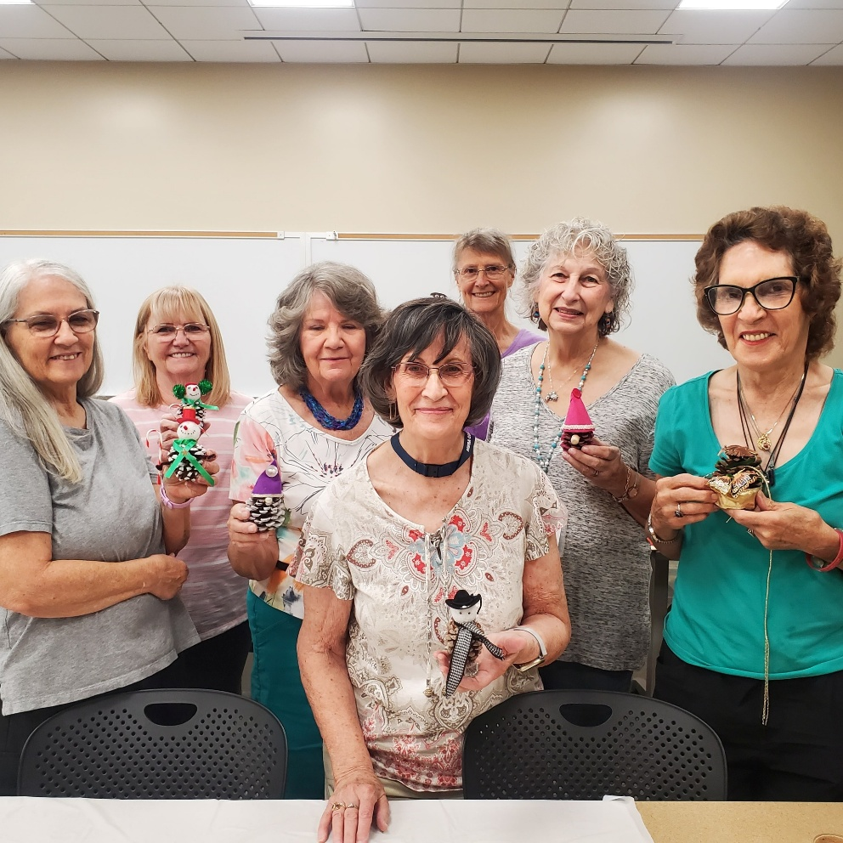

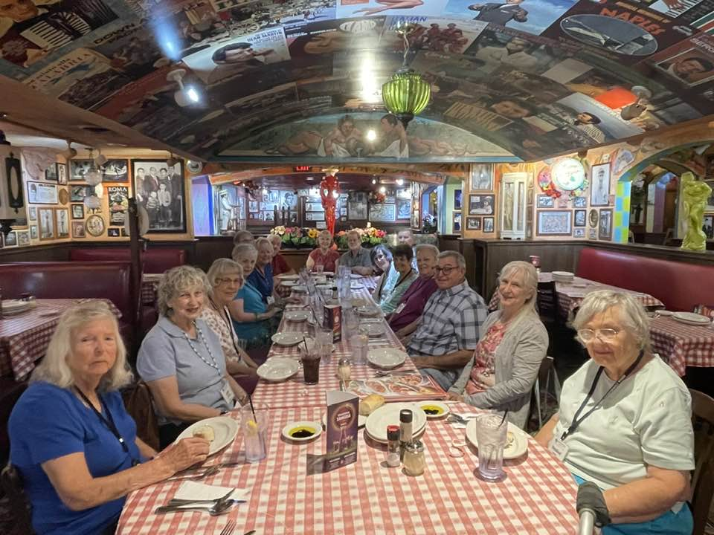

Above, July Out to Lunch Group at Buca di Beppo.

To see more pictures like these below visit New Frontiers on FACEBOOK. Lots of pictures of most of our recent classes, outings, and activities! <https://www.facebook.com/groups/760852587875975>

|  |  |
| --- | --- |
|  | Phone: 480-461-7497 |
| Mesa Community College | Website: [New Frontiers](https://newfrontiers.mesacc.edu/index.html) |
| Office of Community Partnerships | Debby Smith, MCC Liaison, NFLL |
| 7110 East McKellips Road | Email: [newfrontiers@mesacc.edu](mailto:newfrontiers@mesacc.edu) |
| Mesa, AZ 85207 |  |

The Maricopa County Community College District (MCCCD) is an EEO institution and an equal opportunity employer of protected veterans and individuals with disabilities. All qualified applicants will receive consideration for employment without regard to race, color, religion, sex, sexual orientation, gender identity, age, or national origin. A lack of English language skills will not be a barrier to admission and participation in the career and technical education programs of the district. The Maricopa County Community College District does not discriminate on the basis of race, color, national origin, sex, disability or age in its programs or activities. For Title IX/504 concerns, call the following number to reach the appointed coordinator: [480-731-8499](tel:4807318499). For additional information, as well as a listing of all coordinators within the Maricopa College system, visit [www.maricopa.edu/non-discrimination](http://www.maricopa.edu/non-discrimination).