**New Frontiers News**

**September 2025 Volume 34 Issue 2**



**President’s Message**

**Take Note!**

**NFLL calendar** [HERE.](https://newfrontiers.mesacc.edu/calendar.html) Find classes, socials, and more.

**Friday, September 5, Open House,** Red Mountain Campus, 1-3 p.m. Feel free to share the [flyer with others.](https://newfrontiers.mesacc.edu/short-term-flyers/2025-2026-flyers/fall-2025/nfll-openhouse-20250812.pdf)

**Monday, September 8, Board Meeting** Dobson campus, Building 38, Room 608 A/B. 10 a.m. to noon. [Email Allan for Zoom link](mailto:azisner@outlook.com).

**Thursday, September 11, Out to Lunch** 11:30 a.m.[**Red Lobster, 1403 S. Alma School Rd, Mesa**](https://newfrontiers.mesacc.edu/social.html)

**Monday, September 15,** Fall classes begin. [View Schedule.](https://newfrontiers.mesacc.edu/calendar.html)

**Friday, September 19, New Member Coffee**, 10 a.m. to noon

**Tuesday, September 30, Study Hall** [The Vig at Dana Park](https://newfrontiers.mesacc.edu/social.html) 4 to 6 p.m., 1744 S. Val Vista Dr., Suite 5-101, Mesa, AZ

**Report Volunteer Hours**

If you volunteered for NFLL or MCC during the month, please record your hours. Access the form [HERE](https://docs.google.com/forms/d/e/1FAIpQLSctKD_-CbnA37vwXVPJXAw_clNcUva_v8R-hspse1rg4QXrbw/viewform).

Dawn Fleming, Editor



**Welcome to Our New and Returning Members**

September ushers in a season of change, marked by the September equinox and the arrival of fall’s crisp charm. This year, New Frontiers for Lifelong Learning (NFLL) proudly celebrates 30 years of enriching the lives of our vibrant senior community.

NFLL offers a dynamic mix of opportunities for members to learn, connect, and thrive. From engaging in-person and online classes to joining book clubs, hiking and biking groups, weekly game days, crafting circles, and exciting field trips—there’s something for everyone. Seasonal gatherings like our festive Holiday Party and cheerful Spring Picnic add to the sense of camaraderie and community that defines NFLL.

📅 **Fall 2025 Highlights:**

* **Fall Open House:** Friday, September 5
* **Fall Semester:** Monday, September 15 – Friday, December 5
* **New Member Coffee:** Friday, September 19
* **Holiday Party:** Thursday, December 4

Whether you're a longtime member or just discovering NFLL, this fall promises fresh experiences, meaningful connections, and plenty of reasons to celebrate.

**Thank you to NFLL Members**

Dear New Frontiers,

On behalf of Mesa Market, we extend our heartfelt thanks for your generous food and hygiene donation.

Your support during the 2024 - 2025 school year made a real and immediate difference in the lives of our students.  Because of your kindness, the Mesa Market was stocked with essential food, hygiene products, school supplies, and clothing that help students meet their basic needs and focus on their education with dignity and confidence.

Whether it was a bag of groceries, interview clothing, personal care items, or a binder and pen for class, your gift shows our students that they are not alone - that the MCC community cares.

Thank you for helping build a caring and supportive campus.  We are grateful for your compassion and partnership in this work.

With Gratitude,

The Mesa Market Team

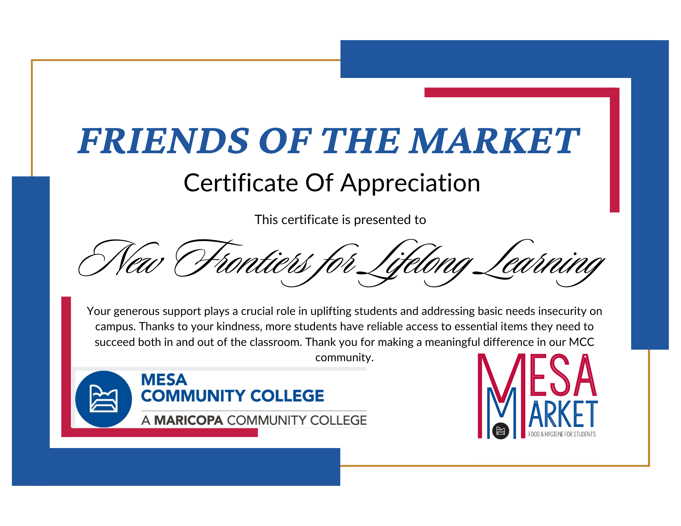

----------------------------------------------------------------------------------------------------------------------------  
Follow New Frontiers on FACEBOOK. Lots of pictures of most of our recent classes, outings, and activities! <https://www.facebook.com/groups/760852587875975>

|  |
| --- |
| **The Social Committee Needs YOU!**  By Joanne Handlong  Calling all fun-loving social beings, male and female. Those who enjoy planning and participating in group social activities. Those who would like to participate in more group social activities. Those who want to expand their circle of friends. And those who would like to be more involved with New Frontiers in an easy, not too time-consuming way. Whatever your reasons--the Social Committee WANTS and NEEDS you. `  We are currently a small cadre of five year-round and two partial-year New Frontiers members who organize and host monthly lunches, happy hours (aka study halls), and interesting (we hope) tours/outings for you. We are the people who plan the annual Holiday Luncheon and the Spring Picnic with an optional (but fun) costume theme. We always have our antennas extended and thinking caps on looking for new venues and activity ideas. We meet monthly to discuss those ideas and take turns hosting the activities, on a voluntary basis.  Our committee was larger in the past and that meant more people to host and more ideas for venues and activities. We now **need** to increase our committee membership—even a few more members would help--as we find ourselves being spread too thinly. In a few cases, we have foregone scheduling a monthly event for lack of someone being available to plan and host it.  We are reaching out to ask YOU to consider joining the New Frontiers Social Committee. If you take that step, I know from personal experience that you will be rewarded with a deepened sense of belonging to New Frontiers, and you will meet some very interesting, fun, and nice people!  I hear you asking yourselves, “what skills do I need, what do I have to do, and how much of my time would be needed?” “Not too much” is the answer to those three questions, with this explanation: You would have to be available to attend our monthly meeting, held on the first Monday of the month, at 10:00 a.m., at the Main Mesa Public Library, 64 E. 1st Avenue, Mesa. The meeting typically lasts about 1 to 1.5 hours. Then, for communication, you need to have some basic computer skills--enough to use email. Pluses: the ability to develop flyers to advertise events (but not required.) You also should have a cell phone to facilitate communication.  Once you have learned the ropes--by teaming up with an experienced committee member for a few activities--you would be arranging events with the restaurant/venue, including making sure they take separate checks for lunches, coordinating deadline dates with the venue and for members if RSVPs are required, taking and acknowledging RSVPs, and then serving as host for the event. It’s “not too much” and it’s fun and rewarding to bring the activity to fruition.  Still have questions? Come to one of our monthly meetings and observe our process. You can also contact me, Joanne Handlong or Roland Tanner for more information. We look forward to hearing from you!  Joanne Handlong, Co-Chair Roland Tanner, Co-Chair  Social Committee, NFLL Social Committee, NFLL  [JOA2049868@maricopa.edu](mailto:JOA2049868@maricopa.edu) [Rol2135531@maricopa.edu](https://d.docs.live.net/a52d29c8e0f64fee/Documents/new%20frontiers/newletter/september2025/Rol2135531@maricopa.edu)  Cell: (480) 296-8512 Cell: (480) 295-2010  **News From the Curriculum Chair by Suzanne Brown**  The Fall 2025 Schedule has been published, and registration began on Aug 28. Now our wait for classes is only a few days away with September 13 coming soon! This term offers over 90 class opportunities for NFLL members to engage in lifelong learning opportunities from travel, history, current events, arts and music, outdoor activities, discussion groups, and more! The Social Committee works diligently to find us 3 or more events each month to meet up and socialize in different settings. Classes are being held online, at Red Mountain Campus, at Dobson Campus, and several offsite locations. Take your pick of the many choices.  New Frontiers is the best value for your money for lifelong learning for a senior audience. At the Annual Fee of $80.00, each activity costs less than 50 cents! Other local lifelong learning groups are more expensive with some charging up to $15.00 per class taken! The volunteer members of NFLL work hard to provide a wide range of classes and social activities for you. Spread the word and help bring in new members!  **SPOTLIGHT ON A PRESENTER**  **Jim Shepherd**  Life-long naturalist, Boyce Thompson Arboretum docent, and author Jim Shepherd is a new presenter to our New Frontiers group this Fall. Jim has a wide range of talks available on Sonoran Desert plants, plant relationships/ adaptations, survival techniques, keystone versus indicator species, medicinal benefits, and wildlife relationships. He will do a one-hour program called “Unique Plants of the Sonoran Desert and Arid Lands” on Thursday Oct 30 at 1:30 at Red Mountain.  A person smiling in front of cactus  AI-generated content may be incorrect.  **Albert Monreal Quihuis**  Albert is a multi-award-winning author in 3 different genres, and he is an Arizona Historian, Educator, and Air Force veteran. This Fall, he volunteered to give NFLL two different talks on Arizona History. He started writing multicultural books to inspire young people to learn more about their culture, history, traditions and being proud of their heritage. Albert has written the following books “The Legacy Journal,” “Journeys to Authorship,” “Better Than Me,” and the “Sofia and Pepe Adventure Series.” Come join your fellow NFLL members and welcome Al as a speaker for **Arizona Wild Territorial Days and its Economic Development** at Dobson Campus at 1:30 on Oct 21 and then again for **Arizona National Monuments and Parks** at Dobson Campus at 1:30 on Oct 28.  Albert Monreal Quihuis  **Healthy Aging** by Sandy Bartlett  September is designated as Healthy Aging Month, first celebrated 30 years ago and confirmed by a US Senate resolution passed in 2021. Its aim is to draw attention to the importance of improving/maintaining good health as we get older as well as “accentuate the positive” aspects of aging and challenge stereotypes about senior citizens.  The five pillars of health aging include:  **Physical Activity:** A wide variety of exercises, including strength, endurance, balance, and flexibility helps to prevent falls, improve mobility, reduce pain, and lessens the risk of chronic diseases associated with aging. Examples of physical activity include walking, swimming, gardening, and hiking. Aim for 150 minutes of moderate-intensity aerobic activities per week. Talk to your doctor before starting an exercise program.  **Healthy Eating:** Maintain a balanced diet by including whole grains, fruits and vegetables, lean meats, low-fat dairy, and nut and legumes. Limit foods high in sodium, fat and highly-processed foods such as lunch meats and frozen meals. Keeping well-hydrated is of utmost importance, especially in our hot desert climate.  **Social Interactions**: Participating in social activities and spending time with your family and friends helps combat loneliness and improves overall well-being. Think about volunteering, engaging in community events, or joining a club.  **Mental Health:** Learn new skills, read that book you never had time to read before, play games and get plenty of sleep (7-9 hours per night). Reduce stress through yoga, deep breathing, and meditation.  **Regular Check-ups:** Schedule your yearly physicals, dental appointments, and eye exams. Make sure you are up-to-date on screenings and vaccinations. Inform your doctor of any changes in your health.  Further information on healthy aging may be found in the National Institute on Aging website at <https://www.nia.nih.gov/>.  _________________________________________________________________________  **CPR (Cardio-Pulmonary Resuscitation)**  By Jennifer Wong  When we heard the wife of an acquaintance recently had a heart attack and her husband, having attended a CPR class, saved her life by administering CPR to her, we were motivated to attend a class on CPR, which was being held at Bridgerland Technical College in Logan, Utah.  Sam Yates, who started out as an EMT and now primarily works in the Emergency Department at both Logan Regional Hospital and Bear River Valley Hospital in Tremonton, offered the following advice.  The purpose of performing CPR is to keep the blood flowing in the individual. You have 5-10 mins. to revive the individual before the individual undergoes irreversible brain damage. However, despite that, you should continue to perform CPR until the first responders arrive.  Perform CPR only on an individual who is no longer breathing and has a high probability of being resuscitated with CPR. Observe the color and temperature of the individual. If the individual looks grey or blue, feels cold and his heart has just stopped beating, you can begin administering CPR.  Before administering CPR, check the individual’s carotid pulse which can be found at the neck. If you cannot find a pulse, you may administer CPR but only after you first call 911 to request medical assistance. Within 10 seconds, before starting CPR, in addition to checking the pulse at the neck, look at the chest and abdomen for movement, listen for the sound of breathing or the feeling of breath on your cheek to determine whether the individual is breathing.  To administer CPR, with the palms of both hands, press down hard on the individual’s chest between the breasts. You may have to break the rib bones, but that is a necessity.  Administer CPR for 2 minutes. by pressing down hard on the chest 30 times, blow air into the lungs 2 times through the mouth, repeating the sequence 5 times and then checking the pulse before rotating to someone else to continue CPR.  The rhythm when pressing down on the individual’s chest should be to the beat of the nursery rhyme, “Row Row Your Boat” or to the disco beat of the Bee Gees’ “Stayin’ Alive”.  Before administering mouth-to-mouth resuscitation, pinch the nose shut and open the airway by tilting the face upward and lift the chin up to open the airway. To administer mouth-to-mouth resuscitation, you should take a normal breath, seal the mouth with yours, and blow into the mouth for about one second. The chest should rise visibly when you breathe into the mouth, and sink again when you stop breathing into the mouth. If you do not know the individual you are performing CPR on and you are reluctant to administer mouth-to-mouth resuscitation, it is not necessary to do this. What is important is that you continue to press down on the chest non-stop until the first responders arrive to take over.  We were also instructed on how to use the Automated External Defibrillator, which is an automated device. When its pads are connected to the individual’s chest, it analyzes the heart's rhythm and gives you step-by-step instructions on what to do next, including when to administer a shock to the individual to re-start the heart.  On a related note, choking can lead to a need to start CPR. This is when the individual’s airway is blocked which prevents him or her from breathing. When the individual is choking, it sounds like he/she is coughing and is unable to talk. Dislodge the blockage to his airway by performing the Heimlich Maneuver. Stand in front of the individual, shove your fist into his stomach and pull upward. You can also stand behind the individual while you perform the Heimlich Maneuver to steady his balance.  Shortly after taking the CPR class, we learnt the acquaintance, who almost passed away, as well as the husband of another acquaintance, both had pacemakers. We later learnt that the average life of a pacemaker is 6 to 15 years. If the pacemaker does not alert you that the battery needs replacing, symptoms such as skipped heartbeats, slowed heart rate, dizziness, palpitations, shortness of breath or lightheadedness are all indicators that the pacemaker needs to be replaced.  Having taken the CPR class, and knowing what we now know, we feel more confident about the prospect of having to perform CPR sometime in the future. By imparting what we have learnt, we hope you will also feel confident about administering CPR whenever it becomes necessary.  Please note the author is not a medical expert. This information is being shared so you are more knowledgeable about CPR. If you have any questions about CPR, Sam will be doing four online classes for New Frontiers on topics that she feels is important for us to maintain good health and wellness. They are:        Neuropathy Concerns            Oct. 23/25 @ 1:30 p.m.        Stroke Facts                        Nov.   6/25 @ 1:30 p.m.        Falls Prevention                     Nov. 13/25 @ 1:30 p.m.        Stop the Bleed                      Nov. 20/25 @ 1:30 p.m. |

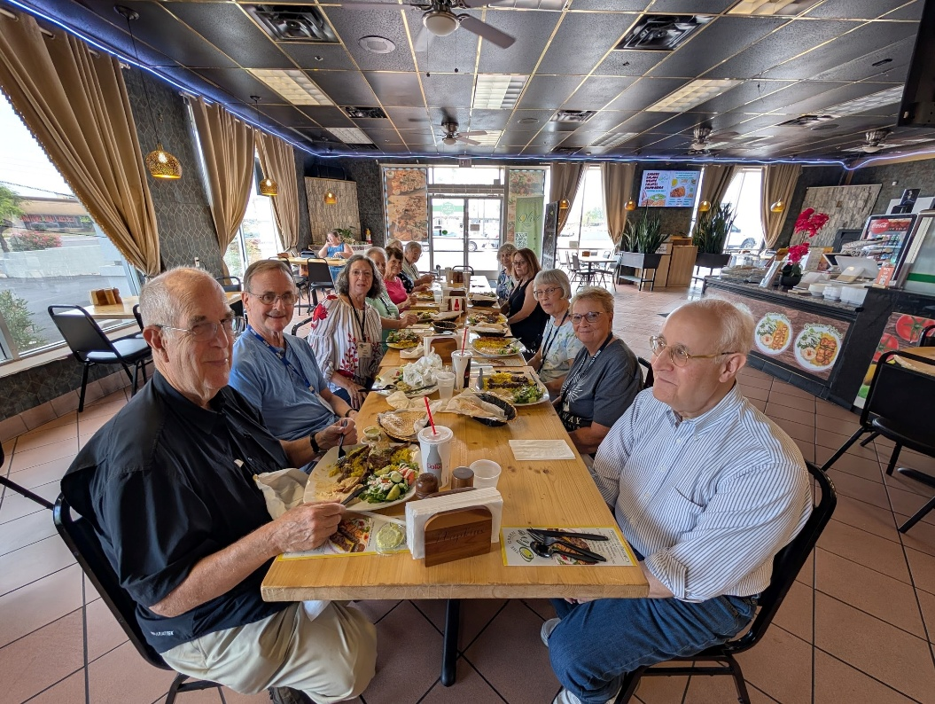

Left: Out to Lunch at Green Olive  
Below: Trip to Heard Museum  
Photos by NFLL members

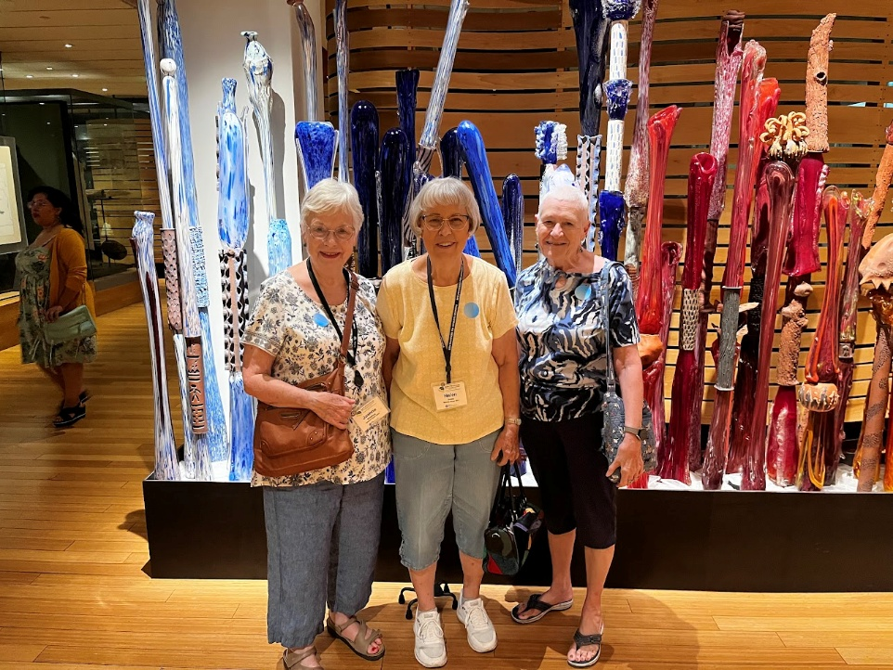

|  |  |
| --- | --- |
| New Frontiers for Lifelong Learning | Phone: 480-461-7497 |
| Mesa Community College | Website: [New Frontiers](https://newfrontiers.mesacc.edu/index.html) |
| Office of Community Partnerships | Debby Smith, MCC Liaison, NFLL |
| 7110 East McKellips Road | Email: [newfrontiers@mesacc.edu](mailto:newfrontiers@mesacc.edu) |
| Mesa, AZ 85207 |  |

The Maricopa County Community College District (MCCCD) is an EEO institution and an equal opportunity employer of protected veterans and individuals with disabilities. All qualified applicants will receive consideration for employment without regard to race, color, religion, sex, sexual orientation, gender identity, age, or national origin. A lack of English language skills will not be a barrier to admission and participation in the career and technical education programs of the District. The Maricopa County Community College District does not discriminate on the basis of race, color, national origin, sex, disability or age in its programs or activities. For Title IX/504 concerns, call the following number to reach the appointed coordinator: [480-731-8499](tel:4807318499). For additional information, as well as a listing of all coordinators within the Maricopa College system, visit [www.maricopa.edu/non-discrimination](http://www.maricopa.edu/non-discrimination).