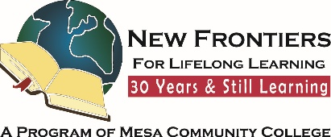

**New Frontiers News**

**October 2025 Volume 34 Issue 3**

**Take Note!**

**NFLL calendar** [HERE.](https://newfrontiers.mesacc.edu/calendar.html) Find classes, socials, and more.

**Monday, October 13, Board Meeting**. 9:30am PV114, Red Mountain. [Email Allan for Zoom link](mailto:azisner@outlook.com).

**Thursday, October 9th, Out to Lunch** 11:30 a.m.[**Black Bear Dinner**,](https://newfrontiers.mesacc.edu/social.html) 1809 E. Baseline Rd, Gilbert

**Tuesday, October 28, Study Hall**

[**RT O’Sullivan’s Study Hall**](https://newfrontiers.mesacc.edu/social.html)**,** 4 to 6 p.m 6646 E, Superstition Springs Blvd, Mesa

**Report Volunteer Hours**

If you volunteered for NFLL or MCC during the month, please record your hours. Access the form [HERE](https://docs.google.com/forms/d/e/1FAIpQLSctKD_-CbnA37vwXVPJXAw_clNcUva_v8R-hspse1rg4QXrbw/viewform).

Dawn Fleming, Editor



**President’s Message – Allan Zisner**

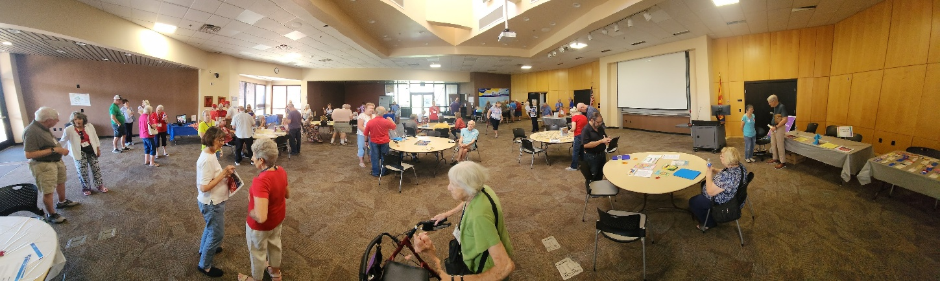

**Open House Success and Growing Membership**

Thank you to everyone who contributed to the success of our New Frontiers Open House earlier this month. Nearly 100 people attended the event, including 20 brand-new members and 20 returning members. The welcoming room layout, designed by the Membership Committee, highlighted the work of our other committees and gave everyone a chance to mingle and learn more about NFLL.

Behind the scenes, many hands made the day enjoyable and productive.

* The Social Committee assisted with the refreshments.
* The Communications Committee assisted with registration and spreading the word through print and digital media.
* The Curriculum Committee shared details about our wide range of classes, with many schedules distributed.
* Mesa Community College’s Enrollment Services offered invaluable assistance to those enrolling as non-credit students.

As of mid-September, our membership stands at 190. With over 90 classes available this fall, there is truly something for everyone—all for the great value of an $80 annual membership.

We extend a special thank you to Dawn Fleming, our Communications Chair, who devoted countless hours to promoting the event and making it such a success. Members can help continue this momentum—whether by sharing the class schedule, handing out tri-fold brochures, or leaving information at local community centers. Together we can keep growing and strengthening New Frontiers for Lifelong Learning.

**Message From Curriculum**Suzanne Brown

Is it October already? Curriculum Committee has been busy in the past two months getting the Fall Schedule out, helping with Open House and New Member Coffee and answering numerous emails, phone calls, and in-person questions on schedules and registering! But all is going well with our 90 plus classes and Social Committee’s activities to fill our calendar!

October brings us many interesting classes including current events, Arizona History, and general fun to learn things. Welcome back to our Snowbird Friends to join in the fun. You can still register for classes that interest you at any time before the class begins by using your Member Account tab on the New Frontiers website.

We have many new members and returning members. Over 40 new faces will be in our classes and activities, so try to meet someone new at each class or event. Let us become a welcoming group for all. We all want to learn and make a strong community of learners. Spread the word and help bring in new members!

**Try Something New – Play the Native American Flute**Dawn Fleming

Have you ever wanted to try something new, but you hesitate? This past year I have tried a lot of new things. I learned to play Bridge, Mah Jong, and bought a RV and had it placed on a permanent site in Flagstaff for the summer months. Sometimes all this makes my head spin but overall, it has kept my mind and spirit full and happy. This year has really stretched me in many positive ways.

One of my favorite things to do is to play my Native American Style Flutes (NASF). There are two ways to play the flute. You can actually play songs by reading the pictures of what holes to cover for each note. You do not need to know how to read music. Or, my favorite, is to play whatever wants to come out of me in that moment. It is called playing from the heart, and there is no wrong way to do this. Playing my NASFs brings me great joy. It is a great way to reduce stress.

Is it hard to get started? No. There is a lot of free information online on how to play and even free music to download. There are many YouTube videos of NASF players sharing their music, which is very inspiring. Most new players buy a flute in the key of Am 440 hz because the fingering holes are usually easy for anyone to cover. I will be doing a presentation on the Native flute on Oct 29th at the Red Mountain campus. Come find out how you can start your Native flute journey.

He/She who hesitates to try new things is not lost but loses out on potential fun and adventure.



Follow New Frontiers on FACEBOOK. Lots of pictures of most of our recent classes, outings, and activities! [https:// www.facebook.com/groups/760852587875975](https://www.facebook.com/groups/760852587875975)

|  |
| --- |
| **Benefits of Travel for Seniors** Shalini Kathuria Narang  Travel for seniors can be enjoyable and enriching, and the benefits go far beyond fun. Seniors Guide looks at a recent roundtable discussion praising the effects of [travel](https://www.seniorsguide.com/category/travel/) on longevity and dementia.  Travel and the activities associated with it can enable healthy longevity, stated [a March 2025 roundtable report](https://www.transamericainstitute.org/docs/research/aging-longevity/travel-catalyst-for-healthy-longevity-roundtable-report-2025.pdf) from the [Global Coalition on Aging](https://globalcoalitiononaging.com/) (GCOA) and the nonprofit [Transamerica Institute](https://www.transamericainstitute.org/), an organization devoted to research and education about retirement security.  The roundtable featured experts on aging, travel, and neuropsychology. It touted the benefits of travel for seniors, though its primary message was to industry stakeholders, encouraging them to make travel even more accessible for older adults, as a win/win proposition.  And the roundtable’s takeaways for seniors and their loved ones and companions were clear and positive.  “Regular travel has been shown to reduce mortality risk by 36.6% and lower Alzheimer’s risk by up to 47% through culturally enriching activities like museum visits, attending live music performances, and exploring historical landmarks,” the roundtable report stated.  The report cited a connection between travel and improved brain health, cardiovascular well-being, and vitality. Similarly, it said, travel helps to combat the challenges of loneliness and social isolation. “Travel embodies many of the modifiable factors that promote health,” said Paul Nussbaum. A contributor to the roundtable, Nussbaum is a clinical neuropsychologist and adjunct professor of Neurological Surgery at the University of Pittsburgh School of Medicine. “It exposes us to new cultures, languages, and problem-solving opportunities – all enriching experiences that contribute to our overall well-being.”  The roundtable discussion also noted the benefits and [increased popularity of intergenerational travel](https://www.travelagewest.com/Travel/Family-Travel/multigenerational-travel-trends-study). Logically, [multigenerational vacations](https://www.boomermagazine.com/multigenerational-travel/) may be more active than trips focusing only on older adults. In addition, [spending time with people of other generations benefits](https://www.seniorsguide.com/lifestyle/multigenerational-friendships-friendship-should-have-no-age-requirements/) young and old alike, as they exchange knowledge, broaden each other’s perspectives, and explore rich topics.  “Intergenerational travel creates meaningful opportunities for connection and understanding across generations,” says Catherine Collinson, roundtable participant and president of Transamerica Institute. “It fosters shared experiences that strengthen family bonds, promote emotional well-being, and create lasting memories – all of which contribute to healthier aging.” |
| Pictures courtesy of Jackie McDugle |

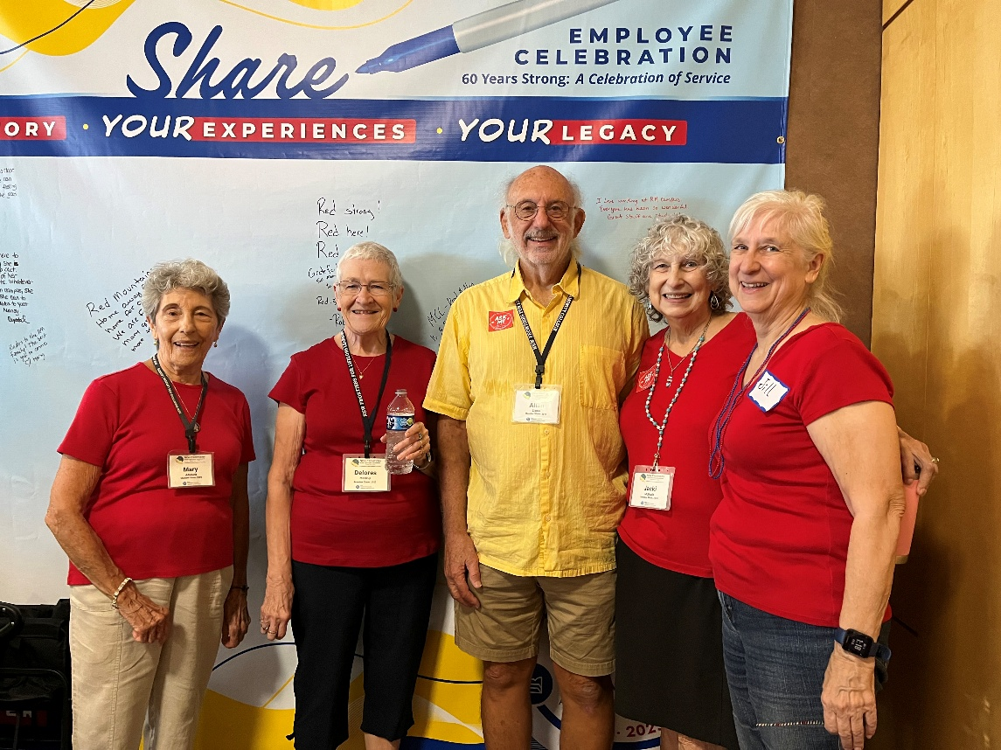

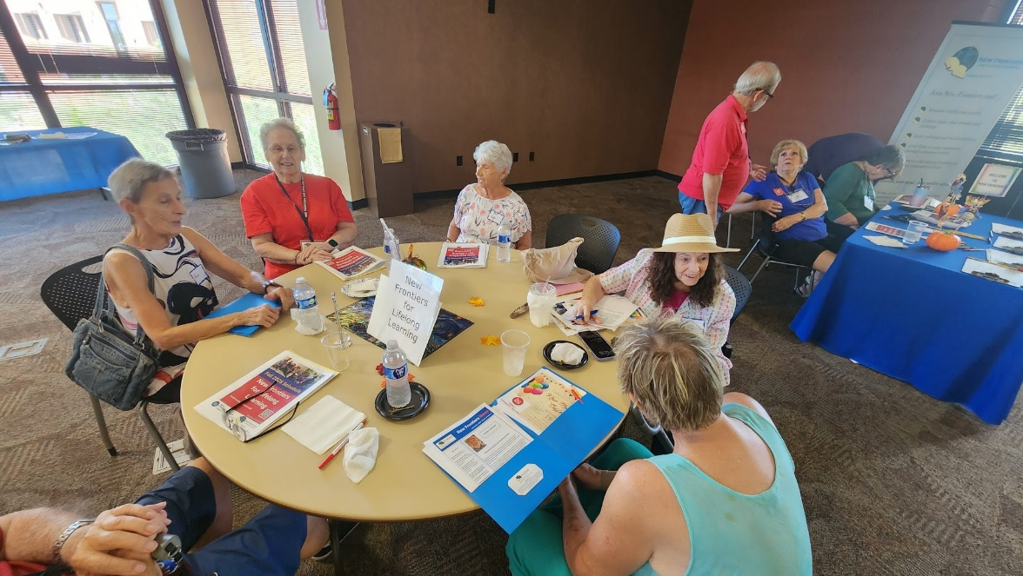

Photos taken at the Open House on September 5th. Bottom picture taken by Allan Zisner

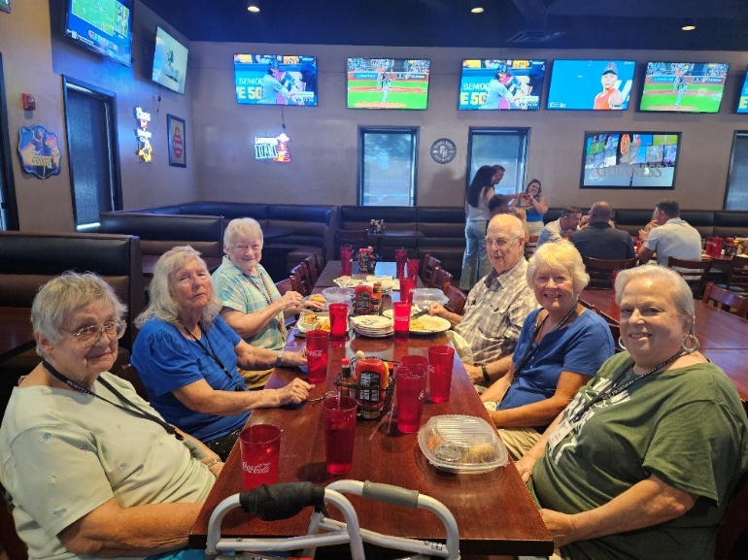

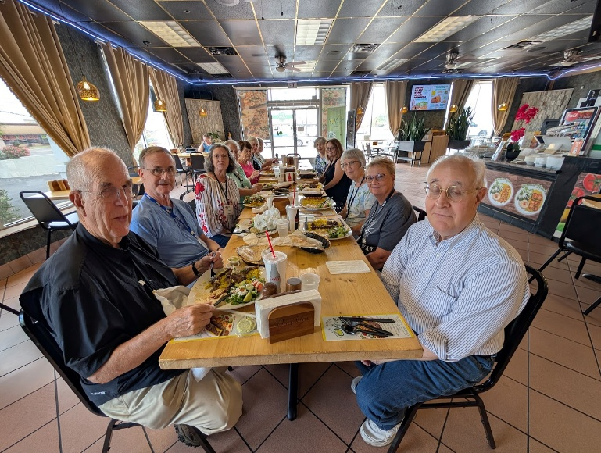

Top picture taken at The Hub by Arlys Medlicott  
Bottom picture taken at Green Olive outing by Allan Zisner.

|  |  |
| --- | --- |
| New Frontiers for Lifelong Learning | Phone: 480-461-7497 |
| Mesa Community College | Website: [New Frontiers](https://newfrontiers.mesacc.edu/index.html) |
| Office of Community Partnerships | Debby Smith, MCC Liaison, NFLL |
| 7110 East McKellips Road | Email: [newfrontiers@mesacc.edu](mailto:newfrontiers@mesacc.edu) |
| Mesa, AZ 85207 |  |

The Maricopa County Community College District (MCCCD) is an EEO institution and an equal opportunity employer of protected veterans and individuals with disabilities. All qualified applicants will receive consideration for employment without regard to race, color, religion, sex, sexual orientation, gender identity, age, or national origin. A lack of English language skills will not be a barrier to admission and participation in the career and technical education programs of the District. The Maricopa County Community College District does not discriminate on the basis of race, color, national origin, sex, disability or age in its programs or activities. For Title IX/504 concerns, call the following number to reach the appointed coordinator: [480-731-8499](tel:4807318499). For additional information, as well as a listing of all coordinators within the Maricopa College system, visit [www.maricopa.edu/non-discrimination](http://www.maricopa.edu/non-discrimination).