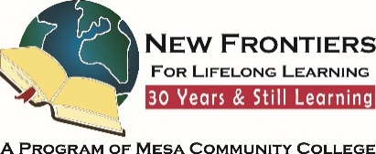
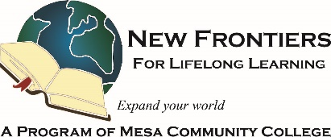

New Frontiers News
November 2025 Volume 34 Issue 4
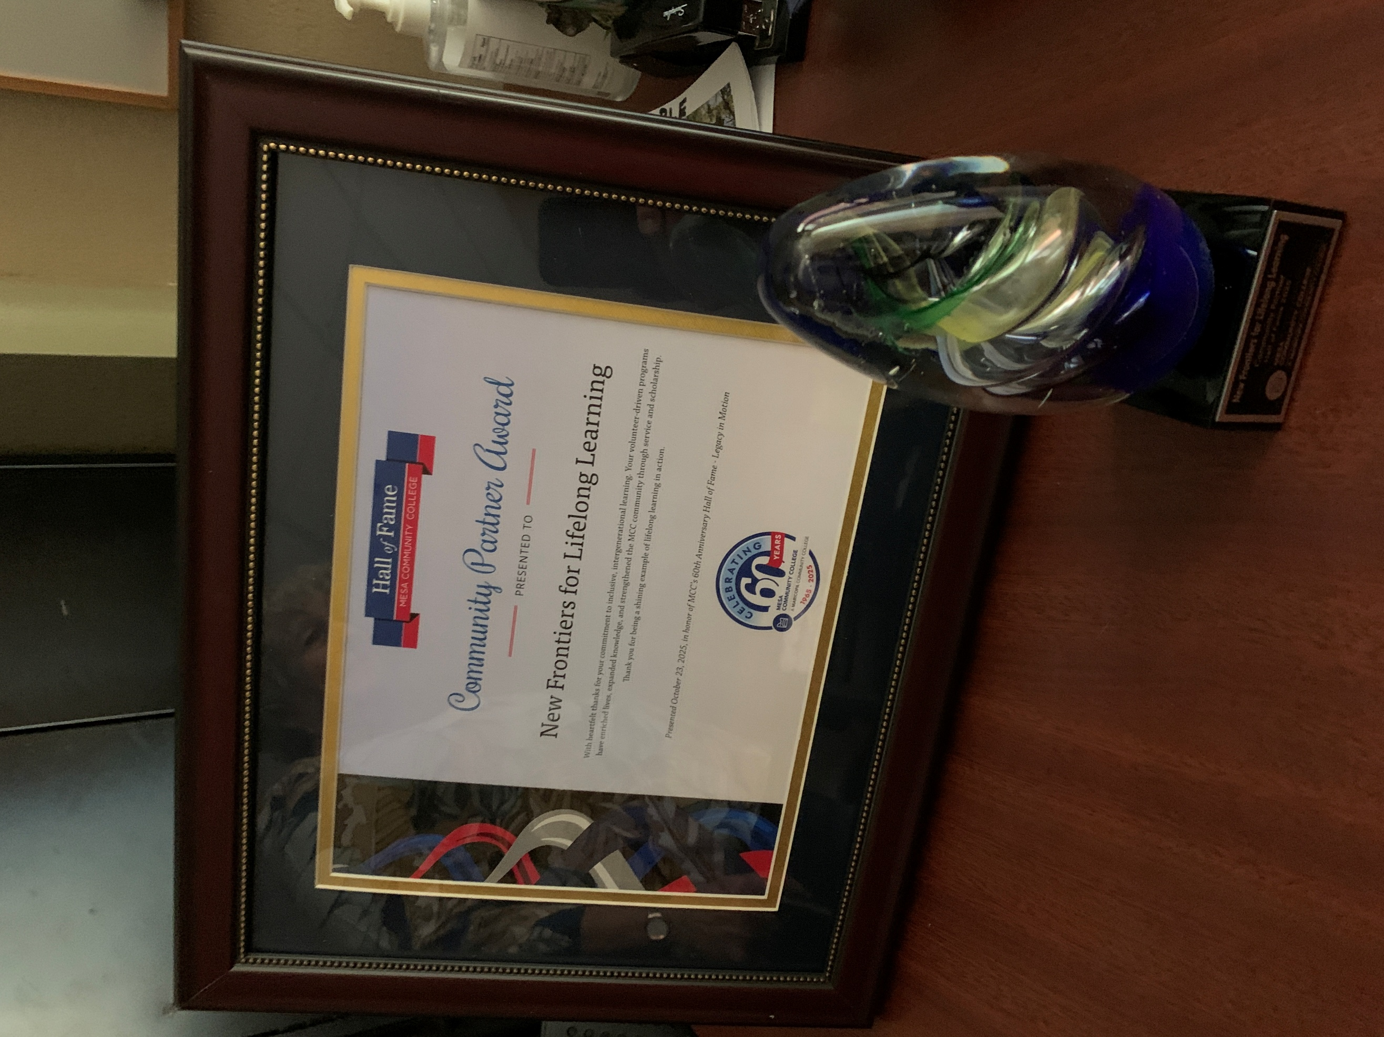
It was a perfect fall evening to attend the outdoor reception preceding the Mesa Community College Hall of Fame Celebration. Attendees had an opportunity to meet and mingle, view works of art by both students and faculty and enjoy the excellent food. On the Hall of Fame wall, I spotted our very own Barb Thelander, who was inducted last year. After the social hour, we were escorted into the theater and greeted with a live performance by the MCC jazz band. Dr. Richard Daniel then introduced the community partners and the contributions they bring to the college. His description of NFLL was thorough and accurate.

On a personal note, working at MCC was my first job when I relocated to AZ from Pennsylvania. It was a warm and welcoming environment. I soon found out employees had the privilege of taking classes for free! As a lifelong learner who already had my BS, I went on to follow my curiosity, taking whatever classes interested me. Spanish, pottery, photography, flora and fauna of AZ, wherever my interests led, I was there. MCC will always hold a special place in my heart.

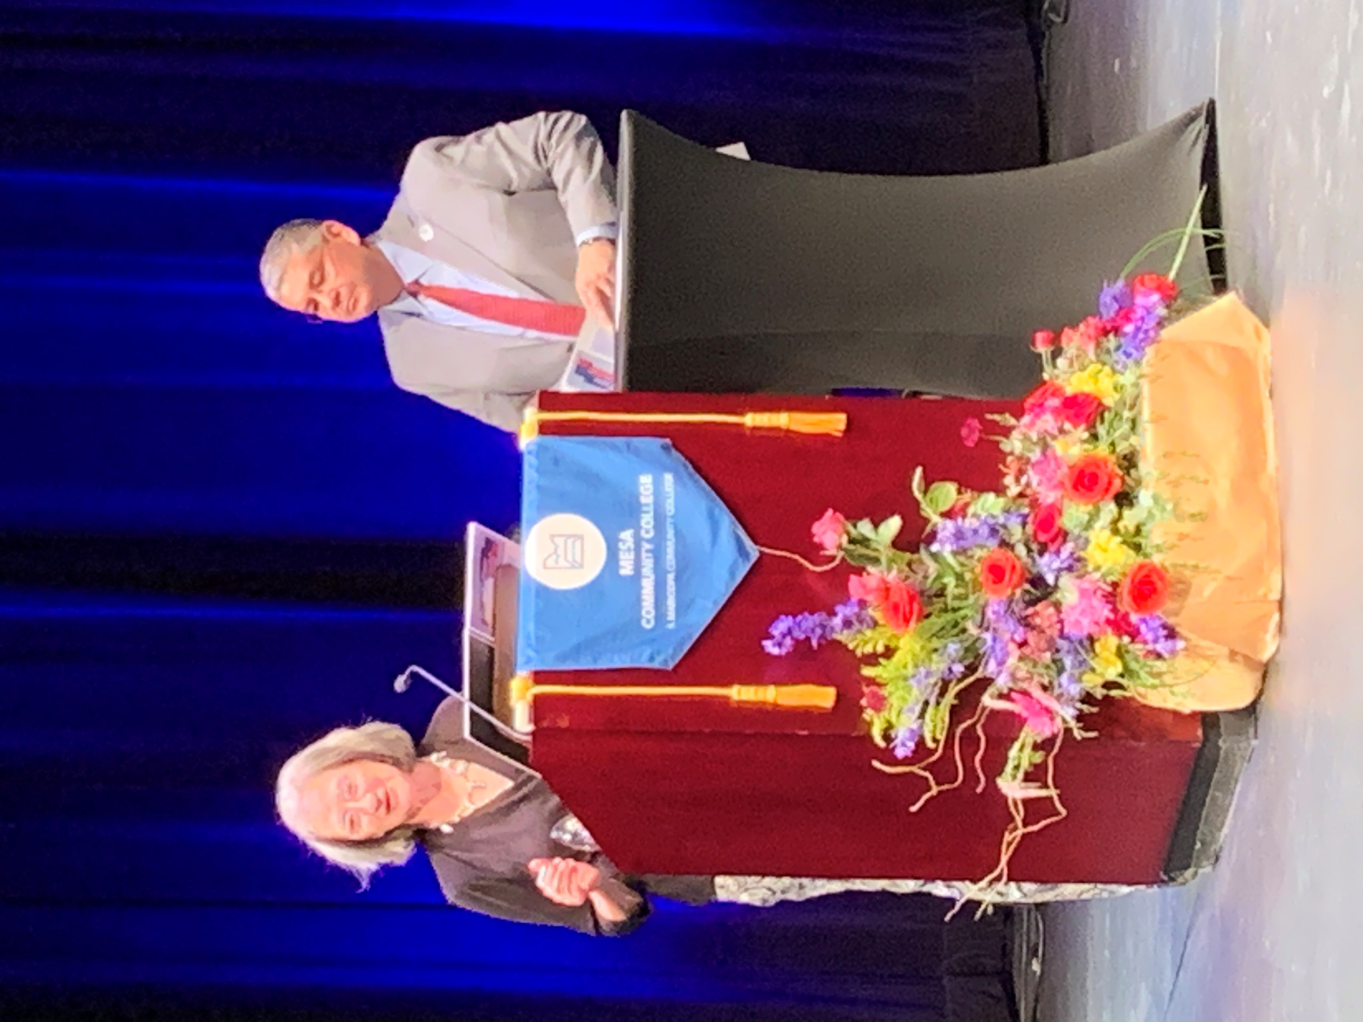

President Richard Daniel looks on as Terri accepts the Hall of Fame honor for New Frontiers’ contributions to Mesa Community College.

Message from Vice President
Terri Pokosh
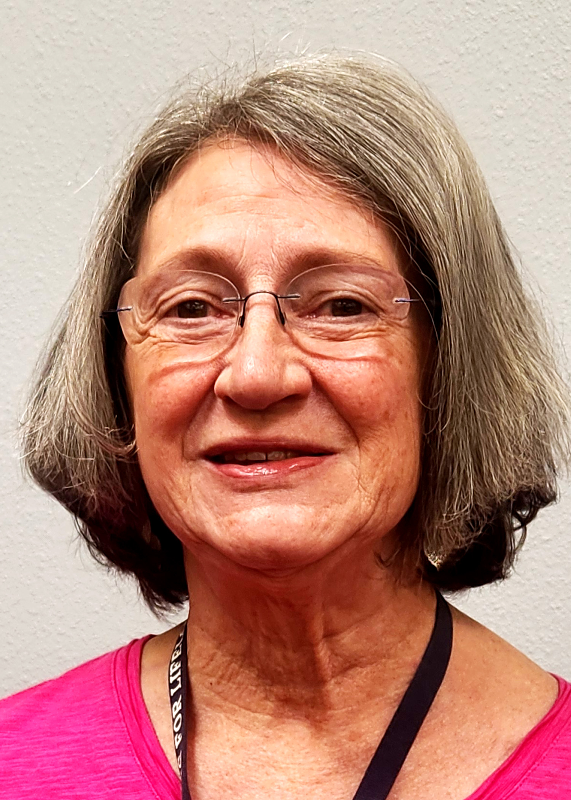
Take Note!
NFLL calendar HERE. Find classes, socials, and more.
NFLL Council Meeting,
November 10, 9:30-11:30 a.m. Southern and Dobson, Bldg. 38, Room 608A/B or by Zoom.
Out to Dinner and Art Walk
(Replaces Out to Lunch)
November 13, 4:30 p.m.
Dinner at Malee's Thai Bistro
7131 E. Main Street, Scottsdale. 6:30 PM - 9:00 p.m. Scottsdale Golden Palette Art Walk.
RSVP required to Roland Tanner rol2135531@maricopa.edu

Visit to Clydesdale Preservation Foundation, Gilbert, November 18,1 p.m. Limit of 20 people
RSVP required to Diana Yarbrough ddyarbs@yahoo.com

Study Hall (Happy Hour)
Republica Empanada,
November 25, 4 p.m. - 6 p.m.,
204 E. 1st Avenue, Mesa
RSVP to Greg Master appreciated
gamst51@gmail.com

Report Volunteer Hours
If you volunteered for NFLL or MCC during the month, please record your hours. Access the form HERE.

Dawn Fleming, Editor
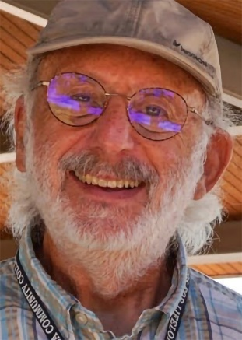
Reflection on Military Service and Memory
By Allan Zisner, NFLL President
Growing up in Chicago, I vaguely remember military veterans handing out poppies. I probably tucked one into a shirt buttonhole without realizing its meaning—it just looked cool to a kid back then.
Sometime after the Great War, maybe in the thirties, my dad volunteered as a medical aide and ambulance driver in the Army Reserve. I remember the leather wrappings on his gear, but he never spoke about his experiences. All I have is a memory of a picture of him and a few of his buddies standing by an old ambulance.
During World War II, Dad lost his brother, Irving, in the Battle of the Bulge—an uncle I never knew, with no stories passed down.
Before Vietnam became a household name, my older brother, also named Irving, received his draft notice. To avoid being sent into combat, he enlisted in the Air Force. I think he was a pacifist at heart. He spent much of his service around Greece and Turkey.
In 1967, I received my own draft notice. Enlisting in the Air Force was likely the best choice to steer clear of the conflict. While stationed in Alaska, I often saw the medical air-evac flights shuttling between Vietnam and the East Coast. Occasionally, when they stopped for refueling, some of the wounded who were able to walk came into the operations center for a short break. Looking back, I wish I’d taken the chance to talk with them.
By the time my son was born, the draft was over. Through Boy Scouts, he learned leadership and responsibility—lessons that serve him well in life.
As I reflect on those who served, I sometimes feel uneasy when someone says, “Thank you for your service.” Everyone’s experience is different, and mine feels like a lifetime ago. I prefer a simple “Thank you.” It’s been more than fifty years since my time in uniform, and I’ve long since moved on with my life—but the memories quietly, and indelibly, linger in the background.
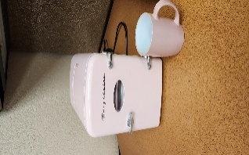
A Barbie Refrigerator SOS
The former refrigerator in the NFLL office has been fired—it quit working. If anyone has a spare refrigerator that they would like to donate or would like to buy a small refrigerator for the office, then give Jacki McDugle a call (815.298.8526) or email her at mcdugle@gmail.com. Shown at right is the actual Barbie refrigerator currently in use next to a coffee mug.
In Memoriam
William ‘Bill’ O’Connor, NFLL member since 2018, died October 1, 2025, one week shy of his 97th birthday. Bill was an advocate for lifelong learning, bringing several of his friends and neighbors to classes and, eventually, joining NFLL. Bill especially loved history and current events but caught on to online learning since the COVID pandemic. He and his wife, Barbara, travelled extensively, and Bill often added personal memories and experiences in the travel-related courses. He is survived by his wife, Barbara, and will be missed by his NFLL friends. No services are planned. (Note: Shared with permission by Barbara O’Connor.)

Message from Curriculum Committee
by Suzanne Brown
Spring Courses Needed
The submission deadline for Spring 2026 courses is November 15, 2025. Proposals can be submitted online using the link on the NFLL website. All types of courses are welcomed. Do you or a friend have a trip or hobby you wish to share? Have you read a book you want to share? All of these make great classes. Please consider doing a class.
This Spring we will try a class called “From our Kitchens.” This will be an every other week class during which one of us will share a favorite recipe. During the class, you can share memories, talk about the recipe and changes throughout the generations, and bring the dish to share. We will not cook the recipe during the class. If you are willing to share a favorite recipe, please contact Suzanne Brown at suzannebrownpt@gmail.com to select a date. NFLL can make copies of the recipe(s) for attendees.
Other classes requested are for our America 250 series. Any class, film, activity celebrating the history or culture of the United States is welcomed. NFLL owns several Great Courses on American history if you would like to use a complete course or just excerpts. Do you know someone who is a history or political buff? If so, ask them if they will present a course.
Arizona State Senator Kuby to Talk
A course has been added to the Fall 2025 schedule: Senator Lauren Kuby, a Senate Member since 2025 representing District 8 (Tempe) will provide NFLL members and guests a non-partisan overview of the Arizona State Legislative Processes on Friday, November 14, at 10:00 a.m. on the Dobson Campus, Room BP 3S. Please register in your Member Account from the NFLL website, or email newfrontiers@mesacc.edu to let us know you intend to come. Guests are welcome. NFLL President Allan Zisner may facilitate the presentation.
Lauren Kuby served on the Tempe City Council from 2014-2022, where she championed climate action, affordable housing, and social equity. Kuby holds a bachelor’s degree from the University of Chicago and a master’s in public history at ASU. As an ASU Senior Global Futures Scientists, she has collaborated with communities, nonprofits, and academic experts to develop climate solutions, co-authored socioecological research, and led the University’s Stardust Center for Affordable Homes and the Family. Retired from ASU in 2023, she remains a Global Futures Scientists and a proud member of United Campus Workers. Elected to the State Senate in 2024, Kuby brings her local governance experience to the state legislature, advocating for policies that address climate change, protect workers, and ensure a robust public education system–from Pre-K to higher education. Kuby’s unique blend of local government experience, subject matter expertise, and policy advocacy makes her a powerful voice in the Arizona Legislature.
Social Committee Hosting Holiday Lunch and Christmas Light Tour
by Joanne Handlong
It’s soon going to be that “most wonderful time of the year”* and the Social Committee is planning two events to help you get into a festive, holiday mood.
Mark your calendars for Thursday, December 4, when we will gather at EVIT (East Valley Institute of Technology) for our annual Holiday Luncheon. In addition to a gourmet meal prepared and served by EVIT’s talented culinary students, the event will feature holiday music by the Salt River Brass Five (Quintet), several raffles of handmade items and pots of poinsettias to lend holiday cheer to your home décor. New members, we encourage you to join us for this festive event. Watch for a flyer coming in your email soon with all the details you’ll need to make your reservation and payment. The cost of this year’s meal will be $30.00 for members and $35.00 for guests. There will be two entrée choices for omnivores and one for vegetarians. The deadline for reservations will be November 17.

The merriment continues on Saturday, December 6, with a Christmas Light Tour of selected east valley neighborhoods. This will be a private, 90-minute, small bus tour with Spirit of Arizona Tours. They have one bus which holds 14 people, and we will have to fill all the seats in order to go forward with the tour. Anticipating that more than 14 of you will be interested, we’ve tentatively scheduled a second tour immediately following the first one. The first tour will be from 6:00 p.m. to 7:30 p.m. The second tour would be from 7:45 p.m. to 9:15 p.m. and is also contingent upon filling all 14 seats. There are large windows on the bus to allow for good views of the lights and there will be two stops where we can get out of the bus and walk in the neighborhoods. The pickup point will be by Starbucks at Price 101 Freeway and Warner Road in Chandler. The cost of this tour will be $28.00 which includes a tip for the driver. Watch for a flyer coming in your email with details and instructions on how to make your reservation and payment. The deadline for reservations will be November 14. Santa hats and reindeer ears are welcome. Anyone for singing carols on the bus?
*"It's the Most Wonderful Time of the Year" is a popular Christmas song written in 1963 by Edward Pola and George Wyle, first sung and recorded by Andy Williams.

New Frontiers Tour of Sky Harbor Airport
by Jennifer Wong
Thanks to Joanne Handlong and the Social Committee, and Doug and Stephen of Sky Harbor Airport, on Thursday, October 16, ten New Frontiers members and one guest had a guided tour of Sky Harbor Airport with special focus on its art museum.
Through precise coordination of the use of Phoenix’s light rail system, the group, some starting from the Gilbert/Main station, others from the Price-101 Freeway/Apache Blvd. station, led by Joanne Handlong, disembarked at the 44th Street/Washington train stop and met up at the end of the pedestrian sky bridge with Doug, a Sky Harbor Navigator volunteer, and Stephen, from Sky Harbor Airport’s Museum staff.
At Terminal 4, we soon discovered that art could be found everywhere at the airport, on the floor and wall, on the columns, in display cases and in mini studios. In most cases, you can take a postcard which gives you information about the artwork you are viewing as well as other artworks which can be found throughout the airport. We learned that Sky Harbor has the largest art collection of any USA airport. It was nice to hear that most of the art in the airport was done by local artists and craftsmen. Photos of some of these artworks are posted on the Photos page of the New Frontiers website.

We learned most international flights fly out from Terminal 4 and they are usually scheduled to fly out in the afternoon. Also, at Terminal 4, senior citizens can use the lounge which is usually reserved for military personnel. More importantly, we heard Terminals 1 and 2 have long since been demolished and their terminal numbers have been retired to avoid having computer glitches. Terminal 4 is now known as Barry M. Goldwater terminal; Terminal 3 is John S. McCain III terminal.
To end our tour, we went to the parking lot on the 9th floor of Terminal 4 where we were able to see the planes landing and taking off from the runway. There is one runway allocated for taking off and another runway for landing only. All planes land and take off in the same direction. It was interesting to learn and see that the runways are two miles long!
According to an article in the October 21, 2025, issue of the Arizona Republic, titled “Sky Harbor was just named among the best airports again," USA Today has ranked Phoenix Sky Harbor International Airport for its 2025 Readers’ Choice Awards as follows:
- No. 5 airport for shopping
- No. 6 airport for dining
- No. 7 best large airport
- No. 8 airport for art
The next time you are at Sky Harbor check out the art that is all around you!
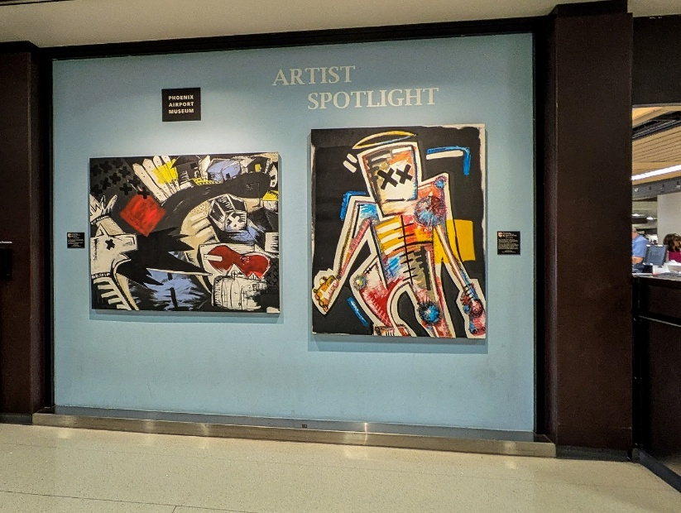
A sample of the art at Sky Harbor.
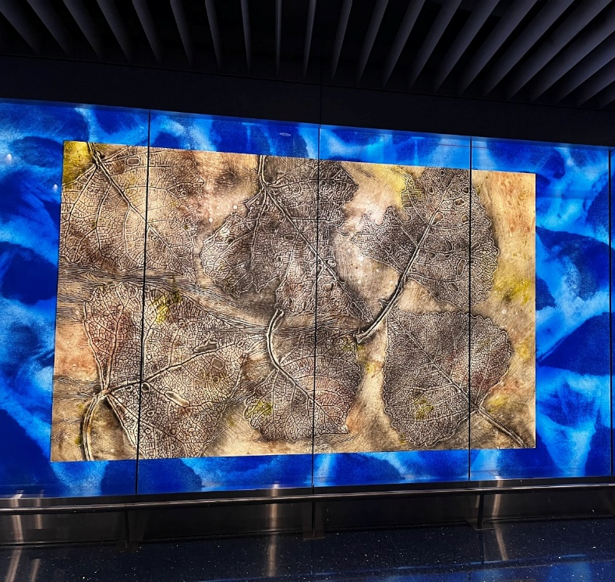
Glass art at Sky Harbor.
Year-End Tax Planning
Many of us are doing year-end tax planning and considering charitable donations. If you have an IRA, 401K, or other tax-deferred retirement plan, you have been postponing taxes on contributions to the plan and the resulting investment returns — not eliminating them. Eventually, you must pay taxes on that money. RMDs (Required Minimum Distributions) make sure that you do that. Federal law sets 73 as the starting age for RMDs. You have until April 1 of the year after you turn 73 (or 75 for those born in 1960 or after) to take your first RMD. After that, the annual deadline is December 31. The RMD amount changes each year, according to your age and how much you have in your retirement savings.
One way to reduce the taxes of your Required Minimum Distribution\] is to consider making a Qualified Charitable Distribution (QCD). A QCD doesn't offer a tax deduction, but the QCD amount is subtracted from your taxable income for that year. In some cases, the tax benefits of a QCD could outweigh the charitable deduction you would have received from donating cash or other assets directly to an eligible charity.
Consult your financial and/or tax advisor for the correct procedure for requesting one or more Qualified Charitable Distributions from your tax-deferred accounts. There will be forms to complete. You will identify the charities and/or other non-profit organizations and your donation amounts (up to your RMD for the tax year).
Please consider giving Mesa Community College a donation to support student scholarships, the planetarium, or other MCC activities. Even small gifts have a great impact, and there’s no better time to extend your commitment.
You can make a secure, non-IRA (not as part of your Required Minimum Distribution) gift online at http://mesacc.edu/philanthropy. Should you encounter any problems, please contact the Office of Philanthropy and Alumni Engagement directly at 480.461.7200, or philanthropy@mesacc.edu, and they’ll be happy to work with you. Thank you for supporting MCC and its students. The Maricopa County Community College District Foundation (MCCCDF) is the 501(c)(3) nonprofit organization designated by the Maricopa County Community College District to receive and manage gifts on behalf of its 10 colleges.

What is so special about November?
by Sandy Barlett
November comes from the Latin word “novem” meaning “nine.” It was originally the ninth month of the Roman calendar year before January and February were added to it, then it became the eleventh month but kept its original name.
November is the National Gratitude month, reminding us to shift our focus from the negative to appreciating the positive elements in our life. Being grateful can decrease our stress, enhance our mood and improve our overall health and well-being.
Native American Heritage Month is a month-long event in November, honoring and celebrating the cultures, contributions and traditions of all the indigenous people in the U.S.
November is also a month of seasonal changes, characterizing late autumn and transitioning to colder weather. Daylight Savings Times ends on November 2nd this year, moving the clocks back an hour (Arizona does not observe it but the Navajo Nation does). A traditional “Indian Summer” occurs between November 11 - November 20.
A full moon in November is called a Beaver Moon. In colonial times, November was the month to set beaver traps before the swamps froze and beavers went back to their lodges to make sure they had a supply of winter furs.
Holidays and Observances
All Saints Day -November 1
All Souls Day (Dia de los Muertos) – Nov 2
Veterans (formerly Armistice) Day – Nov 11
Thanksgiving – Held on the fourth Thursday of November
November is also the awareness month for several causes: diabetes, lung cancer, epilepsy, pancreatic cancer, hospice and palliative care, transgender awareness, and COPD, among others.
“Movember” is an all-month long campaign held in November to raise awareness and funding for men’s health issues, particularly prostate and testicular cancer, as well as mental health. Men recognize Movember by growing a mustache during the month.
November gemstones are citrine and topaz, and its flower is the chrysanthemum.

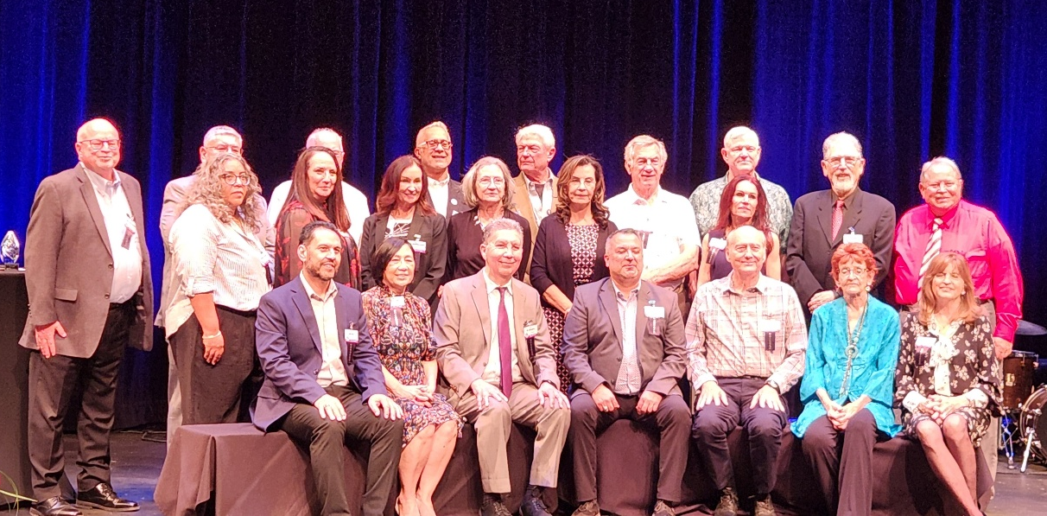
Hall of Fame 2025
Honorees, past and present, being acknowledged at the Hall of Fame. Approximately 100 individuals and organizations have been recognized since the Hall of Fame began in 2015. Individuals in the middle row represent organizations honored this year. NFLL VP Terri Kohosh is fourth from the left in the middle row.
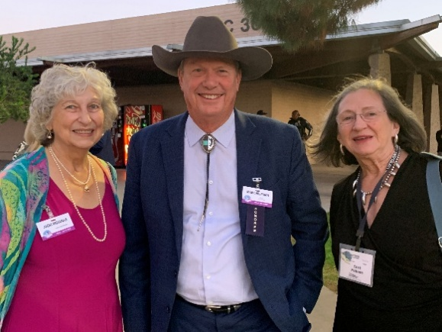
Past President Jacki McDugle and Vice President Terri Pokosh with Mesa Mayor Mark Freeman at the reception prior to the Hall of Fame Ceremony.

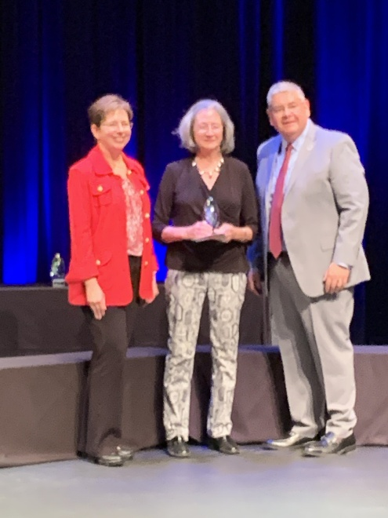

Marcy Snitzer MCC Associate Vice President, Institutional Advancement, Terri Pokosh (NFLL Vice President, and Dr. Richard Daniel (MCC President) during the Hall of Fame ceremony

Photo credits:
Jacki McDugle, Pat King, Jennifer Wong

New Frontiers for Lifelong Learning | Phone: 480-461-7497
Mesa Community College | Website: New Frontiers
Office of Community Partnerships | Debby Smith, MCC Liaison, NFLL
7110 East McKellips Road | Email: newfrontiers@mesacc.edu
Mesa, AZ 85207
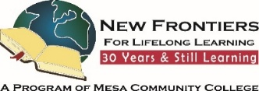


The Maricopa County Community College District (MCCCD) is an EEO/AA institution and an equal opportunity employer of protected veterans and individuals with disabilities. All qualified applicants will receive consideration for employment without regard to race, color, religion, sex, sexual orientation, gender identity, age, or national origin. A lack of English language skills will not be a barrier to admission and participation in the career and technical education programs of the District. The Maricopa County Community College District does not discriminate on the basis of race, color, national origin, sex, disability or age in its programs or activities. For Title IX/504 concerns, call the following number to reach the appointed coordinator: (480) 731-8499. For additional information, as well as a listing of all coordinators within the Maricopa College system, visit http://www.maricopa.edu/non-discrimination.

