Take Note!

NFLL calendar
Click here to find classes, socials, and more.
NFLL Council Meeting, Monday, December 8, 9:30-11:30 a.m. Red Mountain, DW 131 and via Zoom (email mcdugle@gmail.com for the link)

Thursday, December 4, Holiday Luncheon, EVIT Culinary Arts Building, 11:30 a.m.-2 p.m. Reservations required.

Tuesday, December 30, Study Hall, 4-6 p.m.
To be announced. Please reply to the RSVP if possible.

Look for the posting of the Spring Classes at the end of the month!

Report Volunteer Hours
If you volunteered for NFLL or MCC during the month, please record your hours by clicking Volunteer Hours.

Editors for this issue:
Jacki McDugle
Pat King

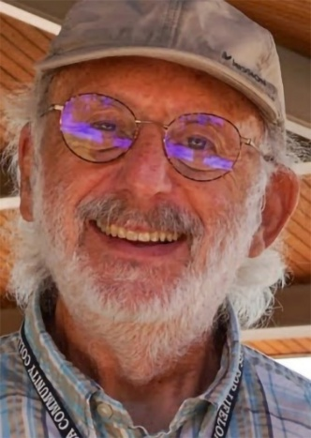
Hello New Frontiers Members,
New Frontiers for Lifelong Learning has a new logo, as displayed in the banner. The updated design preserves familiar elements from the previous logo while aligning more closely with Mesa Community College’s branding standards by using an approved font and MCC’s signature blue. Nametags with the new NFLL logo will be distributed at the upcoming events: the Holiday Luncheon, the Spring Picnic and the General meeting. As other events come up, they will be available as well. This will help reduce mailing costs.
December brings the fall semester to a close, but there are still a few activities to enjoy: Trailers hikes, the Holiday Luncheon, and the Holiday Light Tour. Please continue to stay active and connected with New Frontiers members and friends throughout the holiday season.
December also includes the winter solstice in the Northern Hemisphere, typically around December 21–22, which marks the shortest day of the year. This month’s full moon is known as the Cold Moon, a name that comes from the Mohawk nation.
Allan Zisner, President
Happy Holidays!
Opportunity Knocks
by Terri Pokosh, NFLL Vice President
I had the opportunity to serve at both Red Mountain and Central Campuses for We Serve Wednesday. The experience was well organized with the help of volunteers from MCC. I thought I was assigned an easy task at Red Mountain just wiping the number of the windshield after they passed through the line, but the rain was a challenge as the numbers were washing away before I got to them. If you have not yet volunteered, please consider doing so—it is a fulfilling and bonding experience.

Take a Detour to the Mogollan Rim
By Jennifer Wong
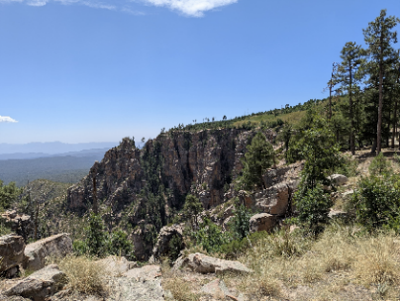
As you drive home on Hwy 87, you can take a detour by turning left off Hwy 87 onto Rural Road 95, just before the Ranger Station, an unpaved road leading to the Mogollan Rim. Although the Mogollan Rim is in the Tonto National Forest, this section is in the Coconino National Forest.

The road will eventually go downward so you can cross a stream which meanders through the gully. Once you cross the stream, admire the rugged scenery just as we did. After you cross the stream, RR 95 becomes RR 96.

On RR 321, you pass lots of Ponderosa pine trees as you drive to the Rim. The Mogollan Rim supposedly is home to the largest natural-standing grove of Ponderosa pine trees in the world. RR 321 climbs upwards, and you will soon find yourself at the Mogollan Rim.

At the Mogollan Rim, the Colorado Plateau descends into the low-lying Sonoran Desert. It begins at Flagstaff, traverses 200 miles across Arizona, and ends at the New Mexico border.
From the Rim, we looked down into the low-lying Arizonan desert with Payson and Mesa both somewhere in the distant horizon.

We have been visiting the Mogollan Rim several times over the years, and we never tire of stopping by the Rim on the way home from Logan, Utah. We had first visited the Mogollan Rim many years ago and, since moving away from Phoenix, had forgotten how to get to the Rim. Since returning to Phoenix a few years ago, we decided to re-visit the Rim once again and stopped by the Ranger Station to find out how to get to the Rim. The drive to the Rim took longer than we expected but, upon seeing the Rim, we were glad we decided to continue to the Rim.
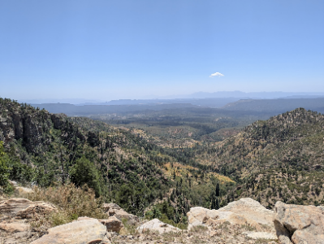
When you are at the Rim, most of the time, you have the place to yourself and you can stay for as long as you want. Driving along the Rim, the scenery changes as the vegetation changes and you can stop whenever the scenery beckons you to take a photograph as a keepsake of your trip or simply spend some time at a particular spot for as long as you wish.

For those who want to see wildlife, be on the lookout for Arizona’s own Sasquatch, the Mogollan Monster. Alas, he could not be seen or heard while we were at the Rim! Maybe we’ll have better luck next year!

At the Rim in August, it was about 85 degrees there at noon. With a slight breeze blowing, the temperature was comfortable.

At the Rim, you turn RR 300/Rim Road to drive along the Rim. If you turn left, you will drive towards Knoll Lake. We turned right on Rim Road and headed back to Hwy 87 descending down towards Pine and Strawberry.

The next time, we will drive along RR 300 toward Knoll Lake to see if the scenery is different from what we have been seeing thus far before we connect with Hwy 260 to head towards Payson.

And that ends a pleasant detour off the beaten path!

Some thoughts on aging from a random person on Facebook (so you know it’s true!)

"When I turned sixty, I sat down in my favorite chair, looked back at the life I had lived, and thought, “Well… looks like I’m entering the final stretch.” And you know what? So much of what I believed in turned out to be illusions.
Kids? They’ve got their own lives.
Health? Slips away faster than water through a cracked bucket.
The government? Just numbers on the news and endless promises.
Aging doesn’t spare anyone—it hits you where it hurts most: your hopes.
So I made a few conclusions. Hard ones. Bitter ones. But the kind that keep you afloat.
Kids don’t save you from loneliness.
We grew up believing, “Raise your children, and your old age will be happy. They’ll be there. They’ll help.” It sounds beautiful. But real life is different. Your kids have their own world—jobs, bills, stress, their own kids. And you sit there waiting for a call like it’s a national holiday. The phone stays silent for weeks, and finally you get a short text: “Hey Mom, all good.” You stare at the screen. You’re glad they’re okay—truly. But the emptiness doesn’t shrink. I finally understood: kids are joy, but they’re not a safety net. Not a cure for loneliness.
Health is not forever
There comes a point when even the trips you used to jump into with excitement suddenly feel like too much. And it hits you: health isn’t background noise—it’s your most valuable capital.
Retirement and money
This one is universal. Retirement is a joke—not a life. If you rely on the government, you’re digging your own grave. I used to think, “The system won’t abandon us.” Well, it will—and it does. Social Security covers utilities and medication. Everything else? You figure it out yourself.
So what principles help you live with dignity? Once the old pillars collapsed, I had to build new ones. Here’s what I came up with — harsh, honest, real-world rules.
Rule 1. Money is more reliable than children
No offense, but kids are love, joy—joy not your retirement plan. So save for yourself. Work. Set aside what you can. Build your own safety cushion, even a small one. Financial independence is freedom.
Rule 2. Your health is your real job
Nothing else matters if you can’t get out of bed. Take care of your body: move more, stretch, walk, swim. Ten squats each morning. Less salt. Less sugar. It’s simple stuff—and it actually works. Illness doesn’t ask if you’re wealthy or broke. But it quietly respects the ones who take care of themselves.
Rule 3. Learn to create your own joy
Expectations are the enemy. You expect calls, attention, gifts—and end up disappointed. So create happiness in small doses: a good meal, a book, music you love. Learning to enjoy your own company is emotional immunity.
Rule 4. Aging isn’t an excuse to become helpless
I’ve seen people my age become professional complainers. “Oh, it hurts. Oh, help me. Oh, everyone is against me.” And you know what happens? People—even family—start avoiding them. Weakness doesn’t earn sympathy. It breeds irritation. People respect those who stay strong even when life gets hard.
Rule 5. Let go of the past and live in the present
The most dangerous trap is, “Back in the good old days…” Back then the grass was greener, kids were better behaved, everything tasted better… “ But those times are gone. You’ve only got now. I’m learning to release the past. I don’t expect life to feel like the 1980s again. Life is different now—and I’m choosing to live this version.
Freedom and strength are still in your hands
Aging is an exam. No one takes it for you. Either you accept life as it is and rebuild it under new rules or you sit on the couch, complain, and wait for someone to come save you.
Spoiler: no one’s coming. But you—you still can."

