January 2026 Volume 34 Issue 6


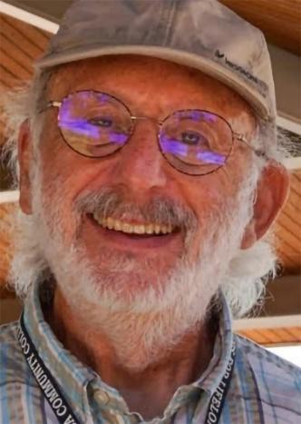
Take Note!
NFLL calendar
Click here to find
classes, socials, and more.

NFLL Council Meeting, Monday, January 12,
9:30-11:30 a.m.
Dobson, Bldg. 38, Room 608A/B or via Zoom (for link email
mcdugle@gmail.com

Thursday, January 8, Out to Lunch,
Charleston’s RSVP
Friday. January 16,
Open House, 1-3 p.m., Red Mountain

Tuesday, January 27 Study Hall, 4-6 p.m. TBD

Friday, January 30, New Member Coffee, 10-11:30 a.m.
Red Mountain

Look for the posting of the Spring Classes!

Report Volunteer Hours If you volunteered for NFLL or MCC during the month, record hours at Volunteer Hours.
Editors for this issue: Jacki McDugle
Pat King

Hello New Frontiers Members,
New Frontiers closes out the fall 2025 session with a lot to celebrate. Membership is up, we offered more than 90 in-person and online classes, and the Social
Committee has kept everyone busy with tours and out-to-lunch outings. They also outdid themselves by arranging this year’s holiday party at EVIT (East Valley Institute of Technology).
Looking ahead, the spring 2026 class schedule is expected to be posted on the website on January 2, with
printed copies available shortly after. Once again, you can look forward to a wide variety of classes, along with special events planned by the Social
Committee—especially the always popular spring picnic. Watch for announcements about upcoming tours, social get-togethers, outdoor
activities, and plenty of classroom and online discussions to keep you learning and connected.
I’m looking forward to being around more this spring—at in-person classes, social events, and other New Frontiers activities. After a major illness and six-
day hospitalization in October 2025, I’m grateful to be fully recovered and back to training. I’m currently preparing for two metric century (63-mile) bike rides, one in February and one in March, and each ride feels like another milestone on the road back.
Allan Zisner, President

New Frontiers 2025 Holiday Luncheon

By Jennifer Wong and Joanne Handlong
On Thursday, December 4th, the Social Committee hosted its annual Holiday Luncheon for New Frontiers members. The luncheon was held at EVIT (East Valley Institute of Technology) in its Culinary Arts building and the food was prepared and served by EVIT’s chefs-in-training.
The event kicked off with a flyer emailed from the Social Committee, inviting New Frontiers members to register for the event by clicking on a link in the flyer which directed them to the Purple Pass website where they could register,
choose their entrée, and pay for the Holiday Luncheon with a credit card.

Using Purple Pass for the luncheon was new this year and most New Frontiers members found the system easy to use. However, if you were unable to register online for the luncheon, you could contact MCC Liaison, Debby Smith, for assistance.
Selections on the menu were either short ribs with root vegetables, crispy shallots and merlot demi-glace; seared salmon filet with cucumber and dill relish; or seasonal vegetable hash sautéed with olive oil over roasted potatoes. The entrees were perfectly prepared and artfully
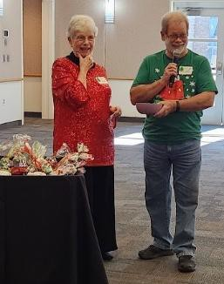
plated. Dessert consisted of three delectable mini tarts.
Continuing New Frontiers’ annual tradition, attendees donated non-perishable foodstuff and personal hygiene items, all of which were donated to Mesa Market, MCC's campus food pantry.
Including MCC staff and entertainers, a total of 71 people attended the
luncheon. Three additional members had paid but were unable to attend. Kathleen Perales, Associate Dean of Student Affairs at MCC, who is currently New Frontiers’
administrator and advocate, attended. Kathleen will be retiring in January of 2026 and shared her farewell with us at the luncheon.
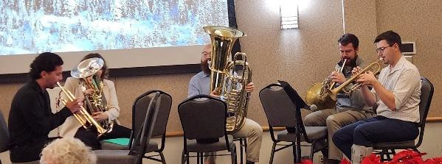
This year, the tables were decorated with a festive garland and seven small candles surrounding a glittery, star-topped, Styrofoam Christmas tree. At the end of the luncheon, each person left with a grab-bag of assorted high-quality candies and a candle.
Entertainment was provided compliments of Suzanne Brown by The Salt River 5, a subset of the Salt River Brass Band, who returned this year to entertain us with holiday music while we dined.

The Christmas tree was decorated this year with crochet-covered ball ornaments made by Wilma Clausing of the Social Committee.
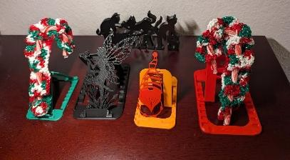
Three New Frontiers members donated items for a raffle to benefit the United Food Bank. For $3 a ticket or $10 for four tickets you had a chance to win a very nice handmade item. Raffle drawings began after lunch for two quilts made by Janice
Overdorff, three Christmas wreaths made by Joanie Hancock, and a set of woven placemats and napkins made by Ruth Tanner. Following the United Food Bank raffle, a “house” raffle was held. Each attendee had received a card with a number when they checked in. If your number was called, you could choose a grab bag of 3-D printed
items, made by Roland Tanner, a pair of socks handknit by Wilma Clausing, or a
poinsettia. Proceeds from the raffle benefiting the United Food Bank amounted to $320.
On behalf of New Frontiers, our thanks go out to the members of the Social Committee, led by Joanne Handlong and Roland Tanner, for their time and effort in making the 2025 Holiday
Luncheon a success! Our heartfelt thanks especially to Janice Overdorff, Joanie Hancock, Wilma

Clausing, Roland Tanner and Ruth Tanner for the handmade items they generously donated for our Holiday Luncheon!
Wreath winners Mary Mullen and Ardis Lehr with artist
Joanie Hancock
Fred Searing winner of the placemat set with Ruth Tanner the artist
Special thanks also go out to Bruce Sandground and staff along with the students of the Culinary School at EVIT. They did a wonderful job even serving our entertainers so their food would be hot while they were eating.
The Social Committee wishes all of you a wonderful holiday and a happy, healthy & prosperous New Year!
Social Committee Members include Mary Boehlen, Wilma Clausing, Helen Dodds, Joanne Handlong, Greg Master, Arlys Medlicott, Roland Tanner, and Diana Yarbrough

Membership Committee News

By Shirley Epp
New Frontiers has a Sunshine Lady, Diana Pearce. She loves to send cards to members letting them know we are thinking of them. If you know of someone needing uplifting contact Diana at 813-546-0790. This number also receives texts.
The Membership Committee is looking for volunteers to join our committee or even to help us at the upcoming Open House, January 16, 2026, and the New Members Tea/Coffee January 30, 2026. Contact either Penny Searing at penny4326@aol.com or Shirley Epp at gsepp@cox.net.
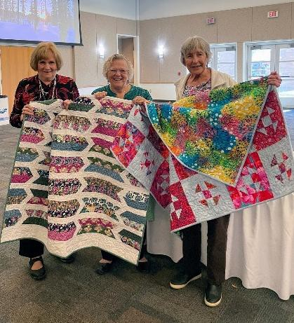
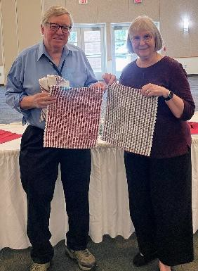
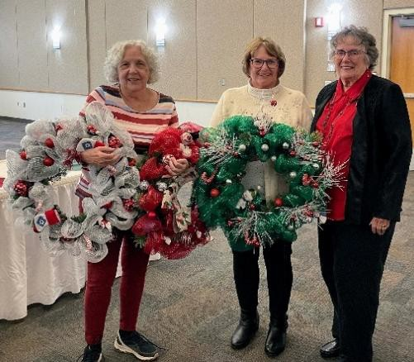
Membership Committee Members are Gloria Bruce, Shirley Epp, Diana Pearce, Kathee Rutherford, Dan Scarpone, Penny Searing, Jennifer Wong, and Sam Wong.
Quilt winners Lois Schaffer and Sandra Lasso with the artist Janice Overdorff

Curriculum Abounds!
The Curriculum Committee has come through with a wonderful selection of classes (Okay, Suzanne Brown did most of the work, as usual)! It’s POSTED ON THE WEBSITE already (yes, Suzanne took it on vacation with her).
So, what do you think your family will put in your obituary? Want to write your own?
Have you ever wanted to see a modern take on Shakespeare? Wondered about how taxes will
affect you in retirement? Wanted to join a group to discuss a book? Questioned where the moon came from? Wanted to hike or bike with someone? Worried about what’s going on in Afghanistan or Ukraine? Wanted to have time to play a game or work on a craft? Brooded about what’s normal aging? Mused about those Google apps and how to use them?
I may have exhausted my Thesaurus on the above, but we have classes for all of the above. Do we have answers for everything—no, but we offer options. Take some time to peruse the catalog and schedule those classes! Printed schedules will be available at the Open House, Friday, January 16 at 1 p.m.
See you in class!



New Frontiers for Lifelong Learning Phone: 480-461-7497
Mesa Community College Website: New Frontiers
Office of Community Partnerships Debby Smith, MCC Liaison, NFLL
7110 East McKellips Road Email: newfrontiers@mesacc.edu Mesa, AZ 85207

