Take Note!
NFLL calendar
Click here to find classes, socials, and more.

Wednesday, March 4, 11 a.m. Tour of Western Spirit Museum, please RSVP

NFLL Council Meeting, Monday, March 9, 9:30-11:30 a.m. Dobson Campus Thunderbird Think Spot or via Zoom (for link email mcdugle@gmail.com)

Thursday, March 26, 11:30 a.m. Annual Picnic at Joe’s Real Barbecue RSVP

Tuesday, March 24 Study Hall, 4-6 p.m. at Uncle Bears

Report Volunteer Hours
If you volunteered for NFLL or MCC during the month, record hours at Volunteer Hours.

Editors for this issue:
Jacki McDugle
Pat King

Hello New Frontiers Members,
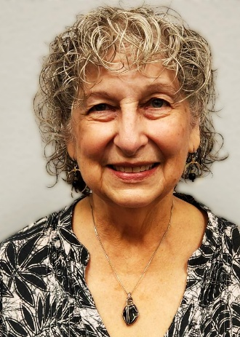
So, just what is your Council up to this month? Look out for the earth to shake, people to quake, and stay awake! It’s coming soon—changes to committee descriptions and duties. Janice Overdorff is chairing a committee of the various committee chairs. This group has defined the duties of the committees. In reality, this won’t have a lot of impact on the committees directly, but it will better define their responsibilities.
Every three years, your Council reviews its Operating Procedures. After much discussion at Council, that document is currently going through the channels to be approved by the MCC powers and legal department. The document will be presented at the May General Assembly for your vote of approval.
Our Technology Committee is undergoing a lot of changes. We will soon be housing our website with MCC. This will involve a new web address and many file changes. The Technology Committee could use some help—if you have any expertise in website management (or are trainable), the MCC staff is willing to work with us to get this site converted and help us manage it.
It’s that time of year—elections are coming up! If you have any interest in running for a position, several of our Council members’ terms are up this year. Please let us know (contact Jacki McDugle at mcdugle@gmail.com). Soon. Elections are in May!
Jacki McDugle, Past President

Did you know?
As a senior citizen, you may take advantage of grocery store discounts on the first Wednesday of each month. Albertsons, Safeway, Bashas’, and Fry’s offer a discount for those 55 and older—a 10 percent discount off their purchases. The discount typically cannot be used for prescriptions, alcoholic beverages, tobacco products, postage stamps, gift cards, Western Union, taxes, fuel or lottery tickets.

Member Feature: The Dennis Austen Story
As told on November 3, 2023, to Allan Zisner and Bob Dukelow
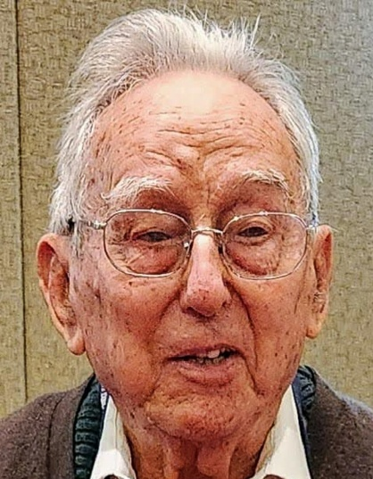
Dennis was born in 1931 in the Medway River area, between London and Canterbury, in the county of Kent — a region steeped in Roman history. The Romans had brought civilization to England, and reminders of that past were everywhere. His true home was the small village of Wainscott, north of Chatham. Along the Medway River and its tributaries to the Thames, old wooden ships sat decaying in the mud—some had once held American prisoners of war during the Revolution and the War of 1812. On nearly every rise of land, beacons stood as navigation markers.
One of Dennis’s neighbors was a kind lady from Spain who made soft gloves from rabbit skins—a useful skill, since many families raised rabbits for meat. Dennis went to primary school in Wainscott and lived in a row house on Dickens Terrace. Out back were open fields, but his front door stood only a few feet from the street, in a tight row of houses. When he was eight, life changed forever: German bombers began their Blitz on London’s East End, not far from his village. Bombers and later the V-1 “doodlebugs” often flew right over his roof on their way toward the city.
At eleven, British children were tested to determine whether they’d attend grammar school, which could lead to university, or technical school, which trained students for skilled trades. Dennis entered technical school at thirteen and stayed until fifteen, when he began an apprenticeship as a shipwright. Wooden boats were still common then, even as steel ships took over the British fleet. Along the Thames, sidewheeler boats still churned the waters. Dennis even built his own—a 16-foot snipe sailboat in his backyard, complete with a 20-foot mast. Later, in a former fisherman’s cottage, he built another boat indoors and had to remove a window to get it outside.
At twenty, in 1951, Dennis and a friend set out sailing into the English Channel. A fierce storm forced them to pull into Dover, where a lifeboat came out to check on them—but they managed to reach the harbor safely on their own.
Life in Wainscott still ran on gas rather than electricity. Homes had gas lamps, stoves, and heaters powered by coin-fed meters. You dropped in coins as you used light or heat, paying as you went.
Dennis finished his apprenticeship in 1952—and military service soon followed. British conscripts had two choices: serve two years wherever assigned or enlist for three years and choose both branch and overseas post. Adventurous and resilient, Dennis chose the longer route and joined the 15th/19th Hussars, a once-cavalry regiment that was now fully mechanized. Their famous history stretched back to the Napoleonic Wars.
He did his basic training at Carlisle, once a Roman fortress, and then advanced training before heading to his first posting in Neumünster, Germany. As a boy, his family had subscribed to Melody Maker, a magazine for professional musicians, where Dennis picked up the basics of reading music. When he joined the army, this small skill landed him a place in the regimental band—no audition, just a tuba thrust into his hands. He loved it. The army issued him six smart uniforms, and he enjoyed the camaraderie of the band, even if the officers—every bit of “upper crust”—owned both the band and a pack of hunting dogs.
After a year in Neumünster, the band relocated to Celle, near the East German border. Choirs from the German Democratic Republic sometimes crossed over to perform, and those concerts left strong impressions. The band also traveled to London’s Whitechapel for a grand international performance. In 1954, the regiment—about a thousand men—shipped out to Malaysia, based at the old Changi Prison in Singapore. For Dennis, army life felt a bit like an extended holiday; only a small squadron ever went into jungle combat.
When he returned to civilian life in 1955, Dennis put his carpentry skills to work—or tried to. Jobs were scarce, so he joined Woolworths in Chatham, stocking shelves in the warehouse above the sales floor. It ran with military precision: managers up top, clerks below, and everyone cleaning the store spotless before Saturday night could end. At Christmas, crowds packed the shops, with mothers straining to find the right toys and clothes. Dennis remembered going with his own mother as a boy to Selfridge’s, the grand store where she bought his school uniforms.
Later, he became a grocer, driving his van to London’s wholesale markets for fresh produce. Bananas came only by the “hand,” and black-market deals thrived behind the loading docks. For a while, he ran what we’d now call a food truck.
In 1967, at thirty-six, Dennis set out for North America. He visited his sister on Vancouver Island, then moved south to the United States the following year. Immigration quotas were tight—just 160,000 British citizens a year—and each applicant needed a skilled trade. His training as a cabinetmaker earned him a visa. Dennis settled in the U.S. and never looked back.

February Out to Lunch was at The Hub on Sossaman. Most of the group of 19 are shown below!
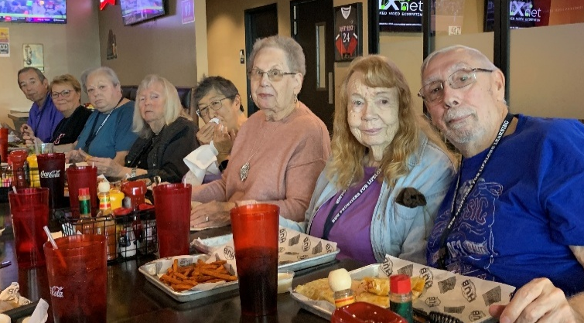
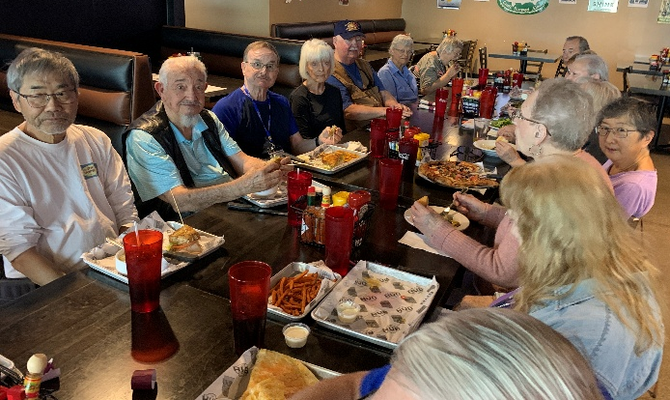
A Surprise Visit to My Homeland
Jennifer Wong
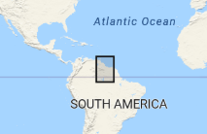
It was in early December when we were finalizing our Christmas vacation plans. Since we would be in Miami on New Year’s Eve, my daughter was inspired to visit my homeland. Guyana, located on the northern coast of South America and sharing a border with Venezuela (west), Suriname (east) and Brazil (south), was just a 4-hour plane ride south from Miami. I had long resisted going home because I was afraid of being bitten by mosquitoes. Nonetheless it was with reluctance that I agreed to return home with my family.
Having decided to go home for the New Year, we quickly got in touch with a local tour company, Dagron Tours, who arranged for us to go on day tours while we were in Guyana. First and most important, we confirmed Dagron would send someone to pick us up at the airport and take us back to the airport when our stay in Guyana ended.
We stayed at Cara Lodge, a Victorian-era wooden home built in the 1840s, which was home to the first Mayor of Georgetown, and was later converted to a hotel. It turned out to be a good choice as Cara Lodge was within walking distance to Bourda Market, which is where the locals go to buy fresh meat and produce.
We began our visit with a tour of Georgetown, stopping at the national park to check out the manatees which have been around since the 1800s. Since someone had thrown grass clippings into the pond, from the movement of the grass clippings and an occasional view of a snout or tail, it was obvious the manatees were munching on the grass clippings.
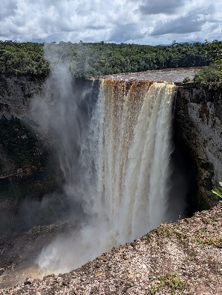
The highlight of our visit was a trip into the Guyana rainforest to see both Kaiteur Falls and Orinduik Falls, both must-see places to visit when you are in Guyana.
Upon arriving by plane to the Visitor’s Center at Kaiteur National Park, a guide took us to three lookout points from which to see Kaiteur Falls from different vantage points in all its might and majesty. With the Potato River plunging down over a cliff during rainy season in a single drop of 741 feet, the sight of such splendor was well worth the trip.
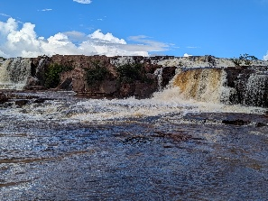
While we were at Kaiteur Falls, we were fortunate to see the Golden Rocket Frog as well as the Guianan Cock-of-the-Rock, both found only at Kaiteur Falls.
Orinduik Falls was another waterfall which was awesome. Sitting in the Pakaraima Mountains at Guyana’s border with Brazil, the Ireng River dropped over a wide cliff, showering bathers below with a cascade of water as they either sat or stood beneath the cliff for a photo op or simply frolic in the water.
Another waterfall which was more readily accessible via a boat ride on the Essequibo River was Baracara Falls which is located along the Mazaruni River and is close to Bartica which is considered to be the gateway to the Hinterland. Like Orinduik Falls, you can bathe in the falls
since the water cascades down several levels. To get to Caracara Falls, be prepared to either wear water shoes or wade barefoot through several shallow creeks before you get to the Falls.
For those who are interested in Guyana’s history with the Dutch, the Essequibo River tour also takes you to the Dutch forts of Fort Zeelandia and Kyk-Over-Al (See-Over-All) which is a fort which is located on a small island located at the confluence of the Cuyuni and Mazaruni Rivers. The fort was a strategic location as it allowed the occupants at Kyk-Over-Al to easily see anyone approaching the fort. Built in 1616, Kyk-Over-Al was occupied for approximately 100 years before being abandoned in 1748 in favor of Fort Zeelandia due to overcrowding.
While we were at Cara Lodge, we dined on some local dishes such as pepperpot, metamgee and curry and roti. Before I left, I made sure to get a bottle of casareep (to make pepperpot) and a bag of cassava bread which is made by the Amerindians to be eaten with pepper pot.
Cassava bread looks similar to Fry Bread which is made by the Native Americans. However, it differs from fry bread in that it is made entirely from grated cassava which is flattened like a tortilla and then cooked over a fire. Since cassava bread contains no herbs or spices, it has a distinct taste of cassava which is known in the U.S. as yucca.
Contrary to my expectations and much to my relief, I was hardly bitten by the mosquitoes. Perhaps it was the insect repellant which I sprayed on my clothes before arriving in Guyana. Maybe there were no mosquitoes in the places which I visited. Plus the fact that I wore jeans for the entire time I was in Guyana despite the temperature being about 83 degrees Fahrenheit could only help my case.
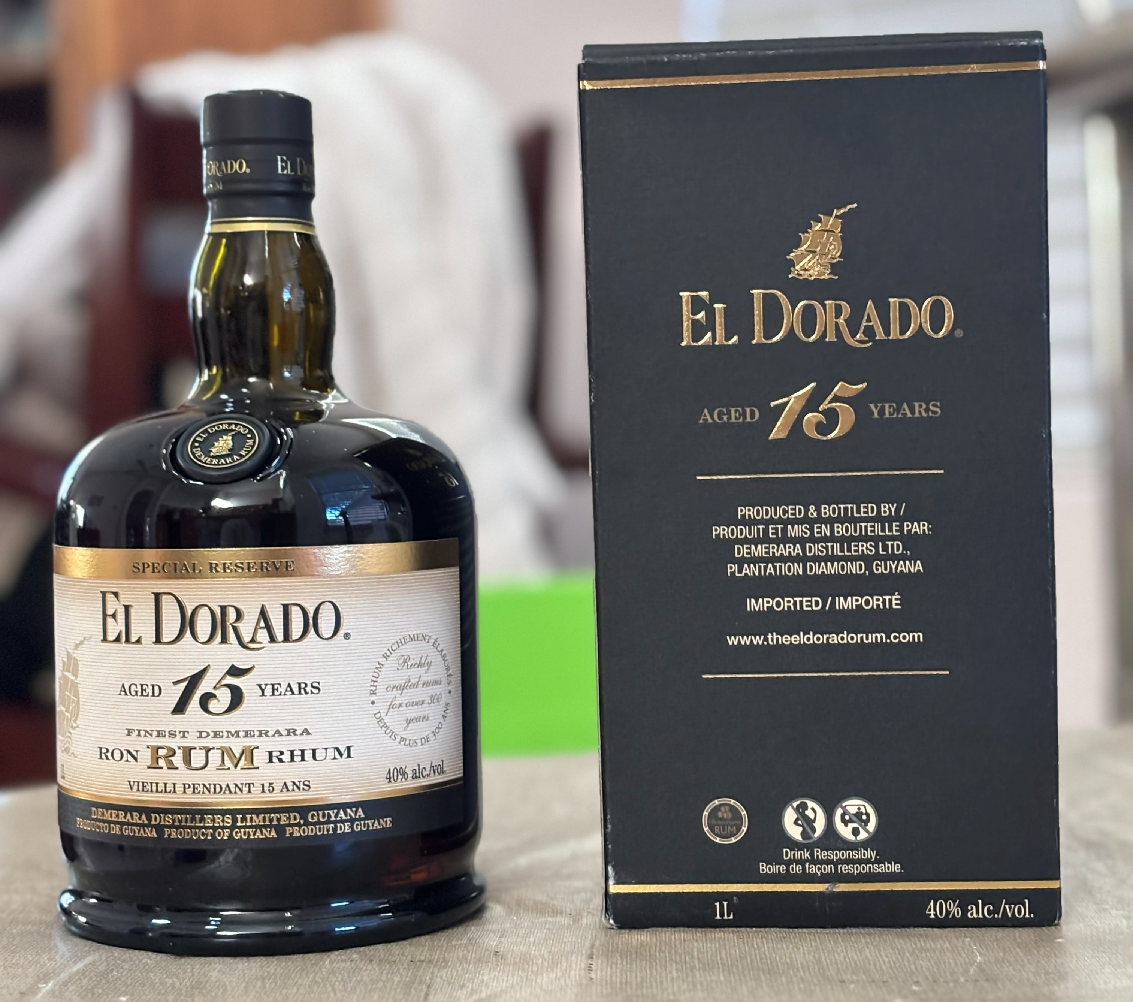
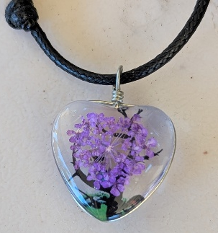
As I returned home, I left with fond memories of my homeland as well as keepsakes of my visit: a few rocks from Kaiteur and Orinduik Falls as well as a chain which was made by an Amerindian craftswoman. What made the pendant unique was the decoration inside the pendant was naturally formed by Mother Nature and can only be found in the Orinduik Falls area. The rocks which I have are one of the oldest rocks on earth since they come from the Guiana Shield, which is approximately 1.7 billion years old, making the area one of earth’s oldest land masses.
And, lest I forget…a bottle of El Dorado rum. Which Guyanese would go home and not come back with a bottle of local rum, especially when it is considered one of the best, if not the best, rum in the world?

Mark Your Calendars for New Frontiers’
Annual Spring Picnic



Thursday, March 26, 2026
11:30 AM
Joe’s Real BBQ
301 N. Gilbert Road, Gilbert
Outside, covered picnic area reserved for NFLL
Purchase own food from Joe’s extensive menu

Theme: “Irish Spring Has Sprung” 

Dress for the theme. Prizes for:
Most Imaginative, Most Colorful, Most Authentic, Funniest

Games * Book Exchange * White Elephant Gift Exchange
FUN FOOD SOCIALIZING
Presented by the Social Committee.
RSVP by March 18 to Joanne Handlong
Justjo34@gmail.com (480) 296-8512

Pictures by Pat King

