



**New Frontiers Holiday Luncheon**

**Thursday, Dec. 5TH, 2024**

**Lunch served at 12:15**

**East Valley Institute of Technology**

**1601 East Main, Mesa 85201**

**Culinary Arts Building**

|  |  |
| --- | --- |
| **CHOOSE 1 (ONE) ENTRÉE:**   * Boneless beef short ribs with root vegetables, crispy shallots, and merlot demi-glace * Seared salmon filet with cucumber, dill relish * Seasonal vegetable hash sautéed with olive oil over roasted potatoes | **WILL BE CATERER PLATED AND SERVED WITH:**   * Salad of mixed greens * Dinner rolls and butter * Chef’s tri-plate dessert * Coffee, tea and/or water |
|  | |
| **Include your entrée selection (Beef, Salmon, or Veg Hash), plus yours and your guests’ names and selections and an email and/or phone number to be notified of receipt of check.**  **Members $27, Guests $32. Make checks payable to MCC/New Frontiers. Checks can be mailed to: ATTN: Debby Smith, 7110 E. McKellips Rd, Room #DW136B, Mesa, AZ 85207.**  **No later than November 20th** | |
| **RAFFLE:** Two quilts donated by Janice Overdorf will be raffled and the proceeds donated to the United Food Bank. Raffle tickets are $3 ea. or 4 for $10.  **DOOR PRIZES:** Poinsettias, center table displays, various gifts/door prizes/wreaths by Joan Hancock  **ENTERTAINMENT:** The Salt River 5 https://www.saltriverbrass.org/saltriver5 | |
| MESA MARKET **FOOD FOR STUDENTS**  Bring items to donate; they will go to the Mesa Market, MCC's campus food pantry.  Cash from Quilt Raffle will be donated to United Food Bank | |
| **SUGGESTED ITEMS** | |
| **NON-PERISHABLE FOOD:**   * Cereal and oatmeal * Rice/Beans * Canned fruit/vegetables * Snack items (granola bars/fruit snacks/crackers) * Canned meat * Pasta and pasta sauce * Soup * Peanut butter/jelly * Gluten-free items | **HYGIENE ITEMS:**   * Shampoo/conditioner * Bars of soap/body wash/deodorant * Toothbrush/Toothpaste * Razor/Shaving cream * Toilet paper/tissues |



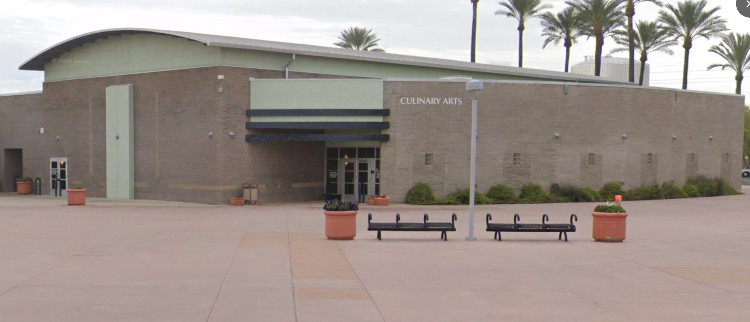

Culinary Arts Building @ EVIT