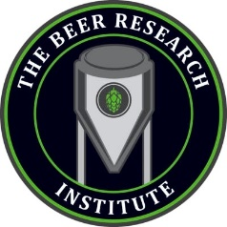

**Study Hall at The Beer Research Institute**

**Craft Brewery and Scratch Food**

**1641 S Stapley Dr, Mesa, Arizona 85204**

South of the 60, East of Stapley Dr.

**Tuesday, March 25th, at 4:00pm**

[**Google Map Link**](https://maps.app.goo.gl/9NKACpJSQBKcEezo9)

**A reservation has been made for an estimated 12-15 attendees.**

**Your RSVP would be helpful, but if you forget don’t let that stop you from attending!**

**To RSVP or if you have any questions, contact Monica Karels.**

**Email**: [phxsunshine@cox.net](mailto:phxsunshine@cox.net)

**Landline:** 480-835-9190 **Cell:** 480-745-9445

Brought to you by NFLL Social Committee. For information on more upcoming activities go to: <https://newfrontiers.mesacc.edu/social.html>

New Frontiers Lifelong Learning – MCC, Community Partnerships Office 7110 E. McKellips - DW 136-B Mesa, AZ 85207 United States