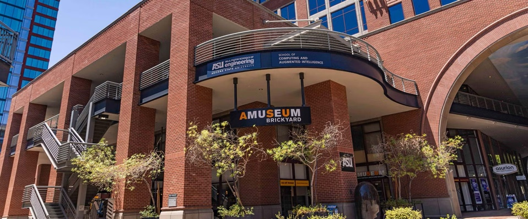

Join us for a guided tour of the

**ASU Art Museum Ceramics Research Center\***

699 South Mill Avenue, Suite 108, Tempe 85281

[**Picture of Entrance**](https://tours.asu.edu/sites/default/files/styles/hero/public/interior/tempe-ceramics-research-interior-2.jpg?itok=VVjdnmd6)

**Wednesday, May 21, 2025**

**10:30 AM**

**Admission FREE**

The ASU Art Museum **Brickyard** houses the [Ceramics Research Center](https://asuartmuseum.org/research-learning/ceramics-research-center-archive/), the ASU Art Museum’s extensive ceramics collection comprised of more than 3,000 pieces. **After the tour, we can walk to a nearby restaurant for lunch.**

*The Ceramics Research Center is located on the ground floor of the Brickyard Engineering building, NE corner of 7th St. and Mill Avenue. Paid parking is available in the Brickyard garage, 7th St. & Myrtle, at $4.00/hour. The garage entrance is east of Mill on 7th Street.

[Google M ap Link](https://www.google.com/maps/place/ASU+Art+Museum+Ceramics+Research+Center/@33.4235713,-111.9418437,986m/data=!3m3!1e3!4b1!5s0x872b08d832a2ec8f:0x64c8cb53de4423a5!4m6!3m5!1s0x872b08d8328497bb:0x3c42ebbfd245497f!8m2!3d33.4235668!4d-111.9392688!16s%2Fg%2F11bw4729d0?authuser=0&entry=ttu&g_ep=EgoyMDI1MDQyOC4wIKXMDSoJLDEwMjExNDU1SAFQAw%3D%3D)

**Register by Monday, May 19th**

**Contact Joanne Handlong**

Email: justjo34@gmail.com Cell: 480-296-8512

Carpooling from MCC Dobson can be arranged.

Brought to you by NFLL Social Committee. For information on more upcoming activities go to: <https://newfrontiers.mesacc.edu/social.html>

New Frontiers Lifelong Learning – MCC, Community Partnerships Office 7110 E. McKellips –

DW 136-B Mesa, AZ 85207