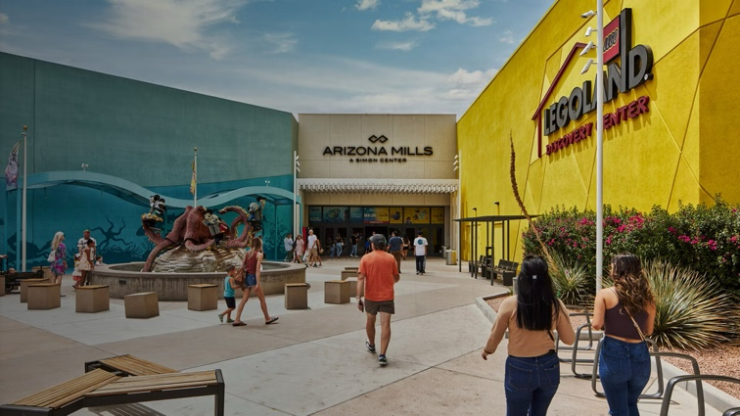

**Join us for Mall Walk and Out to Lunch**

**Thursday, June 12, 2025**

**ARIZONA MILLS**

**5000 S Arizona Mills Cir, Tempe, AZ 85282**

**11:00 AM - Meet for walk beginning at Merry Go Round**

**11:30 AM - Meet for FOOD COURT LUNCH**

**(gather at one table (s))**, AZ 85282

5000 S Arizona Mills Cir, Tempe, AZ 85282

**Map of AZ Mills:** [**https://www.simon.com/mall/arizona-mills/map/#/**](https://www.simon.com/mall/arizona-mills/map/#/)

**The Merry Go Round is in the Food Court closest to Harkins Theater**

**Did you know that a walk around the inside of the mall is ONE MILE?**



**No registration, just show up, and please wear your NFLL name tag**

**Host will be: Joanne Handlong**

E: [justjo34@gmail.com](mailto:justjo34@gmail.com) C: 480-296-8512

Brought to you by NFLL Social Committee. For information on more upcoming activities go to:

<https://newfrontiers.mesacc.edu/social.html>

New Frontiers Lifelong Learning – MCC, Community Partnerships Office 7110 E. McKellips –

DW 136-B Mesa, AZ 85207