Join us for a self-guided tour

of the

**CHANDLER MUSEUM**

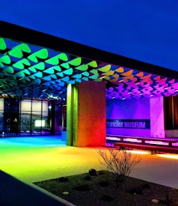  
  
**300 S. Chandler Village Drive  
Chandler, AZ 85226**

**FREE Admission**

[**GOOGLE MAP**](https://www.google.com/maps/place/Chandler+Museum/@33.2978737,-111.905012,17z/data=!3m1!4b1!4m6!3m5!1s0x872baa10ce2dc265:0xfa06f3c976625612!8m2!3d33.2978737!4d-111.9024371!16s%2Fg%2F1263slg0g?entry=ttu&g_ep=EgoyMDI1MDcyMS4wIKXMDSoASAFQAw%3D%3D)

**Tuesday, August 19, 2025**

**11:30 AM**

**(If interested have lunch afterward at Chompie’s)**

**300 feet due east of museum**

**Registration by Monday, August 18th at Noon**

Contact: Roland Tanner at Email: [Rol2135531@maricopa.edu](mailto:Rol2135531@maricopa.edu)

**Be sure that Roland acknowledges your email**

**Roland may be reached by phone at 480-480-2010 if you are unable to email him**

**Brought to you by your NFLL Social Committee**

For information on more upcoming activities go to: <https://newfrontiers.mesacc.edu/social.html>

New Frontiers Lifelong Learning – MCC, Community Partnerships Office

[7110 E McKellips](https://www.google.com/maps/search/7110+E%0D%0AMcKellips?entry=gmail&source=g), DW 136-B                       Mesa, AZ 85207 United States