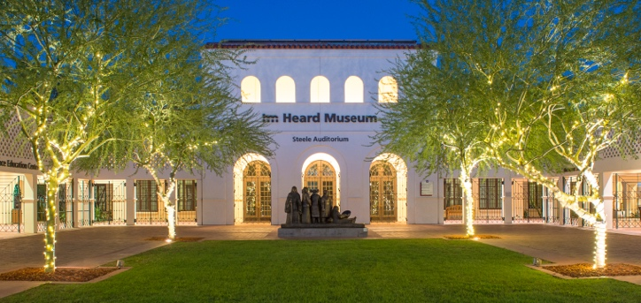

Join us for a **SATURDAY** Outing

*to the*

[**HEARD MUSEUM**](https://heard.org/)

2301 N Central Ave., Phoenix

**Saturday, July 19, 10:30 AM**

**Free Admission**

The third Saturday of the months of June, July, and August are FREE ADMISSION for Family Summer Saturdays. This will be a self-guided tour. We can meet inside the entrance and tour together as a group or go our separate ways, then meet up at a designated time and have lunch together at the museum or at a nearby restaurant.

[**GOOGLE MAP LINK**](https://www.google.com/maps/place/Heard+Museum/@33.4722234,-112.0792712,15z/data=!4m6!3m5!1s0x872b12425b1150ab:0xdc4b09e8041cd722!8m2!3d33.4725814!4d-112.0722331!16zL20vMDVwbXBk?authuser=0&entry=ttu&g_ep=EgoyMDI1MDYxMS4wIKXMDSoASAFQAw%3D%3D)

The Heard Museum is located on Central Avenue four blocks north of McDowell Road at Encanto Blvd. Free on-site parking is available for all visitors. The museum is also easily accessible via Valley Metro Light Rail via the stop at Encanto/Central Avenue.

*Carpooling can be arranged from MCC Dobson.*

**Register by Thursday, July 17**

**Contact person: Joanne Handlong**

Email: [justjo34@gmail.com](mailto:justjo34@gmail.com) Cell: 480-296-8512

Brought to you by NFLL Social Committee. For information on more upcoming activities go to: <https://newfrontiers.mesacc.edu/social.html>

New Frontiers Lifelong Learning – MCC, Community Partnerships Office 7110 E. McKellips –

DW 136-B Mesa, AZ 85207