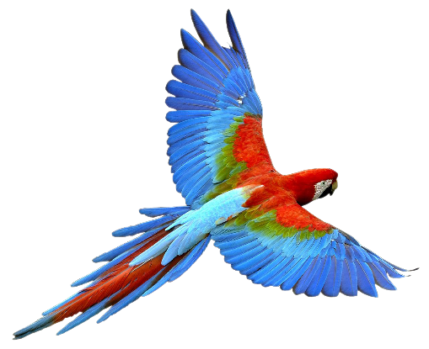

**Study Hall**

August 26, 4 PM to 6 PM

 Enjoy delicious food and fun

with your friends, and the exotic birds at

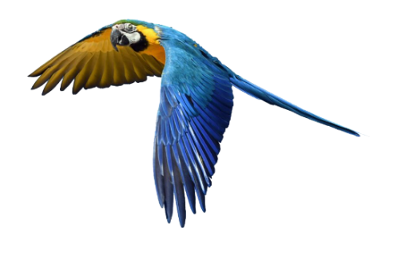The Perch Pub Brewery,

*232 S. Wall St., Chandler*

(Downtown historic district)

[**GOOGLE MAP LINK**](https://www.google.com/maps/place/The+Perch+Brewery/@33.3000481,-111.8450827,17z/data=!3m1!4b1!4m6!3m5!1s0x872baa11865f8d39:0x25398276b446831b!8m2!3d33.3000481!4d-111.8425078!16s%2Fg%2F11bbrcgjlh?authuser=0&entry=ttu&g_ep=EgoyMDI1MDcxNi4wIKXMDSoASAFQAw%3D%3D)

***Your RSVP would be appreciated,***

***but if you can’t commit don’t let that stop you from attending.***

To RSVP or if you have any questions, contact

Arlys Medlicott:  [ajmcmk@aol.com](mailto:ajmcmk@aol.com)

 Cell Phone:  602-284-8523

Brought to you by NFLL Social Committee.

For information on more upcoming activities go to: <https://newfrontiers.mesacc.edu/social.html>

New Frontiers Lifelong Learning – MCC, Community Partnerships Office 7110 E. McKellips - DW 136-B Mesa, AZ 85207 United States