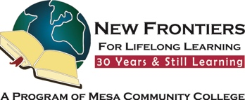

Spend an interesting and fun afternoon at the
USA Clydesdale Preservation Foundation

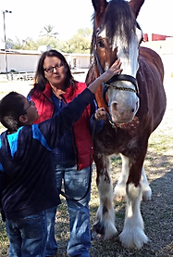
Pet these beautiful horses while you learn all about them.

Must wear closed toed shoes
No fee just a donation

November 18 at 1 p.m.

17268 E Saragosa St. Gilbert

Google Map Link

Register by November 14, 2025 – Limit of 20 people
Contact person: Diana Yarbrough
Email: dyarbs@yahoo.com
Cell: 602-931-3898 Home 480-924-6408

Brought to you by NFLL Social Committee. For information on more upcoming activities go to: https://newfrontiers.mesacc.edu/social.html
New Frontiers Lifelong Learning – MCC, Community Partnerships Office 7110 E. McKellips - DW 136-B Mesa, AZ 85207 United States


