NFLL “Out-to-Lunch” Dinner & Outing
Malee’s & Scottsdale Art Walk
Thursday, Nov 13
Dinner 4:30 PM – 6:00 PM
Art Walk 6:30 – 9:00 PM
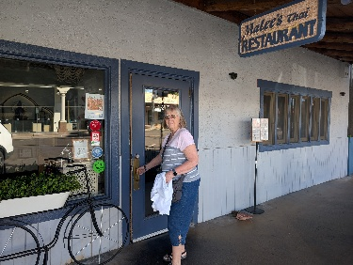
Ruth and I checked it out and the Thai food is great
7131 E Main St, Scottsdale, AZ 85251
https://maps.app.goo.gl/sps29NCAznMc8GQm8

Scottsdale Gold Palette Art Walk https://scottsdalegalleries.com/

After dinner all who would like to go for the ArtWalk will be given maps and I recommend we break up into smaller groups

RSVP by Tuesday (11th) NOON: questions, contact Roland Tanner.
Email: rol2135531@maricopa.edu Cell: 480-295-2010

Brought to you by NFLL Social Committee. For information on more upcoming activities go to: https://newfrontiers.mesacc.edu/social.html
New Frontiers Lifelong Learning – MCC, Community Partnerships Office 7110 E. McKellips - DW 136-B Mesa, AZ 85207 United States

