[](https://newfrontiers.mesacc.edu/index.html)

**Study Hall**

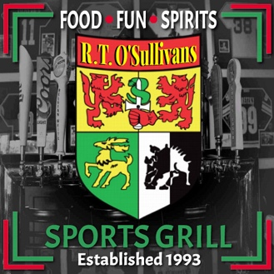

**October 28, 2025 – 4 PM to 6 PM**

**R. T. O’Sullivan’s Sports Grill**

6646 E Superstition Springs Blvd., Mesa

Join us on the patio of this Irish pub

for good food and drinks

[GOOGLE MAP](https://www.google.com/maps/place/R.T.+O'Sullivans+Sports+Grill/@33.3850345,-111.6971962,15z/data=!3m1!4b1!4m6!3m5!1s0x872bae34fd873903:0xc0ac2e4409f3a074!8m2!3d33.385017!4d-111.6869179!16s%2Fg%2F11c59scs53?authuser=0&entry=ttu&g_ep=EgoyMDI1MDkxNy4wIKXMDSoASAFQAw%3D%3D)

**Hosted by Greg Master**

An **RSVP** to Greg would be appreciated so he can request   
adequate seating

**Email:**[g amst51@gmail.com](mailto:gamst51@gmail.com)

**Cell:  832-594-6175**

Brought to you by NFLL Social Committee. For information on more upcoming activities go to: <https://newfrontiers.mesacc.edu/social.html>

New Frontiers Lifelong Learning – MCC, Community Partnerships Office 7110 E. McKellips - DW 136-B Mesa, AZ 85207 United States

