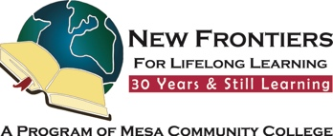

Study Hall
Republica Empanada
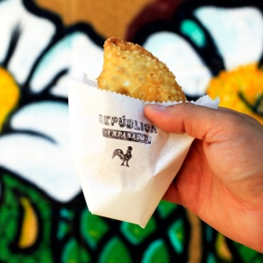
Tuesday, November 25, 2025
4:00 PM – 6:00 PM

204 E. 1st Avenue, Mesa

Large selection of South American-style
savory empanadas | beer and wine
Outdoor seating on the covered patio
Google Map Link

Hosted by: Greg Master
Your RSVP is always appreciated and helpful!
Email: gamst51@gmail.com Cell: 832.594.6175

Brought to you by NFLL Social Committee. For information on more upcoming activities go to: https://newfrontiers.mesacc.edu/social.html
New Frontiers Lifelong Learning – MCC, Community Partnerships Office 7110 E. McKellips - DW 136-B Mesa, AZ 85207 United States
