[](https://newfrontiers.mesacc.edu/index.html)

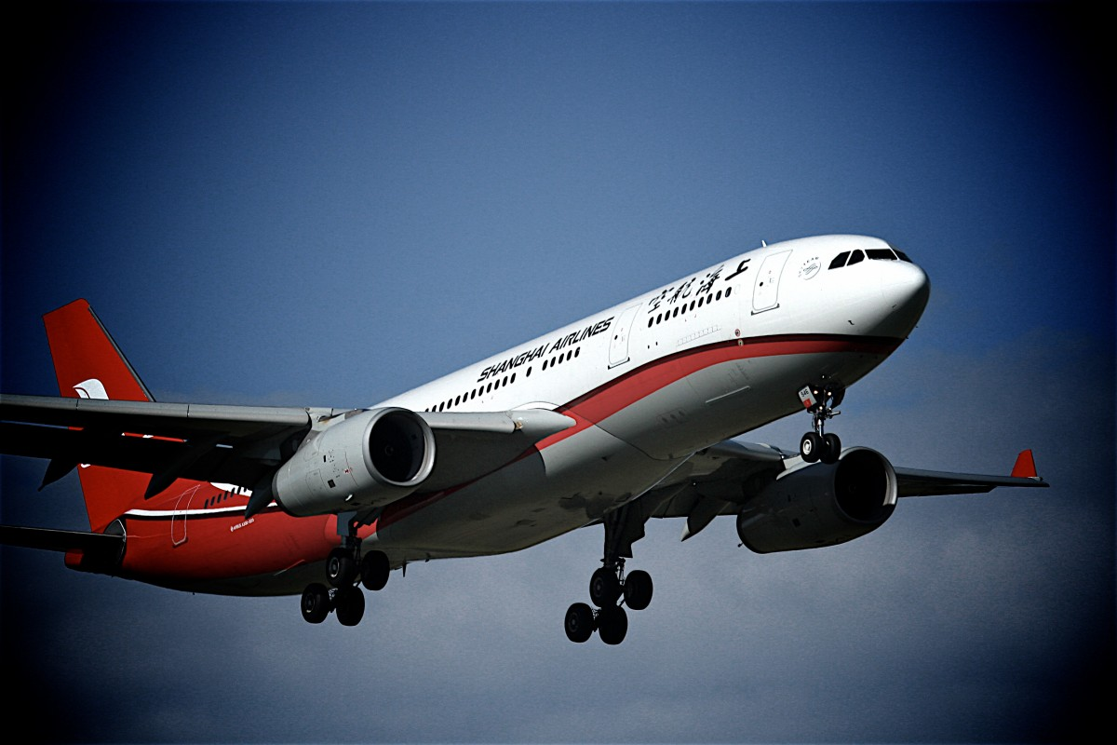

**Join Us for a Light Rail Excursion**

**and**

**Guided Tour of Phoenix Sky Harbor Airport**

**Thursday, October 16th, 2025**

**Tour Times: 1:30 PM – 3:00 PM (90 Minutes)**

**Approximate Time for Light Rail to Airport: 12:24PM – 1:00 PM\***

This 90-minute guided tour will be led by an airport Navigator. It will include a ride on the PHX Sky Train, exploring the Airport Museum, visiting one of the terminals, and watching airplanes. Airport Museum staff will join the tour guide to show and discuss some of the art on exhibit.

**Logistics for Light Rail Portion**

**Light Rail Fare - $2.00 single ride (each way)**

**\*\*\*\*WE WILL TAKE THE LIGHT RAIL THAT ARRIVES AT 44TH ST/WASHINGTON AT 1:00 PM.\*\*\*\***

**Excursion Starting Point: 12:24 PM Boarding Time - Price-101 Freeway/Apache Blvd (Park & Ride Lot)**

Train arrives here at 12:24 PM – Host (Joanne) will park here and be on the platform **by 12:10 PM** to meet you.

**\*If you prefer to board the same light rail train farther east**:

**Farthest East Starting Point: 12:01 PM Boarding Time - Gilbert Road/Main Street (Park & Ride lot)**

Train leaves here at 12:01 PM – Board on your own. Look for Joanne and others at Price-101/Apache Blvd stop.

**Logistics for Tour Portion**

**1:00 PM – LIGHT RAIL ARRIVES AT THE 44th ST/WASHINGTON LIGHT RAIL STATION**

We will get off the train, then take the escalator/elevator up to the pedestrian bridge. We will walk across the pedestrian bridge leading to the 44th Street PHX Sky Train Station. Our guide will be waiting for us at the end of the pedestrian bridge wearing a purple Navigators shirt.

(The guide will be there at 1:15 PM and could start the tour earlier if we are all there by that time.)

**Hosted by Joanne Handlong**

**\*\*RSVP to Joanne by October 14th\*\***

Email: [justjo34@gmail.com](mailto:justjo34@gmail.com) Cell Phone: (480) 296-8512

Brought to you by NFLL Social Committee. For information on more upcoming activities go to: <https://newfrontiers.mesacc.edu/social.html>

New Frontiers Lifelong Learning – MCC, Community Partnerships Office

7110 E. McKellips - DW 136-B Mesa, AZ 85207 United States