Join us for a guided tour of the
Mesa Arts Center
1 East Main Street, Mesa
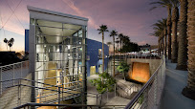

Wednesday, January 14, 2026
10:00 AM – 11:30 AM
Learn about the history, architecture and design of this arts complex which
includes four theaters, arts studios, and a contemporary arts museum.
It is the largest & most comprehensive performing, visual & educational
arts center in the state of Arizona.
This will be a 90-minute walking tour, with opportunities to sit.
Facility is ADA accessible.
Google Map Link

Hosted by Joanne Handlong
RSVP to Joanne by Noon on Friday, January 9th
Email: justjo34@gmail.com Ph: 480-296-8512

*******************************
Directions for Meeting Up on the Mesa Arts Center Campus
We will meet up in front of the North Nose entrance to the theater building at 9:55 AM.
See the attached campus map.

Free parking is available in visitor or handicapped spaces in the multi-story garage
on Sirrine or in the South parking lot.

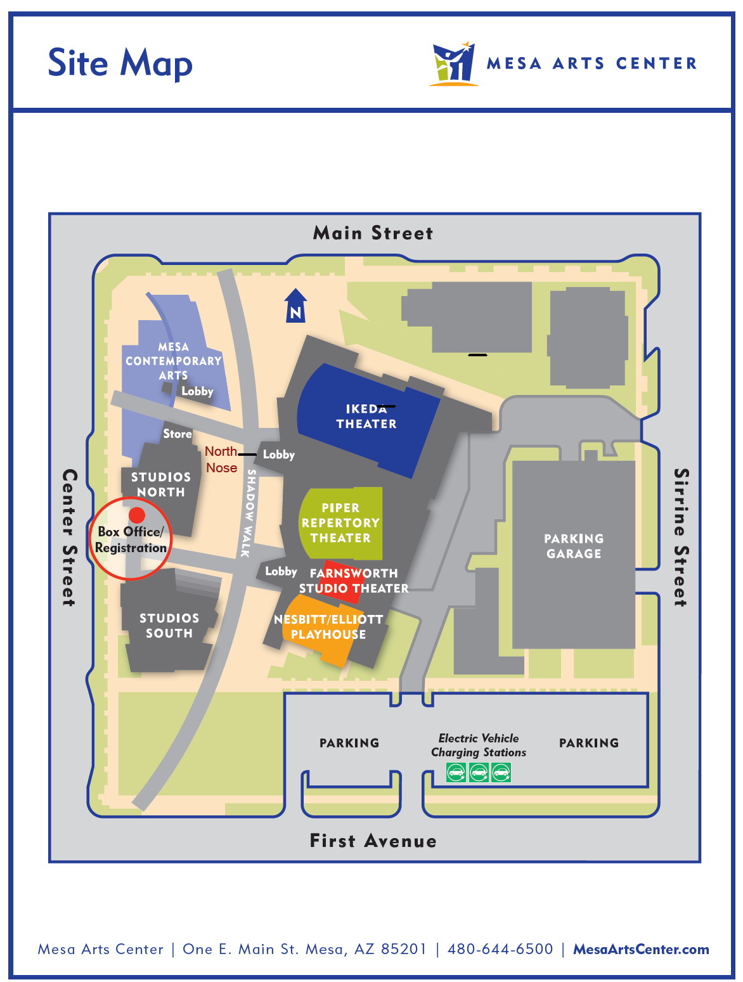
Meeting Location

