Study Hall
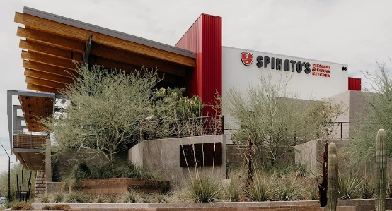
Spinato’s Pizzeria and Family Kitchen

Tuesday, April 28, 2026 - 4:00 PM

98 S. Rockford Drive, Tempe
(From Rio Salado Parkway, turn north at light onto Rockford Drive)

GOOGLE MAP

Hosted by Joanne Handlong
Your RSVP by April 25th would be appreciated*
Email: justjo34@gmail.com Cell: 480-296-8512
*A preliminary reservation has been made for 15 people.
Spinatos would like a final number in advance.

Brought to you by NFLL Social Committee. For information on more upcoming activities go to: https://newfrontiers.mesacc.edu/social.html
New Frontiers Lifelong Learning – MCC, Community Partnerships Office
7110 E. McKellips - DW 136-B Mesa, AZ 85207 United States

