Study Hall

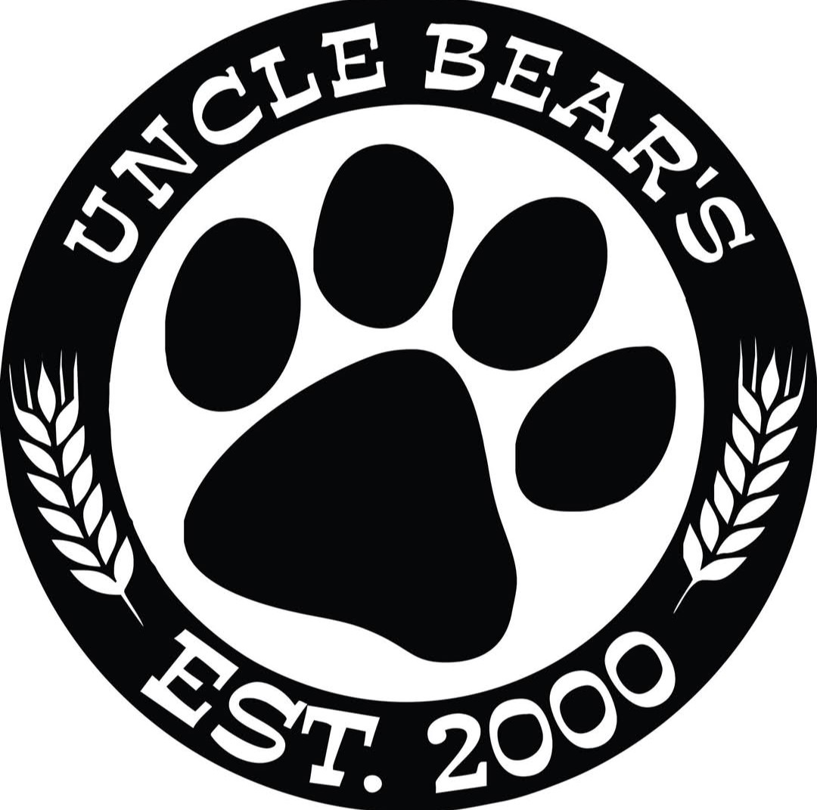

Uncle Bear’s Grill & Tap

Tuesday March 31st from 4pm – 6pm

1110 Greenfield Rd #101A
(NW corner Greenfield & Southern)
Mesa, AZ 85206
480-256-1415

https://maps.app.goo.gl/YndntffWtaypd7458

Hosted by Anita Petty

Your RSVP by March 29th would be appreciated.

Email: louispetty@gmail.com Phone: 480-208-2161

Weather permitting, we will sit on the dog-friendly patio.

Brought to you by NFLL Social Committee. For information on more upcoming activities go to: https://newfrontiers.mesacc.edu/social.html
New Frontiers Lifelong Learning – MCC, Community Partnerships Office
7110 E. McKellips - DW 136-B, Mesa, AZ 85207 United States

