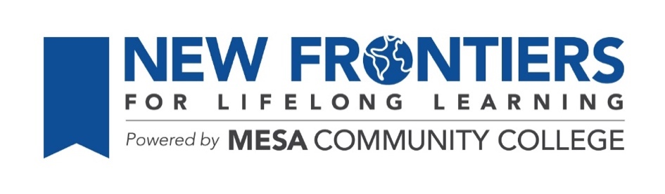
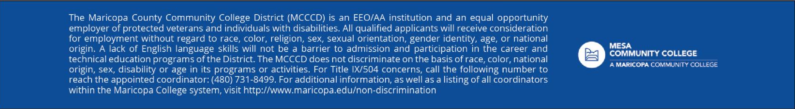
Study Hall
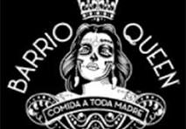
Barrio Queen
Tuesday, February 24th, 4 to 6 PM
388 N. Gilbert Road, Downtown Gilbert

Google Map Link

Hosted by Joanne Handlong
Reservations have been made for 18 people
Your RSVP by February 22nd would be appreciated and helpful.

Email: justjo34@gmail.com Phone: 480.296.8512

Brought to you by the NFLL Social Committee. For information on upcoming activities go to: https://newfrontiers.mesacc.edu/social.html

New Frontiers Lifelong Learning – MCC, Community Partnerships Office 7110 E. McKellips - DW 136-B Mesa, AZ 85207 United States

