
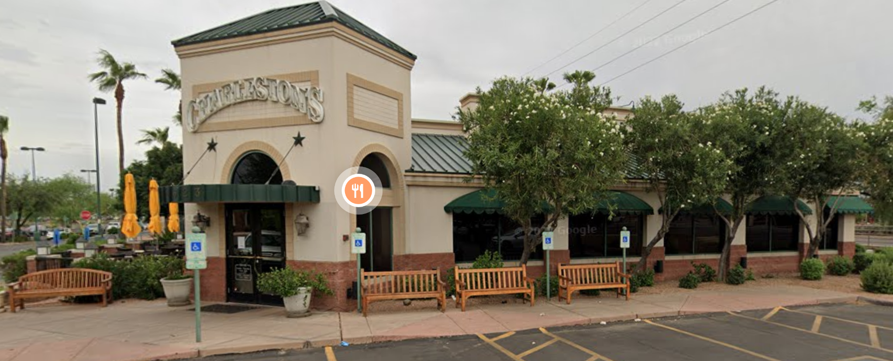

Thursday, January 8, 2026, at 11:30 AM
1623 S Stapley Dr., Mesa, AZ 85204
Google Map Link
We will plan to eat in a separate area in main dining room.
The contact person is Roland Tanner at Rol2135531@maricopa.edu. Be sure that Roland acknowledges your email to reserve a spot for you. Please contact him by email no later than Tuesday, January 6, by late afternoon if you want to attend. We are limited to 17 attendees, so please do not just show up, you may be sitting by yourself!!
Roland may be reached by phone at 480-295-2010 if you are unable to email him.
Brought to you by NFLL Social Committee.
Mesa Community College
MARICOPA COMMUNITY COLLEGES
Social Committee CoChair, NFLL | Community Partnerships
Desert Willow Bldg Room 136-B
1833 West Southern Avenue, Mesa AZ 85202

