OUT TO LUNCH

THE CHEESECAKE FACTORY

Thursday, April 9th, 2026 - 11:30 AM

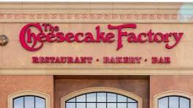

6613 E. Southern Ave., Mesa

At the Superstition Springs Center (Mall)
Southwest of Power and Southern / Northeast side of the mall

Extensive lunch menu but be sure to save room for dessert!

GOOGLE MAP LINK

Hosted by Tina Kasey

Make your reservation with Tina by Tuesday, April 7th at Noon
Email: Tinakasey@protonmail.com Phone: 480-854-8074

Brought to you by NFLL Social Committee. For information on more upcoming activities go to: https://newfrontiers.mesacc.edu/social.html
New Frontiers Lifelong Learning – MCC, Community Partnerships Office 7110 E. McKellips - DW 136-B Mesa, AZ 85207 United States

