Spend an interesting and fun afternoon at the

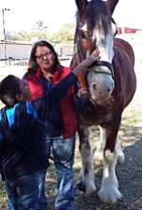
USA Clydesdale Preservation Foundation

Pet these beautiful Horses while you learn all about them.
Closed toed shoes required no fee just a donation

February 5 at 12 p.m.
17268 E Saragosa St. Gilbert

Google Map Link

Register by February 1 2026– Limit of 20 people
Contact person: Diana Yarbrough
Email: dyarbs@yahoo.com

Cell: 602-931-3898 Home 480-924-6408

Brought to you by NFLL Social Committee. For information on more upcoming activities go to: https://newfrontiers.mesacc.edu/social.html
New Frontiers Lifelong Learning – MCC, Community Partnerships Office
7110 E. McKellips - DW 136-B Mesa, AZ 85207 United States

