Announcing the
REVISED FLYER

ANNUAL NEW FRONTIERS’ PICNIC
Thursday, March 26, 11:30 AM
Joe’s Real Barbecue
Outside covered picnic area reserved for New Frontiers

30
301 North Gilbert Road
Cake to celebrate the 30 Year Anniversary of NFLL
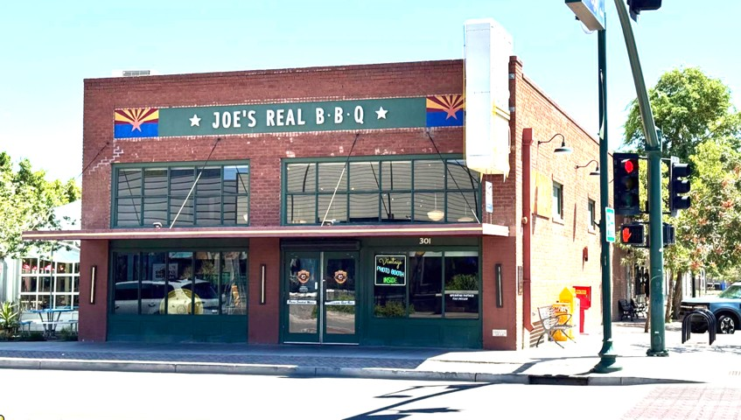

Purchase your own food from Joe’s food line menu:
https://www.joesrealbbq.com/menu-1



Our theme for this year is
Irish Spring Has Sprung ! !
We suggest appropriate wear to honor the theme. Prizes for:
Most Imaginative * Most colorful * Most authentic * Funniest
OTHER ACTIVITIES:
GAMES
Ice Breaker
Corn Hole
Trivia
WHITE ELEPHANT GIFT EXCHANGE
Bring a gift in a brown paper bag and pick a gift. Suggested value no more than $10

BOOK EXCHANGE
Bring your already read or will-never-read books for others to enjoy

RSVP BY MARCH 18TH TO JOANNE HANDLONG
Use this email address
Justjo34@gmail.com (480) 296-8512

Brought to you by NFLL Social Committee. For information on more upcoming activities go to: https://newfrontiers.mesacc.edu/social.html
New Frontiers Lifelong Learning – MCC, Community Partnerships Office 7110 E. McKellips - DW 136-B Mesa, AZ 85207 United States

