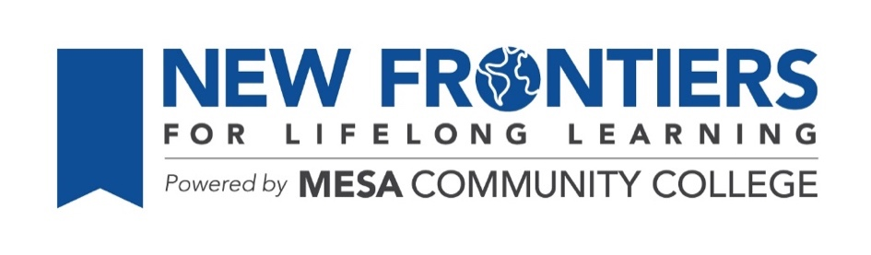
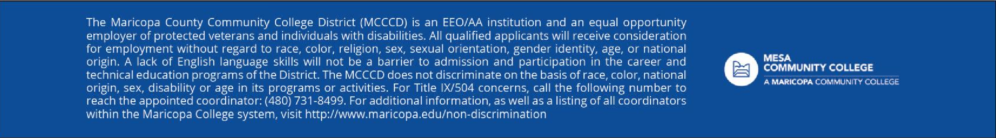
OUT TO LUNCH
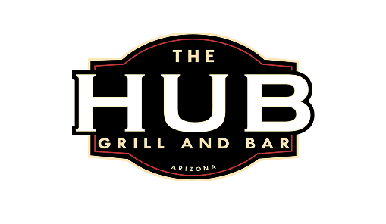
THE HUB GRILL AND BAR
THURSDAY, FEBRUARY 12TH, 11:30 AM
1925 S. SOSSAMAN ROAD, MESA
(Northeast corner of Baseline and Sossaman)

Google Map Link

Hosted by Mary Boehlen
RSVP to Mary by Tuesday, February 10th

Email: minpins48@gmail.com Phone: 460-699-6374

Brought to you by the NFLL Social Committee. For information on upcoming activities go to: https://newfrontiers.mesacc.edu/social.html

New Frontiers Lifelong Learning – MCC, Community Partnerships Office 7110 E. McKellips - DW 136-B Mesa, AZ 85207 United States

